**MISSISSIPPI VALLEY STATE UNIVERSITY**



Department of Social Work

BSW Program

Council on Social Work Education

**Self-Study Document**

**Volume I**

**Standards**

FY 2016-2017

Submitted by the

Bachelor of Social Work Program

Department of Social Work

MVSU 7293

14000 Highway 82 West

Itta Bena, MS 38941-1400

662-254-3365

Dr. William B. Bynum, President

Mississippi Valley State University is accredited by the   
Southern Association of Colleges and Schools Commission on Colleges

To award Bachelor’s and Master’s Degrees

Contact the Commission on Colleges at

1866 Southern Lane

Decatur, GA 30033-4097

or call (404) 679-4500

for questions about the accreditation of Mississippi Valley State University

AN EQUAL OPPORTUNITY EMPLOYER

**Accreditation Standard 1:0 Program Mission and Goals**

|  |
| --- |
| **AS 1.0.1:** The program submits its mission statement and describes how it is consistent with the profession’s purpose and values and the program’s context. |

The social work program has a mission consistent to professional social work education as defined in EP 1.1. The program’s mission is appropriate to the level for which it is preparing students for practice and is consistent with the institution’s mission. Mississippi Valley State University’s mission statement was approved by the Institution of Higher Learning (IHL) Board in March 2011, effective for July 1, 2012. Both the broad vision and the mission of Mississippi Valley State University (MVSU) are presented in the university’s 2012-2017 Strategic Plan titled “Framing the Renaissance.”

University Vision Statement

Mississippi Valley State University aspires to become the educational crown jewel of the Mississippi Delta, and in so doing, the institution will attract students of diverse backgrounds as a result of its innovative academic programs; commitment to developing entrepreneurs; and globalized focus intertwined throughout the academic curricula and support services. In its quest for distinctiveness, uniqueness, innovation, and longevity, the University will become the public square of the Mississippi Delta, responsible for engaging an ever-expanding group of collaborators focused on identifying and implementing solutions to the problems that have plagued the delta region for generations. As a result, Mississippi Valley State University will serve as the catalyst for an enhanced quality of life and increased educational opportunities for the citizens of a revitalized Mississippi Delta.

University Mission Statement

Mississippi Valley State University, as a Carnegie Classified Master’s University, provides comprehensive undergraduate and graduate programs in education, the arts and sciences, and professional studies. The University is driven by its commitment to excellence in teaching, learning, service, and research – a commitment resulting in a learner-centered environment that prepares critical thinkers, exceptional communicators, and service-oriented, engaged, and productive citizens. MVSU is fundamentally committed to positively impacting the quality of life and creating extraordinary educational opportunities for the Mississippi Delta and beyond.

Department of Social Work Mission Statement

The mission of the Department of Social Work at Mississippi Valley State University is to prepare graduates to practice with individuals in need and populations at risk in rural areas. Baccalaureate students are prepared to apply the knowledge and skills of *generalist social work practice* with individuals, families, groups, organizations and communities. The Master of Social Work Program prepares graduates who are competent and committed to applying the knowledge and skills of a generalist social work perspective for advanced practice with systems of all sizes in our concentration areas of Child and Family Welfare. The baccalaureate and master social work education at Mississippi Valley State University are anchored in the “person-in-the-environment perspective.”

Mindful of the dearth of resources and professional agencies in our region, the department prepares its students to assume roles in development of and advocacy for policies and programs sensitive to the needs of rural communities. While maintaining this focus, we also prepare our graduates to practice social work in communities of all sizes and in any region. Therefore, while we prepare students from the generalist perspective they are also taught to integrate the knowledge, values and skills of the social work profession for competent practice within the context of diverse cultures with a rural backdrop. As such, we encourage students to advocate for social justice and to seek to empower those populations who are at risk and who have historically suffered from oppression. We likewise ground our students in the history and philosophy of the social work profession as we prepare them to become competent professionals.

BSW Program Mission Statement

The mission of the BSW Program is to instill within students a firm professional social work identity. Graduates of the program will be prepared to blend the knowledge, values and skills necessary for competent generalist practice and leadership roles with systems of all sizes. We also prepare our graduates to further their individual knowledge of social work practice through the ongoing engagement and consumption of scholarly research. They will thus develop their own skills and use evidence-based practice methods. Consonant with the *Purposes of Social Work Education* (EP1.2) and the University’s Mission Statements, graduates of the BSW Program will be able to generalize the use of social work knowledge, values and skills to the global community with cultural sensitivity.

The mission of the Department of Social Work follows the vision and mission statement of the University, in that we are committed to excellence in teaching, the utilization of research, and the preparation of students to be critical thinkers. We strive to educate students to meet the needs of local communities, while concurrently becoming involved in international issues and concerns. The Department also encourages its students to read scholarly research and employ other knowledge building activities that are applicable to both local and global communities. Consistent with Educational Policy 1.1 of the Council on Social Work Education, we prepare our students to become leaders in the development of social and human service systems in the rural Mississippi Delta, in addition to larger, diverse communities located elsewhere.

|  |
| --- |
| **AS 1.0.2:** The program identifies its goals and demonstrates how they are derived from the program’s mission. |

BSW Program Goals

1. Educate students for entry level social work positions for generalist practice with individuals, families, groups, organizations and communities.
2. Provide students with the necessary knowledge and skills for working with diverse populations, including oppressed, minority and rural populations.
3. Instill in students a professional social work identity which incorporates the values and ethics of the profession.

BSW Program Goals Consistent with Mission Statement

The program goals are derived from the program’s mission statement and the university’s mission and vision statements in that the program strives to provide an academic environment that prepares students to become capable and committed professionals with client systems of all sizes in the immediate environment of the Mississippi Delta. The first goal speaks to the broad purpose of preparing generalist social work practitioners for entry level professional positions. The second goal addresses the program mission of preparing students to work in rural areas for populations at risk, as well as for other individuals with needs. The goal also speaks to our overarching mission of helping students develop the knowledge and skills necessary for practice with minority and oppressed populations living in rural regions. Even though the goals are broad-based the program curriculum is designed to help students to acquire the requisite knowledge and skills in major content areas, including diversity, values, working with populations at risk, social welfare policies, practice, research, human behavior in the social environment and field education. Students are prepared to further the knowledge base of social work practice through the use of “best practices” and to advocate for a valued-based profession. Students are educated to employ practice models that are common to all social workers.

The final goal of the BSW program speaks to the commitment to instilling within students a firm professional social work identity. This goal is consistent with the Department’s mission of grounding our students in the history and philosophy of the social work profession and preparing them to become competent professionals. This goal also follows the university’s mission and vision related to preparing competent graduates who are able to assume professional images as they embark upon their careers and/or graduate education. The BSW curriculum provides students with the knowledge and skills to engage in generalist social work practice across a range of social service systems and diverse populations in rural areas. As such, it supports the program’s goals which follow from the mission but does so with greater depth, breath and coherence.

Linkages of Core Competencies and Program Goals

The BSW Program goals are measured through the use of social work course offerings utilizing EPAS Competencies Practice Behaviors as outcome-based measures for the generalist practice curriculum. Students are educated using the generalist perspective. Below the program goals show the relationship between the goals and appropriate core competencies:

**Goal #1:** Educate students for entry level social work positions for generalist practice with individuals, families, groups, organizations and communities.

1. **EPAS Competency: 2.1.3** Apply critical thinking to inform and communicate professional judgments.
2. **EPAS Competency: 2.1.4** Engage diversity and difference in practice.
3. **EPAS Competency: 2.1.6** Engage in research-informed practice and practice-informed research.
4. **EPAS Competency: 2.1.7** Apply knowledge of human behavior and social environment.
5. **EPAS Competency: 2.1.8** Engage in policy practice to advance social and economic well-being and to deliver effective social work practice.
6. **EPAS Competency: 2.1.9** Respond to contexts that shape practice.
7. **EPAS Competency: 2.1.10(a – d)** Engage, assess, intervene, and evaluate with individuals, families, groups, organizations, and communities.
8. **Rural Competency: 2.1.11:** Use interventions that recognize the needs and strengths present in rural communities.
9. **Rural Competency: 2.1.12:** Coordinate interventions with social workers, related professions, leaders and citizens in rural areas in order to develop resources and programs that enhance services for rural clients.

**Goal #2:** Provide students with the necessary knowledge and skills for working with diverse populations, including oppressed, minority and rural populations.

1. **EPAS Competency: 2.1.2** Apply social work ethical principles to guide professional practice.
2. **EPAS Competency: 2.1.3** Apply critical thinking to inform and communicate professional judgments**.**
3. **EPAS Competency: 2.1.4** Engage diversity and difference in practice.
4. **EPAS Competency: 2.1.5** Advance human rights and social and economic justice.
5. **EPAS Competency: 2.1.8** Engage in policy practice to advance social and economic well-being and to deliver effective social work practice.
6. **EPAS Competency: 2.1.9** Respond to context that shape practice.
7. **EPAS Competency: 2.1.10(a)–(d)** Engage, assess, intervene, and evaluate with individuals, families, groups, organizations, and communities.
8. **Rural Competency: 2.1.11:** Use interventions that recognize the needs and strengths present in rural communities.

**Goal #3:** Instill in students a professional social work identity which incorporates the values and ethics of the profession.

1. **EPAS Competency: 2.1.1** Identify as a professional social worker and conduct oneself accordingly.
2. **EPAS Competency: 2.1.2** Apply social work ethical principles to guide professional practice.
3. **EPAS Competency: 2.1.10(a)–(d)** Engage, assess, intervene, and evaluate with individuals, families, groups, organizations, and communities.

**Educational Policy 1.1 Values**

Social Work Values and Ethics

The BSW curriculum is organized around the core values of the social work profession which are identified in the Code of Ethics of the National Association of Social Workers (NASW). The core values presented are: (a) service; (b) social justice; (c) dignity and worth of the person; (d) importance of human relationships; (e) integrity; and (f) competence. Together, these values form the foundation of social work’s unique purpose and perspective and by extension the foundation of the BSW curriculum. The third program goal of the BSW Program is “to instill in students a professional social work identity and the values and ethics of the profession." The following discussion details how the core social work values are integrated into the curriculum.

***Service***

Service, as a core value, along with its attendant ethical principle, “Social workers’ primary goal is to help people in need and to address social problems,” is particularly suited not only to the social work profession, but also to the environment of our university. The anchor courses for the value of service are SW 330 Methods of Social Work Practice I, SW 410 Methods of Social Work Practice II, and SW 420 Methods of Social Work Practice III and SW 436 Field Practicum. In SW 330 Social Work Practice I, students are presented with the generalist perspective and are encouraged to think not only of individual needs, but also of group and community needs. This course teaches students relationship building, interviewing, and problem solving skills necessary for them to provide professional social work services. Students complete most of the assignments in the student manual which accompanies the text book, Understanding Generalist Practice by Kirst-Ashman and Hull including those related to values, ethics, and the resolution of ethical dilemmas. In depth class discussions take place on these topics. The importance of cultural competency in working with diverse populations is highlighted. The impact of discrimination, economic deprivation and oppression, rural lifestyle and culture, along with knowledge of values, customs and religious beliefs within populations with a special focus on differential assessment and intervention techniques are stressed throughout the course. In this course students are required to complete twenty volunteer hours of service in an agency or organization.

In SW 410 Social Work Practice II and SW 420 Social Work Practice III, students focus on the mezzo and macro levels of practice. Students will learn system theory and the ecological perspective in the application of a planned change process, while incorporating elements of strengths and empowerment perspectives of culturally diverse and disadvantaged populations through role plays and fieldwork experience. Identification with the profession and beginning competencies for generalist practice are enhanced. Further, the change process is studied in depth and applied to group client systems including working with organizations and communities with an emphasis on working with task groups. Students are also required to complete an agency/community profile.

The field education courses, SW 436/437, are related to service as the practicum is designed for students to enhance their social work skills in the provision of services. Students will utilize the values, knowledge and skills of generalist social work practice to develop specialized plans, services and programs for intervention with clients. In addition students will demonstrate use of professional values and ethics in their field practice placement. Students provide exchange of dialogue about their field experience in the field seminar class which allows for the demonstration of a wide variety of issues related to the provision of services, the integration of social work values into practice and value dilemmas. However, values and ethics are addressed in all of social work courses. Each course addresses at least one value and ethic. Students are taught to assist people in strengthening their problem solving capacities and to assist in ameliorating social problems that impact adversely on the lives of individuals, families, groups, organizations and communities.

***Social Justice***

The anchor courses for the value social justice are SW 307 Issues of Diversity and Social Justice and SW 303 Social Welfare Policies and Services II with the remaining courses in the curriculum incorporating social justice in the course content. In the diversity course, a primary focus is on promoting social and economic justice for minorities and other populations at risk. Students learn how to identify, acknowledge, and evaluate their beliefs and attitudes about diverse groups particularly populations at risk. Students must be able to articulate the forms and mechanisms of prejudice, discrimination, economic and social injustices and oppression. In addition, this course requires students to demonstrate strategies of change and advocacy that advance economic and social justice. One of the assignments requires students to identify and discuss in a brief paper the challenges of being old and LGBT, especially in rural settings. The ethical principle, “Social workers challenge social injustice,” is embedded in the social work profession. The history of the profession’s struggles to combat social injustices is taught in SW 302 Social Welfare Policies and Services I. Students are taught to distinguish between “private troubles and public issues” and to recognize current social and economic injustices in policies and services.

The instructional methods used in policy courses require students to seek out the reason for inequities in social policies that lead to gaps in needed services where poor, rural and populations at risk are concerned. Students learn to become advocates by various methods. For example, students in policy courses are expected to attend the annual Legislative Day sponsored by the Mississippi Chapter of National Association of Social Workers (NASW) at the state capitol in Jackson, Mississippi where students meet with various elected officials to lobby on issues relevant to their constituencies or the social work profession. In Policy II, students are prepared to become effective advocates for social justice and social change. As an example, students are required to prepare letters related to social policy issues to be sent to local, state, and or national newspapers. Students are also required to contact their local or state official to present their position on a particular policy or legislation.

***Dignity and Worth of the Individual and Importance of Human Relationships***

The core values dignity and worth of the individual and importance of human relationships are addressed together. The anchor course for both is SW 330 Methods of Social Work Practice I, although these values permeate the entire BSW curriculum and are strongly emphasized in the field education courses. The associated ethical principles, “Social workers respect the inherent dignity and worth of the person,” and “Social workers recognize the central importance of human relationships,” are presented as essential to professional social work practice. In Social Work Practice I, instruction in the facilitative conditions, respect, concreteness, authenticity and empathy underscore the curriculum’s emphasis on the inherent worth and dignity of all persons we work with, despite their situations, personal characteristics or personal troubles. This course stresses social work ethical standards such as the client’s right to self-determination, informed consent, and confidentiality in services. Students become adept at differentiating between the primary commitment to the client and a responsibility to protect society at large when working with potentially dangerous individuals. In field education courses, SW 436 Field Practicum and SW 437 Integration Seminar, students demonstrate these values in practice settings and integrate the concepts with social work knowledge and skills in field seminar.

***Integrity and Competence in Services***

Every course in the BSW curriculum stresses the core values of integrity and competence in services. The ethical principles, “Social workers behave in a trustworthy manner,” and Social workers practice within their areas of competence and enhance their professional expertise,” are emphasized throughout the curriculum. Students integrate these values and principles into their practice philosophies and become fully committed to providing the most competent and quality services within their abilities. Students also accept and incorporate into their practice philosophies the importance of adhering to the ethical standards of National Association of Social Workers (NASW) and the legal requirements of Mississippi’s Board of Examiners (MBOE) for Social Workers and Marriage and Family Therapists. Students understand and accept an obligation to remove themselves from cases where there may be conflict of interest or where they realize that they do not possess the sufficient skills or knowledge needed for a particular situation. Students are instructed on the need to report to NASW and MBOE those social workers who are providing incompetent services, or who are engaging in inappropriate relationships with clients. Students are able to distinguish between commitments to colleagues, clients and the society at large.

While the values of integrity and competence in services are explored in the Final Integrative Paper that are presented in SW 437 Integration Seminar these values are presented throughout the curriculum. They are stressed in the field education courses and demonstrated in the student’s performance in the field education courses SW 436/437. These courses serve as anchors for the values of integrity and competence by ensuring that students are well grounded in the values as well as their accompanying ethical principles. Discussions of students’ field experiences in Integration Seminar demonstrate student’s awareness and commitment to integrity and competence in service. The field performance evaluations of field instructors also attest to awareness and commitment to integrity and competence in service.

***Human Rights***

Human rights issues are first introduced to students in SW 210 Introduction to Social Work where students learn about the responsibility of social workers to advocate for the rights of vulnerable populations. The importance of the value of human rights are realized in the practice courses and in policy courses where students focus on human rights by developing knowledge and skills that are essential for empowerment, advocacy and rights based-practice to develop individuals and community capacity. In Practice I, human rights issues are realized in students’ presentation assignments where they focus on a relevant social or human rights issue such as immigration, environmental justice, human trafficking, poverty, racism, reproductive rights, etc. Whereas in Practice III, students are required to write a paper on human rights and social and economic justice issues in macro practice settings. In Policy II, students are required to write a policy brief legislation that may address topics on child welfare, health care, public assistance, mental health, poverty and homelessness, women’s issues, educational issues, and human rights protections.

***Scientific Inquiry***

Every course in the BSW curriculum discusses evidence-based practice and the need for research to support practice. However, the main courses in the curriculum that teach the process of scientific inquiry are SW 408 Statistics for Social Work Research and SW 409 Methods of Social Work Research. Students are taught the use of statistics to understand better how to read results and what the statistical findings mean. Methods of Social Work Research is designed to provide students with an understanding of the scientific approach to building knowledge so that they can appreciate it and use it to build knowledge for effective practice and to evaluate the practice. In both research and statistics courses, professional ethical standards for conducting research are emphasized.

**Educational Policy 1.2 Program Context**

Mississippi Valley State University is located in the rural Mississippi Delta. The University mission is to provide comprehensive undergraduate and graduate programs in education, the arts and sciences, and professional studies. The University is driven by its commitment to excellence in teaching, learning, service, and research – a commitment resulting in a learner-centered environment that prepares critical thinkers, exceptional communicators, and service-oriented, engaged, and productive citizens. MVSU is fundamentally committed to positively impacting the quality of life and creating extraordinary educational opportunities for the Mississippi Delta and beyond.

The United States Census Bureau defines a rural community as one with less than 2,500 residents. The United States General Accounting Office uses three descriptors to define rural communities: a) remoteness, b) sparseness of population, and 3) dependence upon a single industry. The Mississippi Delta meets the criteria delineated in this definition. Because of these variables associated with rural communities, many “services and other resources are more likely to be deficient in rural communities than in metropolitan areas” (Ginsberg, 1998, p. 7). Such services include health care, mental health care, and transportation. The decreased availability of such resources tends to exacerbate individual problems. Students at MVSU will need to demonstrate an insight into the intersection of the individual and environmental contexts of problems. The most commonly accepted definition of the Mississippi Delta’s boundaries is that it begins in the lobby of the Peabody Hotel in Memphis and ends on Catfish Row in Vicksburg. While this description is more literary than geographic, it does speak to the peculiar hold that the cotton plantations had on the region for several decades.

The Mississippi Delta is not merely a large alluvial plain situated between the Mississippi and Yazoo rivers. It is a vastly rural area where growing cotton is still a major industry. The plantation system that ruled the Delta for years ensured that many African-Americans were tied paternalistically to the land. Economic development was largely hindered in the area because the planters did not want workers to leave the land for better paying jobs. Once mechanization of farming took hold in the early 1960s, many persons who relied upon farming jobs were displaced.

The previous paragraphs provide a brief glimpse into environmental conditions affecting many poor and minority persons living in the Delta. Our Program prepares students to work with these populations and situations that often accompany these conditions. Given the history of the planters’ power over economic decisions there are scant resources which social workers can draw on when designing suitable interventions. The Delta continues to have an unemployment rate that is higher than other regions of Mississippi. Many poor and older persons residing in small towns and in isolated rural regions lack access to affordable goods and services. The grocery and retail stores that exist in these areas charge exceptionally high prices for food and personal care items because they lack competition. Many poor persons, particularly the elderly ones, cannot afford transportation to larger commercial centers where prices are competitive.

There has been a sparse development of social services in the Delta as well. Each county has its local offices of the state department of human services and health. Regional mental health centers provide services to people in the counties, but persons in rural communities often have to travel to larger communities to receive services. There is one domestic violence shelter that serves the entire region. Private, non-profit agencies that exist in Mississippi’s metropolitan areas serving children and families are non-existent in the rural Delta.

Because of these factors such as fewer services to which clients may be referred, our students must be prepared to engage in creative social work interventions. When referring them to services provided by public agencies, many clients may lack adequate or affordable transportation to access them. Our graduates must therefore become prepared to work with the other professionals serving these communities. They must be leaders in coordinating efforts to bridge gaps in services and to increase accessibility of the poorest and most isolated populations. Therefore, throughout the curriculum, content on at-risk populations, oppression, social and economic justice, poverty, and rural populations is taught to helps students to incorporate knowledge and skills related to effective assessment of how lack of resources affect the community’s response to need and service delivery.

Also, integrated throughout our courses is the emphasis on looking at how institutions, values and politics affect how we deliver professional services. Course activities such as the Task Group and Intervention with Groups assignment completed in SW410 Methods of Social Work Practice II, consists of an analysis of social work interventions with a group to address a specific social problem (illness, life occurrence, violence, poverty, aging, social justice, class, race, multicultural issues and rurality). In SW 436 Field Practicum/SW 437 Integration Seminar students complete a Portfolio that looks at how rural values and belief systems shape the response to a host of social needs and problems. The policy analyses and advocacy projects completed in our various policy courses prepare students to look at how existing policies may neglect the needs of communities including rural communities or at least of the poorest and most oppressed residents of those communities. The policy brief assignment enables students to incorporate their knowledge and skills necessary to review legislation and submit an op-ed to the newspaper advocating for more effective programs/policies to enhance services.

Students are prepared to look at the issue of inequitable services for communities from different vantage points. They internalize an understanding that the dearth of services in rural areas is one component of a multi-dimensional issue. The services that do exist tend to operate from a middle-class, suburban bias. This is particularly true of the public agencies. They use a monolithic approach which fails to consider how the dearth of goods, services and political power in rural areas influences the problems confronting rural clients. Agency professionals who use the urban bias are unable to connect client attempts at problem solving with rural values. Our students are prepared to look at how rural values shape responses to problems. They also internalize insight into the deleterious effects that regional, race and class biases have upon determinations of need for persons coming from rural areas.

Technology is critical to the social and economic development of rural communities everywhere. Because of the remoteness of some sections of the rural Mississippi Delta, state of the art technologies are essential to the delivery of social work services. Our Program uses distance technologies to hold meetings, and network with practitioners. Recently we have incorporated the use of Skype for video and audio contacts. Students make use of this technology as do faculty.

**Accreditation Standards B2.0 – Curriculum**

|  |
| --- |
| **B2.0.1:** Discusses how its mission and goals are consistent with generalist practice as defined in EP B2.2. |

The mission and goals are consistent with generalist practice the first goal of the program is to educate students for entry level social work positions for generalist practice with individuals, families, groups, organizations and communities; and it is the mission of the BSW Program to instill within students a firm professional identity. Graduate of the program will be prepared to blend the knowledge, values and skills necessary for competent generalist practice and leadership roles with systems of all sizes. We also prepare our graduates to further their individual knowledge of social work practice through the ongoing engagement and consumption of scholarly research.

Our curriculum prepares students to work with individuals, families, groups, organizations/agencies and communities. The course, SW330, methods of Social Work Practice I, provides basic information into social work practice with systems of all sizes. Here, students gain some initial insight into practice with micro, mezzo and macro systems. Students acquire knowledge and skills related to micro systems (individuals and families) and some with mezzo systems (small groups) in SW 410, Methods of Social Work Practice II. Macro social work issues are addressed in SW 420, Methods of Social Work Practice III. Students in this class do agency profiles and/or community studies.

The second goal is to provide students with the necessary knowledge and skills for working with diverse populations, including oppressed, minority and rural populations. This goal is consistent with generalist practice in that generalist practitioners incorporate diversity in their practice and advocate for human rights and social and economic justice. Generalist practice permeates across the curriculum the anchor course in our curriculum to address diversity and social justice is SW 307 Issues of Diversity and Social Justice. In SW 302 Social Welfare Policy and Services I students are engaged in policy advocacy activities.

The third goal is to instill in students a professional social work identity which incorporates the values and ethics of the profession. This goal is consistent with generalist practice in that generalist practitioner identifies with the social work profession and applies ethical principles and critical thinking in practice.

The ability to think critically is an essential ingredient to generalist social work practice across a range of social systems. Practitioners think critically when collecting data, assessing the problem(s) to be addressed and deciding on interventions. Policy practitioners use critical thinking skills when analyzing, formulating and advocating for policies. Linking assessments and interventions to people based upon life cycle issues requires critical thinking. Students acquire knowledge and skills related to this issue in our human behavior in the social environment courses. The research courses prepare students to become research-informed by reading research articles/reports and decide whether the research reaches conclusions useful to practitioners. Students are taught in all three practice courses how to assess and analyze situation(s) to make appropriate decisions for intervening with clients. In field practicum, students must exercise critical thinking skills related to client needs in a practical setting. Also, in these courses student learn to respect and recognize clients’ strengths.

EPAS competencies are integrated throughout the curriculum including two rural competencies that was added because Mississippi Valley State University is located in the rural Mississippi Delta.

|  |
| --- |
| **B2.0.2:** Identifies its competencies consistent with EP 2.1 through 2.1.10(d). |

Competencies as adopted from 2008 EPAS:

**EPAS Competency: 2.1.1** Identify as a professional social worker and conduct oneself accordingly.

**EPAS Competency: 2.1.2** Apply social work ethical principles to guide professional practice.

**EPAS Competency: 2.1.3** Apply critical thinking to inform and communicate professional judgments**.**

**EPAS Competency: 2.1.4** Engage diversity and difference in practice.

**EPAS Competency: 2.1.5** Advance human rights and social and economic justice.

**EPAS Competency: 2.1.6** Engage in research-informed practice and practice-

informed research.

**EPAS Competency: 2.1.7** Apply knowledge of human behavior and the social environment.

**EPAS Competency: 2.1.8** Engage in policy practice to advance social and economic

well-being and to deliver effective social work practice.

**EPAS Competency: 2.1.9** Respond to contexts that shape practice.

**EPAS Competency: 2.1.10(a)–(d)** Engage, assess, intervene, and evaluate with individuals, families, groups, organizations, and communities.

**Rural Competency: 2.1.11:** Use interventions that recognize the needs and strengths present in rural communities.

**Rural Competency: 2.1.12:** Coordinate interventions with social workers, related professions, leaders and citizens in rural areas in order to develop resources and programs that enhance services for rural clients.

|  |
| --- |
| **B2.0.3:** Provide an operational definition for each its competencies used in its curriculum design and its assessment [EP2.1 through 2.1.10(d)]. |

**Core Competencies**

The following core competencies and operational definition are authorized by CSWE:

**Educational Policy 2.1.1 - Identify as a professional social worker and conduct oneself accordingly:** Social workers serve as representatives of the profession, its mission, and its core values. They know the profession's history. Social workers commit themselves to the profession's enhancement and to their own professional conduct and growth. Social workers a) advocate for client access to the services of social work; b) practice personal reflection and self-correction to assure continual professional development; c) attend to professional role and boundaries; d) demonstrate professional demeanor in behavior, appearance, and communication; e) engage in career-long learning; and f) use supervision and consultation.

**Educational Policy 2.1.2 - Apply social work ethical principles to guide professional practice:** Social workers have an obligation to conduct themselves ethically and to engage in ethical decision-making. Social workers are knowledgeable about the value base of the profession, its ethical standards, and relevant law. Social Workers a) recognize and manage personal values in a way that allows professional values to guide practice; b) make ethical decisions by applying standards of the National Association of Social Workers Code of Ethics2 and, as applicable, of the International Federalism of Social Workers/International Association of Schools of Social Work Ethics in Social Work, Statement of Principles;3 c) tolerate ambiguity in resolving ethical conflicts; and d) apply strategies of ethical reasoning to arrive at principled decisions.

**Educational Policy 2.1.3 - Apply critical thinking to inform and communicate professional judgments:** Social workers are knowledgeable about the principles of logic, scientific inquiry, and reasoned discernment. They use critical thinking augmented by creativity and curiosity. Critical thinking also requires the synthesis and communication of relevant information. Social workers a) distinguish, appraise, and integrate multiple sources of knowledge, including research-based knowledge, and practice wisdom; b) analyze models of assessment, prevention, intervention, and evaluation; and c) demonstrate effective oral and written communication in working with individuals, families, groups, organizations, communities, and colleagues.

**Educational Policy 2.1.4 - Engage diversity and difference in practice:** Social workers understand how diversity characterizes and shapes the human experience and is critical to the formation of identity. The dimensions of diversity are understood as the intersectionality of multiple factors including age, class, color, culture, disability, ethnicity, gender identity and expression, immigration status, political ideology, race, religion, sex, and sexual orientation. Social workers appreciate that, as a consequence of difference, a person's life experiences may include oppression, poverty, marginalization, and alienation as well as privilege, power, and acclaim. Social workers a) recognize the extent to which a culture's structures and values may oppress, marginalize, alienate, or create or enhance privilege and power; b) gain sufficient self-awareness to eliminate the influence of personal biases and values in working with diverse groups; c) recognize and communicate their understanding of the importance of difference in shaping life experiences; and d) view themselves a learners and engage those with whom they work as informants.

**Educational Policy 2.1.5 - Advance human rights and social and economic justice:**

Each person, regardless of position in society, has basic human rights, such as freedom, safety, privacy, an adequate standard of living, health care, and education. Social workers recognize the global interconnection of oppression and are knowledgeable about theories of justice and strategies to promote human and civil rights. Social work incorporates social justice practices in organization, institutions, and society to ensure that these basic human rights are distributed equitably and without prejudice. Social workers a) understand the forms and mechanisms of oppression and discrimination; b) advocate for human rights and social and economic justice; and c) engage in practices that advance social and economic justice.

**Educational Policy 2.1.6 - Engage in research-informed practice and practice-informed research:** Social workers use practice experience to inform research, employ evidence-based interventions, evaluate their own practice, and use research findings to improve practice, policy, and social service delivery. Social workers comprehend quantitative and qualitative research and understand scientific and ethical approaches to building knowledge. Social workers a) use practice experience to inform scientific inquiry and b) use research evidence to inform practice.

**Educational Policy 2.1.7 - Apply knowledge of human behavior and the social environment:** Social workers are knowledgeable about human behavior across the life course; the range of social systems in which people live; and the ways social systems promote or deter people in maintaining or achieving health and well-being. Social Workers apply theories and knowledge from the liberal arts to understand biological, social, cultural, psychological, and spiritual development. Social workers a) utilize conceptual frameworks to guide the processes of assessment, intervention, and evaluation; and b) critique and apply knowledge to understand person and environment.

**Educational Policy 2.1.8 - Engage in policy practice to advance social and economic well-being and to deliver effective social work services:** Social work practitioners understand that policy affects service delivery, and they actively engage in policy practice. Social workers know the history and current structures of social policies and services; the role of policy in service delivery; and the role of practice in policy development. Social workers a) analyze, formulate, and advocate for policies that advance social well-being; and b) collaborate with colleagues and clients for effective policy action.

**Educational Policy 2.1.9 - Respond to contexts that shape practice:** Social workers are informed, resourceful, and proactive in responding to evolving organizational, community, and societal contexts at all levels of practice. Social workers recognize that the context of practice is dynamic, and use knowledge and skill to respond proactively. Social workers a) continuously discover, appraise, and attend to changing locales, populations, scientific and technological developments, and emerging societal trends to provide relevant services; and b) promoting leadership in promoting sustainable changes in service delivery and practice to improve the quality of social services.

**Educational Policy 2.1.10 (a)-(d) - Engage, assess, intervene, and evaluate with individuals, families, groups, organizations, and communities:** Professional practice involves the dynamic and interactive processes of engagement, assessment, intervention, and evaluation at multiple levels. Social workers have the knowledge and skills to practice with individuals, families, groups, organizations, and communities. Practice knowledge includes identifying, analyzing, and implementing evidence-based interventions designed to achieve client goals; using research and technological advances, evaluating program outcomes and practice effectiveness; developing, analyzing, advocating, and providing leadership for policies and services; and promoting social and economic justice.

**Educational Policy 2.1.10(a) – Engagement:** Social workers a) substantively and affectively prepare for action with individuals, families, groups, organizations, and communities; b) use empathy and other interpersonal skills; and c) develop a mutually agreed-on focus of work and desired outcomes.

**Educational Policy 2.1.10(b) – Assessment:** Social workers a) collect, organize, and interpret client data; b) assess client strengths and limitations; c) develop mutually agreed-on intervention goals and objectives; and d) select appropriate intervention strategies.

**Educational Policy 2.1.10(c) – Intervention:** Social workers a) initiate actions to achieve organizational goals; b) implement prevention interventions goals client capacities; c) help clients resolve problems; d) negotiate, mediate, and advocate for clients; and e) facilitate transitions and endings.

**Educational Policy 2.1.10(d) – Evaluation:** Social workers critically analyze, monitor, and evaluate interventions.

**Competencies and Practice Behaviors**

|  |  |
| --- | --- |
| *Competencies* | *Practice Behaviors* |
| **2.1.1** Identify as a professional social worker and conduct oneself accordingly. | Social workers   * advocate for client access to the services of social work; * practice personal reflection and self-correction to assure continual professional development; * attend to professional roles and boundaries; * demonstrate professional demeanor in behavior, appearance, and communication; * engage in career-long learning; and * use supervision and consultation. |
| **2.1.2** Apply social work ethical principles to guide professional practice. | Social workers   * recognize and manage personal values in a way that allows professional values to guide practice; * make ethical decisions by applying standards of the National Association of Social Workers Code of Ethics and, as applicable, of the International Federation of Social Workers/International Association of Schools of Social Work Ethics in Social Work, Statement of Principles; * tolerate ambiguity in resolving ethical conflicts; and * apply strategies of ethical reasoning to arrive at principled decisions. |
| **2.1.3** Apply critical thinking to inform and communicate professional judgments. | Social workers   * distinguish, appraise, and integrate multiple sources of knowledge, including research-based knowledge, and practice wisdom; * analyze models of assessment, prevention, intervention, and evaluation; and * demonstrate effective oral and written communication in working with individuals, families, groups, organizations, communities, and colleagues. |
| **2.1.4** Engage diversity and difference in practice. | Social workers   * recognize the extent to which a culture’s structures and values may oppress, marginalize, alienate, or create or enhance privilege and power; * gain sufficient self-awareness to eliminate the influence of personal biases and values in working with diverse groups; * recognize and communicate their understanding of the importance of difference in shaping life experiences; and * view themselves as learners and engage those with whom they work as informants. |
| **2.1.5** Advance human rights and social and economic justice. | Social workers   * understand the forms and mechanisms of oppression and discrimination; * advocate for human rights and social and economic justice; and * engage in practices that advance social and economic justice. |
| **2.1.6** Engage in research-informed practice and practice-informed research. | Social workers   * use practice experience to inform scientific inquiry and * use research evidence to inform practice. |
| **2.1.7** Apply knowledge of human behavior and the social environment. | Social Workers   * utilize conceptual frameworks to guide the processes of assessment, intervention, and evaluation ; and * critique and apply knowledge to understand person and environment. |
| **2.1.8** Engage in policy practice to advance social and economic well-being and to deliver effective social work services. | Social workers   * analyze, formulate, and advocate for policies that advance social well-being; and * collaborate with colleagues and clients for effective policy action. |
| **2.1.9** Respond to contexts that shape practice. | Social workers   * continuously discover, appraise, and attend to changing locales, populations, scientific and technological developments, and emerging societal trends to provide relevant services; and * provide leadership in promoting sustainable changes in service delivery and practice to improve the quality of social services. |
| **2.1.10(a)–(d)** Engage, assess, intervene, and evaluate with individuals, families, groups, organizations, and communities. | ***Engagement***  Social workers   * substantively and affectively prepare for action with individuals, families, groups, organizations, and communities; * use empathy and other interpersonal skills; and * develop a mutually agreed-on focus of work and desired outcomes.   ***Assessment***  Social workers   * collect, organize, and interpret client data; * assess client’s strengths and limitations; * develop mutually agreed-on intervention goals and objectives; and * select appropriate intervention strategies.   ***Intervention***  Social workers   * initiate actions to achieve organizational goals; * implement prevention interventions that enhance client capacities; * help clients resolve problems; * negotiate, mediate, and advocate for clients; and * facilitate transitions and endings.     ***Evaluation***   * Social workers critically analyze, monitor, and evaluate interventions. |
| **2.1.11:** Use interventions that recognize the needs and strengths present in rural communities. | Social workers   * understand and use appropriate interventions needed to address the strengths of individuals, families, groups, and communities in rural areas. |
| **2.1.12:** Coordinate interventions with social workers, related professions, leaders and citizens in rural areas in order to develop resources and programs that enhance services for rural clients. | Social workers   * demonstrate knowledge of local resources in rural settings in order to effectively empower children and families to enhance their capacities. |

|  |
| --- |
| **B2.0.4:** Provides a rationale for its formal curriculum design demonstrating how it is used to develop a coherent and integrated curriculum for both classroom and field (EP 2.0). |

The formal curriculum design follows logically from the Educational Policy and Standards (EPAS) and the core competencies advanced by CSWE. These competencies are augmented by two rural-based competencies which comports well our context and the Mississippi Delta’s diverse population.

The curriculum is built around the traditional content areas of formal social work education. These include: 1) Social Work Practice; 2) Social Policies and Welfare Services; 3) Human Behavior in the Social Environment; 4) Diversity; 5) Values and Ethics; 6) Populations at Risk and Social and Economic Justice; 6) Research and Field. Courses within the BSW curriculum cover these content areas both as primary content and as secondary or support content areas. For example, area HBSE classes are the anchor courses for human behavior and the social environment and yet content from diversity, social policies and social work values are integrated in the course material. This is the standard for all courses in the curriculum. All of the courses in social work blend together into an integrated and coherent whole. None exist as discrete entities.

A telling description of the curriculum stems from the case assignment given as part of the portfolio assignment given in integration field seminar. When a student prepares a case study, they must look at the case from a generalist intervention model (Practice); the person in the environment perspective (HBSE); the relevant policies and programs (Social Welfare Policy and Services); the demographics that apply to an individual (Diversity); and the evidence that informs the intervention (Research). Because of our context, students learn to view these social work content areas through rural lens. It is during the field experience that students apply the logical integration of the entire curriculum into a generalist practice setting.

Social work education is grounded in the liberal arts, which provide the intellectual basis for the BSW curriculum. The BSW program was previously constructed around the program’s goals and objectives. The program has been restructured around the 2008 EPAS Core Competencies and practice behaviors but remain consistent with the program’s mission and goals. The program prepares its graduates for generalist practice through mastery of the core competencies which are operationalized by the practice behaviors that are measureable learning outcomes. Competencies are infused into content across the curriculum to become totally integrated.

The baccalaureate social work curriculum at Mississippi Valley State University is built upon on a strong liberal arts perspective. Through liberal arts content, students acquire the knowledge, values, skills and attitudes consistent with the values of generalist social work practice and a generalist social work perspective. Liberal arts content in human biology, sociology, political science, psychology, economics, English literature and composition, mathematics, the humanities and history are prerequisites for students entering the BSW program. Students are also required to take six hours of foreign language. Content from the liberal arts is infused throughout the curriculum.

Concepts and knowledge from human biology, psychology and sociology help students to understand the biopsychosocial approach when working with client systems of different sizes. More specifically, these three content areas help students comprehend issues related to people as individuals, human development, human behavior in the social environment, family functioning, life-cycle issues, group processes, social institutions, social change, human sexuality, social inequality, cultural differences, social problems, communities and organizations.

Content from human biology helps students perceive the natural relationships among all living things and their environment with particular reference to man and his utilization of living organisms. It also provides students with knowledge of and insight into the physiological functioning of human beings.

Content in English composition and literature provides a firm foundation for our curriculum. Writing is emphasized and required in all of our courses. Students must be able to develop written communication skills. They do this by writing papers and essays in their different classes. In field internships, they must be able to write professional case recordings and reports. In addition, they must use their oral language skills through class presentations. Students are also encouraged to submit proposals and make presentations at professional conferences.

Liberal arts content is relevant to all social work courses: Specific examples follow:

1. SW301 – Interviewing

English composition and oral communications content lay the liberal arts foundation for our professional curriculum course in interviewing. A minimal ability to write is essential for organizing a professional interview and composing the questions. Composition courses enable students to organize their thoughts on paper. The speech requirement helps students to gain the experience and confidence necessary for conducting professional interviews. Given the necessity for developing rapport with and successfully engaging clients, a course in oral communications helps students to develop the skills related to maintaining composure during meetings with clients.

1. SW302 and SW303, Social Welfare Policy and Services I and II

Prior to taking these courses, students are required to have completed a course in American National Government. This political science course provides students a foundation into how policies and programs that are created by the federal government are implemented and distributed at state and local levels. The knowledge about the mechanisms of government and the creation and enactment of laws prepares students to analyze social policies. They further gain the knowledge and skills necessary for developing and lobbying for social programs that address inequities in the distribution of economic and social resources.

The program’s requirements in sociology, economics, history, English composition and oral communication further lay the liberal arts foundation for the welfare policy and services courses. The sociological content provides the student with knowledge into how social interactions determine how policies are enacted and programs implemented. This content enables the student to connect the concept of social problems, as defined by interest groups, with social policies intended to solve those problems. The knowledge acquired in history classes provides students an insight into previous efforts by national, state and local governments that have attempted to deal with social problems. Content related to the economics discipline helps students to understand how social programs must be funded and delivered. Policy analysis, formulation and advocacy require competencies in written and oral communications. Students develop their abilities to write in English composition courses. Through speech courses they sharpen their oral communications skills.

1. SW307 Issues in Diversity and Social and Economic Justice

Courses in psychology, sociology and economics help to lay a firm liberal arts base for our anchor course in diversity and social justice. Psychological content helps students to understand the harmful effects of racism, sexism, and ageism upon oppressed persons and populations. Sociology courses, including the introductory course and classes in social problems and social psychology help the students to connect the inequitable distribution of power and resources to the oppression of persons who are poor and who are members of devalued groups. The students take a course in macroeconomics which enables them to understand how monetary resources are distributed. The knowledge and skills contained in such core courses helps students to understand the need to advocate for distributive and economic justice when working with client populations. They in particular come to see how the scare availability of resources in rural communities hinders the achievement of social and economic justice.

1. SW320 and SW327, Human Behavior in the Social Environment I and II

All social work practice is anchored in the person in the environment perspective. It is therefore vital that students understand the personal as well as the social/environmental dimensions when collecting data and assessing need. The core requirement in psychology helps students to understand the individual/intrapsychic dimensions of the client’s presenting problem(s). Sociological content enables students to understand the roles played by interactions between clients and their peers, other persons and institutions in how well they are able to function. Students are also required to take a course in social-psychology as a pre-requisite for human behavior courses. They are therefore able to understand the reciprocal influences of individual and society that becomes critical for relating human behavior to the social environment.

Six hours of biology with laboratory experience are required of our students. This helps them to understand the biological base for much of human behavior. The biological content also underscores theories and applications of life cycle development. Students are able to connect human behavior and activities at certain stages of life to biological factors and thus understand what is expected as opposed to what is problematic.

1. SW 330 Methods of Social Work Practice I; SW 410 Methods of Social Work Practice II; SW 420 Methods of Social Work Practice III

Primarily, the sociology courses lay the foundation needed for students to understand the theories that guide social work practice. The BSW curriculum stresses social systems theory and a person-in-environment perspective. Students need an understanding of theoretical constructs to apply these ideas to practice.

The course in introductory sociology provides a base for understanding the macro elements of society, such as norms and culture. It likewise provides insight into the role of social interactions in influencing human behavior and hence environmental situations. Through courses in sociology, students are presented with a wide range of theories to explain social problems and human behavior. Among these are social structural, functional and conflict theories, as well as symbolic interactionism and social constructionism. While we emphasize social systems theory and the ecological perspective in our baccalaureate curriculum, the exposure to a wide range of theories helps students gain a fuller understanding of how to apply the knowledge, values and skills of generalist social work practice with individuals, families, groups, organizations/ agencies and communities. The other sociology courses, Social Problems and Social Psychology, help to reinforce the connection between sociological theories and social work practice.

English courses provide the foundation necessary for written communication skills. Social workers must keep comprehensive and coherent process recordings. Practitioners’ case notes are critical in developing treatment plans. They may also be used in court hearings and thus influence the placement of children or other vulnerable persons. Students must therefore develop minimal skills in written language. The six hours of composition required of students help them to develop those written skills. Essay assignments in social work classes aid students in integrating those composition skills into social work practice. Literature courses help students sharpen both their command of the language and understanding of human interactions.

Because of the central importance of the interview to social work practice, oral communication skills are critical to the student. Our requirement in speech helps students to develop knowledge and skills essential to the interview process. The three hour requirement for Psychology helps students understand the intra-psychic dimensions of the person in environment configuration.

1. SW408 Statistics for Social Workers (Research I) and SW409 Methods of Social Work Research (Research II)

College algebra lays the foundation for our course in statistics. Students acquire a greater ability to compute statistics through the required course on data processing. Courses in Psychology and sociology lay the foundation for the subject matter of research. The knowledge and skills acquired in the six hours of composition taken by students enable them to write research papers and the three hours required in oral communications allow them to be able to give professional presentations on research studies.

1. SW491 Pre-Field Seminar; SW436/437 Field Internship/Integrated Seminar

Content from the liberal arts foundation heavily influences our field courses. The writing skills attained in the English composition courses enable students to effectively communicate through written reports and case recordings. Courses in world literature help them to gain insight into human behavior, particularly among diverse cultures. They are able to sharpen their oral presentation and interviewing skills through the required course in public speaking.

The sociology content students acquire in the core curriculum provides a foundation for understanding the cultural and environmental contexts that clients live in. Content in psychology helps students understand the cognitive and emotional dimensions of clients, while the six required hours of biological science provides students insight into life cycle development and physical health. The biological, psychological and sociological content helps students to achieve the milestone of considering the person-in-environment perspective when working with individuals, families, groups, organizations/agencies and communities.

Content from other liberal arts courses also provide a firm foundation for the field experience. Students are required to take three hours in political science. Understanding the mechanisms of government at national levels helps them to understand the role of policies in creating responses to social problems. Students must be able to interpret agency as well as larger policies in effectively performing within a formal agency structure. They also advocate for policy changes, or form benefits for clients within existing policy frameworks. Content in political science allows them to understand how the policy processes work and to become effective practitioners. Because policies often carry funding requirements, or are intended to address some economic disparities affecting client populations, the required course in macroeconomics helps students learn to tie financial variables to policy analyses.

Courses in history help students to understand the events and contexts in which certain policy responses were created. They are able to connect larger events to the development of program creation at national levels and the process by which these macro policies filter down to local levels and programs. Knowledge of history allows students to show in policy analyses and advocacy how policy responses proposed today have often been tried unsuccessfully in the past.

All of these courses lay a critical foundation for field internships. It is at this stage of baccalaureate social work education that students begin to connect the entire social work curriculum into the coherent whole known as generalist social work practice.

|  |  |  |  |  |  |  |  |  |  |  |  |  |  |  |  |  |  |  |  |  |  |  |
| --- | --- | --- | --- | --- | --- | --- | --- | --- | --- | --- | --- | --- | --- | --- | --- | --- | --- | --- | --- | --- | --- | --- |
| **Mississippi Valley State University**  **Department of Social Work**  **Major:**  Social Work  **Catalog Year:** 2016 | | | | | | | | | | **ACADEMIC MAP** | | | | | | | | | | | | |
| **Degree Requirements** | | | | | | | | **Details** | | | | | | | | | | | | | | |
| Total Credit Hours | | | | | | | | 124 credit hours | | | | | | | | | | | | | | |
| Grade Point Average | | | | | | | | 2.0 GPA | | | | | | | | | | | | | | |
| Residency Rule | | | | | | | | Complete the last 32 semester credit hours at Mississippi Valley State University | | | | | | | | | | | | | | |
| Academic Advisor | | | | | | | |  | | | | | | | | | | | | | | |
| Student Name | | | | | | | |  | | | | | | | | | | | | | | |
| Student ID# | | | | | | | |  | | | | | | | | | | | | | | |
| **General Core**  **Curriculum** | | **Course**  **Number** | | | | **Credit**  **Hours** | | | **Semester**  **Offered** | | |  | **General Core**  **Curriculum** | | | | **Course**  **Number** | | | **Credit**  **Hours** | **Semester**  **Offered** |
| Freshman Composition | | EN 101 | | | | 6 | | | FA, SP, S1 | | |  | Social and Behavioral  Sciences: Economics, Political Science, Psychology, Public Administration and Sociology | | | | BA 211 | | PS 205 | 6 | FA |
| En 102 | | | |  | | | FA, SP, S2 | | | BA 212 | | PS 216 |  | SP |
| Humanities:  History and English  Students must take  *(6hrs EN & 3 hrs HI or 6hrs HI & 3hrs EN)* | | EN 201 | | | | 9 | | | FA, SP, S1 | | | ED 102 | | SO 212 |  | FA & SP |
| EN 202 | | | |  | | | FA, SP, S2 | | | PA 101 | | SO 213 |  |  |
| HI 101 | | | HI 202 |  | | | FA & SP | | | SO 211 | |  |  |  |
| HI 102 | | | HI 215 |  | | |  | | | PS 201 | | |  | FA, SP, S1, S2 |
| HI 201 | | |  |  | | |  | | | Speech | | | | SP 201 | | | 3 | FA, SP, S1, S2 |
| Fine Arts | | AR 101  MU 107 | | TH 201 | | 3 | | | FA & SP | | | Health and Physical  Education or ROTC | | | | HL 101 | | PE 102 | 2/3 | FA & SP |
|  | | |  | | | MS 101 | | |  | FA |
| Orientation | | FY 101 | | | | 1 | | | FA & SP | | | MS 102 | | |  | SP |
| Natural Sciences | |  | | |  | 6/8 | | |  | | |  | College Algebra | | | | MA 111 | | | 3 | FA & SP |
|  | | | | | | | | | | | | | | | | | | | | | |
| **Subtotal 39/42** | | | | | | | | | | | | | | | | | | | | | |
| **Semester 1** | | | **Course**  **Number** | | | | **Credit**  **Hours** | | | **Semester**  **Offered** | | | | **Semester**  **Taken** | **Grade**  **Earned** | **Also**  **Allowed** | | **Pre/Co-requisites** | | | |
| Freshman Composition | | | EN 101 | | | | 3 | | | Fall | | | |  |  |  | | EN 100B or ACT English Score of 17 | | | |
| Humanities | | | (EN 201 or EN 202) | | | | 3 | | | Fall | | | |  |  |  | |  | | | |
| Humanities | | | HI 101, 102, 201, 202, 205, or 215 | | | | 3 | | | Fall | | | |  |  |  | |  | | | |
| Computer Science | | | CS 111 | | | | 3 | | | Fall | | | |  |  |  | |  | | | |
| Science | | | SC 151/151L | | | | 3 | | | Fall | | | |  |  |  | |  | | | |
| Freshman Year Experience Seminar | | | FY 101 | | | | 1 | | | Fall | | | |  |  |  | |  | | | |
|  | | | **Total Hours** | | | | **16** | | |  | | | |  |  |  | |  | | | |
| **Semester 2** | | | **Course**  **Number** | | | | **Credit**  **Hours** | | | **Semester**  **Offered** | | | | **Semester**  **Taken** | **Grade**  **Earned** | **Also**  **Allowed** | | **Pre/Co-requisites** | | | |
| Freshman Composition | | | EN 102 | | | | 3 | | | Spring | | | |  |  |  | | EN 101 or  EN 100B or ACT English Score of  17 | | | |
| Math | | | MA 111 | | | | 3 | | | Spring | | | |  |  |  | | MA 100B or ACT Math Subtest Score of 20 | | | |
| Education: General Psy. | | | ED 102 | | | | 3 | | | Spring | | | |  |  |  | |  | | | |
| Fine Arts | | | AR 101; MU 107 or TH 201 | | | | 3 | | | Spring | | | |  |  |  | |  | | | |
| Health | | | HL 101; PE 102;  MS 101 or MS 102 | | | | 3/2 | | | Spring | | | |  |  |  | |  | | | |
| Science | | | SC 152/152L | | | | 3 | | | Spring | | | |  |  |  | |  | | | |
|  | | | **Total Hours** | | | | **18/17** | | |  | | | |  |  |  | |  | | | |

***The Department of Social Work does not grant course credit for life or previous work experience.***

|  |  |  |  |  |  |  |  |
| --- | --- | --- | --- | --- | --- | --- | --- |
| **Semester 3** | **Course**  **Number** | **Credit**  **Hours** | **Semester**  **Offered** | **Semester**  **Taken** | **Grade**  **Earned** | **Also**  **Allowed** | **Pre/Co-requisites** |
| Foreign Language | 101 | 3 | Fall |  |  |  |  |
| Humanities | EN 201/202; HI 101, 102, 201, 202, 205, or 215 | 3 | Fall |  |  |  |  |
| Speech | SP 201 | 3 | Fall |  |  |  |  |
| Sociology (Intro) | SO 211 | 3 | Fall |  |  |  |  |
| Social & Behavioral Sciences | BA 211;BA 212; PA 101;  PS 201; PS 205 or PS 216 | 3 | Fall |  |  |  |  |
|  | **Total Hours** | **15** |  |  |  |  |  |

|  |  |  |  |  |  |  |  |
| --- | --- | --- | --- | --- | --- | --- | --- |
| **Semester 4** | **Course**  **Number** | **Credit**  **Hours** | **Semester**  **Offered** | **Semester**  **Taken** | **Grade**  **Earned** | **Also**  **Allowed** | **Pre/Co-requisites** |
| Foreign Language | 102 | 3 | Spring |  |  |  |  |
| Introduction to Social Work | SW 210 | 3 | Spring |  |  |  |  |
| Social & Behavioral Sciences | BA 211;BA 212; PA 101;  PS 201; PS 205 or PS 216 | 3 | Spring |  |  |  |  |
| Sociology (Social Problems) | SO 212 | 3 | Spring |  |  |  |  |
| Sociology (Social Psy.) | SO 213 | 3 | Spring |  |  |  |  |
| Elective |  | 3 |  |  |  |  |  |
|  | **Total Hours** | **18** |  |  |  |  |  |

|  |  |  |  |  |  |  |  |
| --- | --- | --- | --- | --- | --- | --- | --- |
| **Semester 5** | **Course**  **Number** | **Credit**  **Hours** | **Semester**  **Offered** | **Semester**  **Taken** | **Grade**  **Earned** | **Also**  **Allowed** | **Pre/Co-requisites** |
| Interviewing Techniques | SW 301 | 3 | Fall |  |  |  |  |
| Social Welfare Policies & Serv. I | SW 302 | 3 | Fall |  |  |  | SW 210 Introduction to Social Work |
| Issues of Diversity & Social Justice | SW 307 | 3 | Fall |  |  |  |  |
| HBSE I | SW 320 | 3 | Fall |  |  |  | ED 102 General Psychology  SO 213 Social Psychology |
| Methods of SW Practice I | SW 330 | 3 | Fall |  |  |  | SW 210 Introduction to Social Work |
| Elective |  | 3 | Fall |  |  |  |  |
|  | **Total Hours** | **18** |  |  |  |  |  |

|  |  |  |  |  |  |  |  |
| --- | --- | --- | --- | --- | --- | --- | --- |
| **Semester 6** | **Course**  **Number** | **Credit**  **Hours** | **Semester**  **Offered** | **Semester**  **Taken** | **Grade**  **Earned** | **Also**  **Allowed** | **Pre/Co-requisites** |
| Social Welfare Policies & Serv. II | SW 303 | 3 | Spring |  |  |  | SW 302 Social Welfare Policy & Services I |
| HBSE II | SW 327 | 3 | Spring |  |  |  | SW 320 HBSE I |
| Methods for SW Practice II | SW 410 | 3 | Spring |  |  |  | SW 330 Methods of SW Practice I |
| SW 408 Statistics for SW Research | SW 408 | 3 | Spring |  |  |  |  |
| Elective |  | 3 | Spring |  |  |  |  |
|  | **Total Hours** | **15** |  |  |  |  |  |

***The Department of Social Work does not grant course credit for life or previous work experience.***

|  |  |  |  |  |  |  |  |
| --- | --- | --- | --- | --- | --- | --- | --- |
| **Semester 7** | **Course**  **Number** | **Credit**  **Hours** | **Semester**  **Offered** | **Min**  **Grade** | **Grade**  **Earned** | **Also**  **Allowed** | **Pre/Co-requisites** |
| Methods of SW Research | SW 409 | 3 | Fall | C |  |  | SWW 330 Methods of Social Work  Practice I  SW 408 Statics for Social Work |
| Methods of SW Practice III | SW 420 | 3 | Fall | C |  |  | SW 330 Methods of SW Practice I  SW 410 Methods for SW Practice II |
| Pre-Field Seminar | SW 491 | 1 | Fall | C |  |  |  |
| Social Work Elective | SW | 3 | Fall | C |  |  |  |
| Social Work Elective | SW | 3 | Fall | C |  |  |  |
|  | **Total Hours** | **13** |  |  |  |  |  |

|  |  |  |  |  |  |  |  |
| --- | --- | --- | --- | --- | --- | --- | --- |
| **Semester 7**  **Graduating Seniors Only** | **Course**  **Number** | **Credit**  **Hours** | **Semester**  **Offered** | **Min**  **Grade** | **Grade**  **Earned** | **Also**  **Allowed** | **Pre/Co-requisites** |
| Field Practicum | SW 436 | 9 | Fall | C |  |  | SW 210, SW 301, SW 302, SW 303, SW 307, SW 320, SW 327, SW 330, SW 408, SW 409, SW 410, SW 420, & SW 491  Co-requisites: SW 437 Integration Seminar  Admission to Field Practicum  Liability Insurance |
| Integration Seminar | SW 437 | 3 | Fall | C |  |  | SW 210, SW 301, SW 302, SW 303, SW 307, SW 320, SW 327, SW 330, SW 408, SW 409, SW 410, SW 420, & SW 491  Co-requisites: SW 436 Field Practicum |
|  | **Total Hours** | **12** |  |  |  |  |  |

|  |  |  |  |  |  |  |  |
| --- | --- | --- | --- | --- | --- | --- | --- |
| **Semester 8** | **Course**  **Number** | **Credit**  **Hours** | **Semester**  **Offered** | **Min**  **Grade** | **Grade**  **Earned** | **Also**  **Allowed** | **Pre/Co-requisites** |
| Field Practicum | SW 436 | 9 | Spring | C |  |  | SW 210, SW 301, SW 302, SW 303, SW 307, SW 320, SW 327, SW 330, SW 408, SW 409, SW 410, SW 420, & SW 491  Co-requisites: SW 437 Integration Seminar  Admission to Field Practicum  Liability Insurance |
| Integration Seminar | SW 437 | 3 | Spring | C |  |  | SW 210, SW 301, SW 302, SW 303, SW 307, SW 320, SW 327, SW 330, SW 408, SW 409, SW 410, SW 420, & SW 491  Co-requisites: SW 436 Field Practicum |
|  | **Total Hours** | **12** |  |  |  |  |  |

***The Department of Social Work does not grant course credit for life or previous work experience.***

***SW 210 Introduction to Social Work and SW 330 Methods of SW Practice I have a mandatory requirement of 20 service learning hours for each course.***

|  |
| --- |
| **B2.0.5:** Describe and explains how the curriculum content (knowledge, value, and skills) implements the operational definition of each competencies. |

The Core Competencies including the rural competencies are infused throughout the BSW curriculum through class discussion, literature, and required assignments. There are twelve competencies included in the BSW curriculum design which includes the ten competencies developed by the Council on Social Work Education and two rural competencies added by the BSW faculty.

*Competencies and Practice Behaviors*

|  |  |
| --- | --- |
| *Competencies* | *Practice Behaviors* |
| **2.1.1** Identify as a professional social worker and conduct oneself accordingly. | Social workers   * advocate for client access to the services of social work; * practice personal reflection and self-correction to assure continual professional development; * attend to professional roles and boundaries; * demonstrate professional demeanor in behavior, appearance, and communication; * engage in career-long learning; and * use supervision and consultation. |
| **2.1.2** Apply social work ethical principles to guide professional practice. | Social workers   * recognize and manage personal values in a way that allows professional values to guide practice; * make ethical decisions by applying standards of the National Association of Social Workers Code of Ethics and, as applicable, of the International Federation of Social Workers/International Association of Schools of Social Work Ethics in Social Work, Statement of Principles; * tolerate ambiguity in resolving ethical conflicts; and * apply strategies of ethical reasoning to arrive at principled decisions. |
| **2.1.3** Apply critical thinking to inform and communicate professional judgments. | Social workers   * distinguish, appraise, and integrate multiple sources of knowledge, including research-based knowledge, and practice wisdom; * analyze models of assessment, prevention, intervention, and evaluation; and * demonstrate effective oral and written communication in working with individuals, families, groups, organizations, communities, and colleagues. |
| **2.1.4** Engage diversity and difference in practice. | Social workers   * recognize the extent to which a culture’s structures and values may oppress, marginalize, alienate, or create or enhance privilege and power; * gain sufficient self-awareness to eliminate the influence of personal biases and values in working with diverse groups; * recognize and communicate their understanding of the importance of difference in shaping life experiences; and * view themselves as learners and engage those with whom they work as informants. |
| **2.1.5** Advance human rights and social and economic justice. | Social workers   * understand the forms and mechanisms of oppression and discrimination; * advocate for human rights and social and economic justice; and * engage in practices that advance social and economic justice. |
| **2.1.6** Engage in research-informed practice and practice-informed research. | Social workers   * use practice experience to inform scientific inquiry and * use research evidence to inform practice. |
| **2.1.7** Apply knowledge of human behavior and the social environment. | Social Workers   * utilize conceptual frameworks to guide the processes of assessment, intervention, and evaluation ; and * critique and apply knowledge to understand person and environment. |
| **2.1.8** Engage in policy practice to advance social and economic well-being and to deliver effective social work services. | Social workers   * analyze, formulate, and advocate for policies that advance social well-being; and * collaborate with colleagues and clients for effective policy action. |
| **2.1.9** Respond to contexts that shape practice. | Social workers   * continuously discover, appraise, and attend to changing locales, populations, scientific and technological developments, and emerging societal trends to provide relevant services; and * provide leadership in promoting sustainable changes in service delivery and practice to improve the quality of social services. |
| **2.1.10(a)–(d)** Engage, assess, intervene, and evaluate with individuals, families, groups, organizations, and communities. | ***Engagement***  Social workers   * substantively and affectively prepare for action with individuals, families, groups, organizations, and communities; * use empathy and other interpersonal skills; and * develop a mutually agreed-on focus of work and desired outcomes.   ***Assessment***  Social workers   * collect, organize, and interpret client data; * assess client’s strengths and limitations; * develop mutually agreed-on intervention goals and objectives; and * select appropriate intervention strategies.   ***Intervention***  Social workers   * initiate actions to achieve organizational goals; * implement prevention interventions that enhance client capacities; * help clients resolve problems; * negotiate, mediate, and advocate for clients; and * facilitate transitions and endings.     ***Evaluation***   * Social workers critically analyze, monitor, and evaluate interventions. |
| **2.1.11:** Use interventions that recognize the needs and strengths present in rural communities. | Social workers   * understand and use appropriate interventions needed to address the strengths of individuals, families, groups, and communities in rural areas. |
| **2.1.12:** Coordinate interventions with social workers, related professions, leaders and citizens in rural areas in order to develop resources and programs that enhance services for rural clients. | Social workers   * demonstrate knowledge of local resources in rural settings in order to effectively empower children and families to enhance their capacities. |

The bar graph shows that all of the competencies are covered in course content in the curriculum. It also provides the percentage of courses integrating each competency.

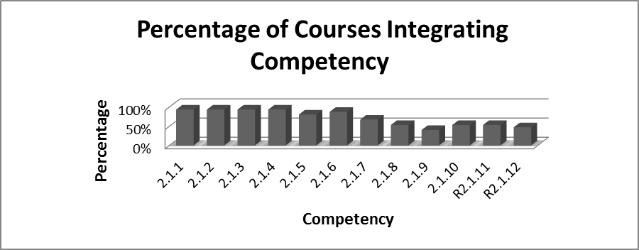

EPAS Competency: 2.1.1 Identify as a professional social worker and conduct oneself accordingly, EPAS Competency: 2.1.2Apply social work ethical principles to guide professional practice, EPAS Competency: 2.1.3 Apply critical thinking to inform and communicate professional judgments and EPAS Competency: 2.1.4Engage diversity and difference in practice are supported in 90% or fourteen (SW 210, 301, 302, 303, 307, 320, 327, 330, 409, 410, 420, 436, 437, & 491) of the courses in the curriculum. EPAS Competency: 2.1.5 Advance human rights and social and economic (SW 210, 301, 302, 303, 307, 320, 327, 409, 410, 420, 436, 437, & 491) demonstrates integration in 81% or thirteen courses; EPAS Competency: 2.1.6 Engage in research-informed practice and practice-informed research is supported in 81% or thirteen (SW 210, 302, 303, 307, 320, 327, 330, 408, 409, 410, 420, 436, & 437) courses; EPAS Competency: 2.1.7Apply knowledge of human behavior and the social environment is supported by 60% or ten courses including SW 210, 301, 302, 303, 320, 330, 410, 420, 436, and 437; EPAS Competency: 2.1.8Engage in policy practice to advance social and economic well-being and to deliver effective social work services is supported by 50% or eight (SW 303, 307, 320, 330, 410, 420, 436, & 437) courses; EPAS Competency: 2.1.9 Respond to contexts that shape practice is supported by 35% or six courses including SW 330, 409, 410, 420, 436, & 437; EPAS Competency: 2.1.10(a)–(d)Engage, assess, intervene, and evaluate with individuals, families, groups, organizations, and communities include eight courses (SW 303, 307, 320, 330, 410, 420, 436, & 437) is supported by integration into 50% of courses.

There are two rural competencies R2.1.11 and R2.1.12 included in the curriculum. Rural Competency: 2.1.11 Use interventions that recognize the needs and strengths present in rural communities is supported by 50% or eight courses (SW 210, 327, 330, 409, 410, 420, 436, & 437) and; Rural Competency: 2.1.12Coordinate interventions with social workers, related professions, leaders and citizens in rural areas in order to develop resources and programs that enhance services for rural clients include seven courses (SW 210, 409, 410, 420, 436, 437, & 491) or integration into 40% courses.

*SW 210 Introduction to Social Work*

This course provides an overview of social work as a profession, and of the concepts and philosophy of social work, and fields of practice. Students are introduced to the concepts and philosophy of social work as well as to the different fields of practice. Students will gain insight into the diverse, at-risk populations with whom generalist social workers typically work. The course enables students to begin to explore the process of problem-solving with individuals, families, groups, social networks, organizations and communities. Activities which include developing a community resource directory, discussion on NASW Code of Ethics, value clarification exercise, research project, selected fields of practice, class discussion and exams support the infusion of the core competencies; EPAS 2.1.1 – Identify as a professional social worker and conduct oneself accordingly; EPAS 2.1.2 **–** Apply social work ethical principles to guide professional practice; 2.1.3 **–** Apply critical thinking to inform and communicate professional judgments; 2.1.4 **–** Engage diversity and difference in practice; 2.1.5 **–** Advance human rights and social and economic justice; 2.1.6 **–** Engage in research-informed practice and practice-informed research; 2.1.7 **–** Apply knowledge of human behavior and the social environment. These assessments also support the two rural competencies; R2.1.11 – Use interventions that recognize the needs and strengths present in rural communities and; R2.1.12 **–** Coordinate interventions with social workers, related professions, leaders and citizens in rural areas in order to develop resources and programs that enhance services for rural clients.

*SW 301Interviewing Techniques*

This course explores key interviewing principles and techniques that are used in a variety of social service settings. The interview is a tool used by all social and human service workers, including social workers. The interview is used to gather information, assess clients, develop intervention plans, implement intervention plans, evaluate interventions and terminate the social work process. This course is designed for students to gain knowledge of basic concepts and principles related to the interviewing process and their use in various situations, especially in the social work problem solving process. It is important that social workers acquire the knowledge and skills that are valid and reliable to collect relevant information about clients. Through this course the following competencies are infused; EPAS 2.1.1 – Identify as a professional social worker and conduct oneself accordingly; EPAS 2.1.2 **–** Apply social work ethical principles to guide professional practice; 2.1.3 **–** Apply critical thinking to inform and communicate professional judgments; 2.1.4 **–** Engage diversity and difference in practice and; EPAS 2.1.7 **–** Apply knowledge of human behavior and the social environment where practice behaviors are measured by assignments such as reading, literature review, in-class interviews, interview project of a licensed social work interview and professional dress day.

*SW 302 Social Welfare Policies and Services I*

The following competencies EPAS 2.1.1 – Identify as a professional social worker and conduct oneself accordingly; EPAS 2.1.2 **–** Apply social work ethical principles to guide professional practice; 2.1.3 **–** Apply critical thinking to inform and communicate professional judgments; 2.1.4 **–** Engage diversity and difference in practice; 2.1.5 **–** Advance human rights and social and economic justice; 2.1.6 **–** Engage in research-informed practice and practice-informed research; 2.1.7 **–** Apply knowledge of human behavior and the social environment are infused into SW 302 through assignments such as know your lawmakers, evaluation of a community, attending a public meeting and class discussions. This course presents the historical development of social welfare policies and programs and a focus on the implementation and qualifications for use of such programs. It entails an examination of social welfare, policies, programs and services. It is in this class that students begin to develop skills in policy analysis, advocacy, planning, and evaluation. The course provides the student with knowledge about the policy foundations of the social work profession. Students learn to identify the different types of social welfare programs, particularly related to the types of benefits, the different eligibility requirements and methods of distribution. Students also learn to connect the history of social policy development to the creation of current policies and services. This course also, helps students to become critical thinkers on how politics and laws have impacted the development of social welfare policy, programs, and service delivery to diverse and marginalized groups in our society.

*SW 303 Social Welfare Policies and Services II*

This course is designed to help students acquire the knowledge and skills necessary for policy analysis and policy advocacy. The student will develop their abilities relative to understanding how social policies are developed and implemented. They will also learn how different interest groups influence social policy. Student will gain some exposure and experience in the practice of policy advocacy. Through this course students will be able to understand and articulate the integration of policies at all levels of social work practice. The following competencies EPAS 2.1.1 – Identify as a professional social worker and conduct oneself accordingly; EPAS 2.1.2 **–** Apply social work ethical principles to guide professional practice; 2.1.3 **–** Apply critical thinking to inform and communicate professional judgments; 2.1.4 **–** Engage diversity and difference in practice; 2.1.5 **–** Advance human rights and social and economic justice; 2.1.6 **–** Engage in research-informed practice and practice-informed research; 2.1.7 **–** Apply knowledge of human behavior and the social environment; 2.1.8 Engage in policy practice to advance social and economic well-being and to deliver effective social work services; 2.1.10(a)–(d) Engage, assess, intervene, and evaluate with individuals, families, groups, organizations, and communities are integrated using classroom discussions, policy brief, policy analysis paper, chapter presentation, and examinations.

*SW 307 Issues of Diversity and Social Justice*

This course covers the study of diversity in America, populations at risk, oppressed populations, and social justice. Course instruction will foster the integration of ethics and values into the knowledge and skills used in micro level practice. The range of social systems emphasized in this course includes individuals, families and small groups, although environmental issues related to the problems confronting these systems are incorporated into data collection, assessment and intervention activities. EPAS 2.1.1 – Identify as a professional social worker and conduct oneself accordingly; EPAS 2.1.2 **–** Apply social work ethical principles to guide professional practice; 2.1.3 **–** Apply critical thinking to inform and communicate professional judgments; 2.1.4 **–** Engage diversity and difference in practice; 2.1.5 **–** Advance human rights and social and economic justice; 2.1.6 **–** Engage in research-informed practice and practice-informed research; 2.1.8 Engage in policy practice to advance social and economic well-being and to deliver effective social work services; 2.1.10(a)–(d) Engage, assess, intervene, and evaluate with individuals, families, groups, organizations, and communities are infused in this course through the use of group analysis and development projects, group process analysis, PowerPoint presentations and examinations.

*SW 320 Human Behavior in the Social Environment I*

This course is the first of two courses on Human Behavior and the Social Environment. It is designed to provide students with a comprehensive understanding of theories and research related to human behavior and the social environment as they relate to human similarity and difference and interactional processes from conception to young adulthood. It covers theories and concepts of human behavior and the social environment. Attention is also given to specific life events and issues that people face as they progress through the life span. The life span is divided into four major phases: infancy and childhood; adolescence; young and middle adulthood; and later adulthood. Each phase is described and examined from a biological, psychological, and social perspective. The competencies that are infused in this course are EPAS 2.1.1 – Identify as a professional social worker and conduct oneself accordingly; EPAS 2.1.2 **–** Apply social work ethical principles to guide professional practice; 2.1.3 **–** Apply critical thinking to inform and communicate professional judgments; 2.1.4 **–** Engage diversity and difference in practice; 2.1.5 **–** Advance human rights and social and economic justice; 2.1.6 **–** Engage in research-informed practice and practice-informed research; 2.1.8 Engage in policy practice to advance social and economic well-being and to deliver effective social work services; 2.1.10(a)–(d) Engage, assess, intervene, and evaluate with individuals, families, groups, organizations, and communities. Students are required to complete a critical analysis of HBSE issue paper, group chapter presentation, PowerPoint Presentation and examinations.

*SW 327 Human Behavior and the Social Environment II*

The competencies that are infused in this course are EPAS 2.1.1 – Identify as a professional social worker and conduct oneself accordingly; EPAS 2.1.2 **–** Apply social work ethical principles to guide professional practice; 2.1.3 **–** Apply critical thinking to inform and communicate professional judgments; 2.1.4 **–** Engage diversity and difference in practice; 2.1.5 **–** Advance human rights and social and economic justice; 2.1.6 **–** Engage in research-informed practice and practice-informed research; and rural competency R2.1.11 **–** Use interventions that recognize the needs and strengths present in rural communities. Integration of competencies is through assignments such as know your lawmakers, evaluation of community, attending public meeting, class discussion, research paper, oral presentation and exams. This course is a continuation of SW 320 HBSE I with a focus on young adulthood to end of life with emphasis on organizations, communities and societies. Additionally, this course studies the theories and research about human behavior and the social environment in understanding and describing human similarity and differences.

*SW 330 Methods of Social Work Practice I*

This course is designed to introduce students to the basic concepts of generalist social work practice. Students will acquire an understanding of how social work values, knowledge and skills are used to intervene with client systems at different levels, including individuals, families, groups, agencies/organizations and communities. Through course instruction students are introduced to a strengths-based approach. In this way students look not only at problems with the client and his/her environment, but at resources each possesses as well. Activities which includes role play, oral presentation, exams, class discussions and case studies support the infusion of the core competencies; EPAS 2.1.1 – Identify as a professional social worker and conduct oneself accordingly; 2.1.2 **–** Apply social work ethical principles to guide professional practice; 2.1.3 **–** Apply critical thinking to inform and communicate professional judgments; 2.1.4 **–** Engage diversity and difference in practice; 2.1.6 **–** Engage in research-informed practice and practice-informed research; 2.1.7 **–** Apply knowledge of human behavior and the social environment; 2.1.8 – Engage in policy practice to advance social and economic well-being and to deliver effective social work services; 2.1.9 – Respond to contexts that shape practice; 2.1.10(a)–(d) – Engage, assess, intervene, and evaluate with individuals, families, groups, organizations, and communities and; rural competency R2.1.11 **–** Use interventions that recognize the needs and strengths present in rural communities.

*SW 408 Statistics for Social Work Research*

Course content covers the following competency EPAS 2.1.6 – Engage in research-informed practice and practice-informed research. This course is designed as an introduction to basic statistics for application in social work evaluation and research. It is important for social workers to equip themselves with the cutting-edge knowledge in the field that is reliable, valid and useful. While this kind of knowledge is derived through systematic investigations using qualitative and quantitative approaches, the quantitative approach seems to dominate the research arena. Statistics is the tool that quantitative researchers widely use to understand the data and the language to report the findings. It is incumbent upon social workers to learn this important research tool and “research language.” This course is designed to provide an introduction to this important tool, statistics, and to prepare students to appreciate, interpret, use, and integrate statistics within professional social work practice. In this context, the primary text book is used to define and discuss statistical concepts and methods, handouts and scientific articles from social work journals are used to illustrate their use, and computers are used to build students’ computerized statistical skills.

*SW 409 Methods of Social Work Research*

This course is structured to provide the student with an understanding of the scientific approach to building knowledge so that they can appreciate it and use it to build knowledge for practice and to evaluate the practice. This course focuses on how people know things and how to apply these approaches in the field of social work for planned, reflective and inventive practice. It deals with application of basic concepts of research methodology in building knowledge in the field of social work. It also applies basic concepts and methods of research for the evaluation of social work practice through both single system designs and group designs. The course underscores the role of both qualitative and quantitative approaches in understanding social work issues. In linking the practice and research it focuses on the evidence based practice. It also provides the students with an understanding of professional ethical standards for conducting research in social work. The following competencies are included in this course; EPAS 2.1.1 – Identify as a professional social worker and conduct oneself accordingly; 2.1.2 **–** Apply social work ethical principles to guide professional practice; 2.1.3 **–** Apply critical thinking to inform and communicate professional judgments; 2.1.4 **–** Engage diversity and difference in practice; 2.1.5 – Advance human rights and social and economic justice; 2.1.6 **–** Engage in research-informed practice and practice-informed research; 2.1.9 –Respond to contexts that shape practice; and rural competencies R2.1.11 **–** Use interventions that recognize the needs and strengths present in rural communities and; R2.1.12 **–** Coordinate interventions with social workers, related professions, leaders and citizens in rural areas in order to develop resources and programs that enhance services for rural clients.

*SW 410 Methods for Social Work Practice II*

All of the EPAS competencies are integrated in SW 410 Methods for Social Work Practice II. EPAS 2.1.1 – Identify as a professional social worker and conduct oneself accordingly; 2.1.2 **–** Apply social work ethical principles to guide professional practice; 2.1.3 **–** Apply critical thinking to inform and communicate professional judgments; 2.1.4 **–** Engage diversity and difference in practice; 2.1.5 – Advance human rights and social and economic justice; 2.1.6 **–** Engage in research-informed practice and practice-informed research; 2.1.7 Apply knowledge of human behavior and the social environment; 2.1.8 **–** Engage in policy practice to advance social and economic well-being and to deliver effective social work services: 2.1.9 – Respond to contexts that shape practice; 2.1.10(a)–(d); Engage, assess, intervene, and evaluate with individuals, families, groups, organizations, and communities and; rural competencies R2.1.11 **–** Use interventions that recognize the needs and strengths present in rural communities and; R2.1.12 **–** Coordinate interventions with social workers, related professions, leaders and citizens in rural areas in order to develop resources and programs that enhance services for rural clients. This is the second in a sequence of three practice courses (SW330, SW410, and SW420) designed to help baccalaureate students develop the knowledge and skills necessary to use the generalist method in entry level social work practice. Students will learn to use systems theory and the ecological perspective in the application of a planned change process, while incorporating elements of strengths and empowerment perspectives. Course instruction will foster the integration of ethics and values into the knowledge and skills used in micro level practice. The range of social systems emphasized in this course includes individuals, families, and small groups, although environmental issues related to the problems confronting these systems are incorporated into data collection, assessment and intervention activities.

*SW 420 Methods of Social Work Practice III*

This is the third in a sequence of three practice courses (SW330, SW410, and SW420) designed to help baccalaureate students develop the knowledge and skills necessary to use the generalist method in entry level social work practice. Students will learn to use systems theory and the ecological perspective in the application of a planned change process, while incorporating elements of strengths and empowerment perspectives. Course instruction will foster the integration of ethics and values into the knowledge and skills used in macro level practice. The range of social systems emphasized in this course includes large groups, agencies/organizations, and physical environments such as neighborhoods and communities. Students will also acquire the knowledge and skills necessary to perform social work activities with communities of identity (e.g. race/ethnic groups; women, elderly, children, gays/lesbians, persons with mental and physical handicaps, the poor, and rural communities). All of the EPAS competencies are infused in this course including the two rural competencies; EPAS 2.1.1 – Identify as a professional social worker and conduct oneself accordingly; 2.1.2 **–** Apply social work ethical principles to guide professional practice; 2.1.3 **–** Apply critical thinking to inform and communicate professional judgments; 2.1.4 **–** Engage diversity and difference in practice; 2.1.5 – Advance human rights and social and economic justice; 2.1.6 **–** Engage in research-informed practice and practice-informed research; 2.1.7 Apply knowledge of human behavior and the social environment; 2.1.8 **–** Engage in policy practice to advance social and economic well-being and to deliver effective social work services: 2.1.9 – Respond to contexts that shape practice; 2.1.10(a)–(d); Engage, assess, intervene, and evaluate with individuals, families, groups, organizations, and communities; R2.1.11 **–** Use interventions that recognize the needs and strengths present in rural communities and; R2.1.12 **–** Coordinate interventions with social workers, related professions, leaders and citizens in rural areas in order to develop resources and programs that enhance services for rural clients.

*SW 436 Field Practicum*

The purpose of SW 436 Field Practicum is to provide students a learning opportunity to learn how to practice generalist social work under the direct supervision of a field instructor at an approved field agency. This course allows students to experience, integrate and practice classroom learning with actual clients, community organizations and agency programs. Field opportunity also allows students to blend values, skills and knowledge together into coherent practice model. Students are expected to complete a minimal of 432 hours in a field agency prior to earning a BSW degree. In field practicum all of the competencies are integrated including the two rural competencies; EPAS 2.1.1 – Identify as a professional social worker and conduct oneself accordingly; EPAS 2.1.2 **–** Apply social work ethical principles to guide professional practice; EPAS 2.1.3 **–** Apply critical thinking to inform and communicate professional judgments; EPAS 2.1.4 **–** Engage diversity and difference in practice; EPAS 2.1.5 – Advance human rights and social and economic justice; EPAS 2.1.6 **–** Engage in research-informed practice and practice-informed research; EPAS 2.1.7 Apply knowledge of human behavior and the social environment; EPAS 2.1.8 **–** Engage in policy practice to advance social and economic well-being and to deliver effective social work services: EPAS 2.1.9 – Respond to contexts that shape practice; 2.1.10(a)–(d); Engage, assess, intervene, and evaluate with individuals, families, groups, organizations, and communities; R2.1.11 **–** Use interventions that recognize the needs and strengths present in rural communities and; R2.1.12 **–** Coordinate interventions with social workers, related professions, leaders and citizens in rural areas in order to develop resources and programs that enhance services for rural clients.

*SW 437 Integration Seminar*

SW 437 Integrated Seminar is designed to help students integrate, analyze, articulate, and apply classroom knowledge into the experience gained from field practicum. This course provides a forum for the integration of academic learning with field –based agency experiences. Through facilitated discussion, students learn about social work practice in various settings and assist each other in seeing the similarities and differences in applying generalist social work practice, knowledge, and skills across service delivery systems and practice methods. SW 437 Integration Seminar must be taken as a co-requisite with SW 436 Field Practicum. This course gives students educational and administrative support to synthesize knowledge from all previous social work courses and experiential learning from field. This seminar is comprised of students who are seniors that are enrolled in field practicum. All EPAS competencies and two rural competencies are integrated into this course; EPAS 2.1.1 – Identify as a professional social worker and conduct oneself accordingly; EPAS 2.1.2 **–** Apply social work ethical principles to guide professional practice; EPAS 2.1.3 **–** Apply critical thinking to inform and communicate professional judgments; EPAS 2.1.4 **–** Engage diversity and difference in practice; EPAS 2.1.5 – Advance human rights and social and economic justice; EPAS 2.1.6 **–** Engage in research-informed practice and practice-informed research; EPAS 2.1.7 Apply knowledge of human behavior and the social environment; EPAS 2.1.8 **–** Engage in policy practice to advance social and economic well-being and to deliver effective social work services: EPAS 2.1.9 – Respond to contexts that shape practice; 2.1.10(a)–(d); Engage, assess, intervene, and evaluate with individuals, families, groups, organizations, and communities; R2.1.11 **–** Use interventions that recognize the needs and strengths present in rural communities and; R2.1.12 **–** Coordinate interventions with social workers, related professions, leaders and citizens in rural areas in order to develop resources and programs that enhance services for rural clients. Activities supporting the integration include agency profile, portfolio, class discussion, oral presentation, and mezzo project, professional resume and community project.

*SW 491 Pre-Field Seminar*

The pre-field seminar is a weekly one (1) hour seminar that is designed to prepare students for entering BSW social work field education. This seminar will assist in identifying the client populations and placement opportunities that are of interest to the student. This course allows students to discuss and research various organizations and agencies from a diverse field of practice and prepare students for their interview with field instructors for possible placement. The following competencies are infused into this course; EPAS 2.1.1 – Identify as a professional social worker and conduct oneself accordingly; 2.1.2 **–** Apply social work ethical principles to guide professional practice; 2.1.3 **–** Apply critical thinking to inform and communicate professional judgments; 2.1.4 **–** Engage diversity and difference in practice; 2.1.5 – Advance human rights and social and economic justice and; R2.1.12 **–** Coordinate interventions with social workers, related professions, leaders and citizens in rural areas in order to develop resources and programs that enhance services for rural clients.

The matrix on the next page shows the coverage of practice behaviors across the curriculum. The courses are listed horizontally and the standards or core competencies are listed vertically to show a comprehensive coverage.

**BSW Practice Behaviors across the Curriculum**

|  |  |  |  |  |  |  |  |  |  |  |  |  |  |  |  |
| --- | --- | --- | --- | --- | --- | --- | --- | --- | --- | --- | --- | --- | --- | --- | --- |
| **Practice**  **Behaviors** | **210** | **301** | **302** | **303** | **307** | **320** | **327** | **330** | **408** | **409** | **410** | **420** | **436** | **437** | **491** |
| 2.1.1a | √ |  | √ | √ | √ | √ | √ | √ |  |  | √ | √ | √ | √ | √ |
| 2.1.1b |  |  |  | √ | √ | √ |  | √ |  |  | √ | √ | √ | √ | √ |
| 2.1.1c |  |  |  |  |  |  |  | √ |  |  | √ | √ | √ | √ | √ |
| 2.1.1d | √ | √ | √ |  |  |  | √ | √ |  | √ | √ | √ | √ | √ | √ |
| 2.1.1e | √ |  | √ |  |  |  | √ |  |  |  | √ | √ | √ | √ |  |
| 2.1.1f |  |  |  |  |  |  |  |  |  |  | √ | √ | √ | √ |  |
| 2.1.2a | √ | √ | √ |  | √ | √ | √ | √ |  | √ | √ | √ | √ | √ |  |
| 2.1.2b | √ |  | √ |  | √ | √ | √ | √ |  | √ | √ | √ | √ | √ |  |
| 2.1.2c |  |  |  |  |  | √ |  | √ |  | √ | √ | √ | √ | √ | √ |
| 2.1.2d |  |  |  |  | √ | √ |  | √ |  | √ | √ | √ | √ | √ | √ |
| 2.1.3a |  |  |  | √ | √ | √ |  | √ |  | √ | √ | √ | √ | √ | √ |
| 2.1.3b |  |  |  | √ | √ | √ |  | √ |  | √ | √ | √ | √ | √ | √ |
| 2.1.3c | √ | √ | √ | √ |  | √ | √ | √ |  | √ | √ | √ | √ | √ | √ |
| 2.1.4a | √ |  | √ | √ | √ | √ | √ | √ |  |  | √ | √ | √ | √ | √ |
| 2.1.4b | √ | √ |  | √ | √ | √ |  | √ |  | √ | √ | √ | √ | √ | √ |
| 2.1.4c |  | √ |  |  | √ | √ |  | √ |  |  | √ | √ | √ | √ | √ |
| 2.1.4d |  |  |  |  | √ | √ |  | √ |  | √ | √ | √ | √ | √ |  |
| 2.1.5a | √ |  | √ | √ | √ | √ | √ |  |  |  | √ | √ | √ | √ | √ |
| 2.1.5b | √ |  | √ | √ | √ | √ | √ |  |  |  | √ | √ | √ | √ | √ |
| 2.1.5c |  |  |  | √ | √ | √ |  |  |  | √ | √ | √ | √ | √ | √ |
| 2.1.6a |  |  |  |  |  |  |  |  | √ | √ | √ | √ | √ | √ |  |
| 2.1.6b | √ |  | √ | √ | √ | √ | √ |  | √ | √ | √ | √ | √ | √ |  |
| 2.1.7a |  |  |  | √ |  | √ |  | √ |  |  | √ | √ | √ | √ |  |
| 2.1.7b | √ | √ | √ | √ |  | √ |  | √ |  |  | √ | √ | √ | √ |  |
| 2.1.8a |  |  |  | √ | √ | √ |  | √ |  |  | √ | √ | √ | √ |  |
| 2.1.8b |  |  |  |  |  | √ |  | √ |  |  | √ | √ | √ | √ |  |
| 2.1.9a |  |  |  |  |  |  |  | √ |  | √ | √ | √ | √ | √ |  |
| 2.1.9b |  |  |  |  |  |  |  | √ |  |  | √ | √ | √ | √ |  |
| 2.1.10a1 |  |  |  |  |  |  |  |  |  |  | √ | √ | √ | √ |  |
| 2.1.10a2 |  |  |  |  |  |  |  | √ |  |  | √ | √ | √ | √ |  |
| 2.1.10a3 |  |  |  |  |  |  |  |  |  |  | √ | √ | √ | √ |  |
| 2.1.10b1 |  |  |  | √ | √ | √ |  |  |  |  | √ | √ | √ | √ |  |
| 2.1.10b2 |  |  |  | √ |  |  |  | √ |  |  | √ | √ | √ | √ |  |
| 2.1.10b3 |  |  |  | √ |  |  |  | √ |  |  | √ | √ | √ | √ |  |
| 2.1.10b4 |  |  |  | √ |  |  |  | √ |  |  | √ | √ | √ | √ |  |
| 2.1.10c1 |  |  |  | √ |  |  |  |  |  |  | √ | √ | √ | √ |  |
| 2.1.10c2 |  |  |  |  |  |  |  | √ |  |  | √ | √ | √ | √ |  |
| 2.1.10c3 |  |  |  |  |  |  |  | √ |  |  | √ | √ | √ | √ |  |
| 2.1.10c4 |  |  |  |  |  |  |  | √ |  |  | √ | √ | √ | √ |  |
| 2.1.10c5 |  |  |  |  |  |  |  | √ |  |  | √ | √ | √ | √ |  |
| 2.1.10d1 |  |  |  |  |  |  |  |  |  | √ | √ | √ | √ | √ |  |
| R.2.1.11 | √ |  |  |  |  |  | √ | √ |  | √ | √ | √ | √ | √ |  |
| 2.1.12 | √ |  |  |  |  |  |  |  |  | √ | √ | √ | √ | √ | √ |

**Accreditation Standard 2.1 –Field Education**

|  |
| --- |
| **2.1.1:** The program discusses how its field education program connects the theoretical and conceptual contribution of the classroom with the practice setting, fostering the implementation of evidence-informed practice. |

The theoretical and conceptual contribution of the classroom is connected with the practice setting through the activities and tasks outlined in the field learning contract, field integration seminar and field instructor’s training.

The learning contract serves as the blueprint for the application of social work knowledge, skills and values in the field setting. Social Work core competencies and practice behaviors direct the establishment of field learning activities and tasks that provide opportunities for students to connect the theoretical and conceptual contribution of the classroom with the practice setting. This outcome based approach supports and fosters the implementation of evidence –informed practice.

The Field Integration Seminar, SW 437, taken concurrently with SW 436 (Field Internship) provides a forum for the discussion of the integration of social work values, ethics, theory, policy and research in a practice setting.

Field instructors play a critical role in the application of the classroom experience in practice settings. Effective supervision is critical to positive field learning outcomes. Therefore, training for field instructors is an essential component of field education. Orientation for field instructors includes training on social work core competencies, practice behaviors and generalist social work practice. The training of field instructors in the “why, what and how” related to the core competencies, practice behaviors and generalist social work practice supports efforts to connect classroom contribution with the practice setting. Training for field instructors is usually held during the fall semester. The annual social work conference, sponsored by the Department of Social Work, is held during the spring semester and provides on-going opportunities for the field instructors’ professional growth and development.

|  |
| --- |
| **B2.1.2:** The program discusses how its field education program provides generalist practice opportunities for students to demonstrate the core competencies. |

The field learning contract, integration seminar and field instructor’s training, as stipulated in Educational Policy 2.1.1 above, are the major methods for providing generalist practice opportunities for students. In addition to these methods, BSW Practice courses I, II, and III (SW 330, SW410 and SW420), provide classroom assignments that allow students to assimilate and apply generalist practice methods.

|  |
| --- |
| **2.1.3:** The program discusses how its field education program provides a minimum of 400 hours of field education for baccalaureate programs and 900 hours for master’s programs. |

BSW students are required to complete a minimum 432 clock hours. The completion of field hours is monitored through weekly time sheets and field logs signed by the student and field instructor. These documents are submitted to the BSW Field Coordinator for review and are maintained in individual student field files. At the completion of the 432 clock hours, the field instructor submits a signed copy of the *Verification of Internship Hours* (BSW Field Manual, p. 83) to the BSW Field Coordinator.

|  |
| --- |
| **2.1.4:** The program discusses how its field education program admits only those students who have met the program’s specified criteria for field education. |

The following criteria have been established for admission to field (BSW Student Handbook, Field Practicum Admission Requirements, Page 17):

In order to be accepted for admission to the field practicum, a student must have:

1. Been officially admitted to the BSW program
2. Completed all BSW required liberal arts courses
3. Completed all required social work courses with the possible exception of SW409, Methods of Social Work Research and SW420 Methods of Social Work Practice III. The Integration Seminar (SW437) is taken concurrently with Field Practicum
4. A grade point average of 2.0 in required social work courses
5. An overall grade point average of 2.0 or better

Students are required to submit an application for field placement. An official transcript review is a part of the application process. It is the responsibility of the BSW Field Coordinator to determine if students meet the program’s specific criteria for field placement.

|  |
| --- |
| **2.1.5:**  The program discusses how its field education program specifies policies, criteria, and procedures for selecting field settings; placing and monitoring students; maintaining field liaison contacts with field education settings; and evaluating student learning and field setting effectiveness congruent with the program’s competencies |

**Selecting Field Settings (BSW Field Manual, pp. 22-23)**

*Field Agencies*

Potential field placements may be identified in a number of ways. Agencies may request

students or be recommended by a student, faculty member, alumnus, or community representative. After verification of the availability of appropriate internship work assignments and a qualified field instructor, the agency submits a Field Agency Profile. The BSW Field coordinator conducts a pre-placement visit to the agency to discuss/review potential internship work assignments, availability of resources for the intern and special requirements of the agency. The BSW Field Coordinator provides information to the agency on the BSW curriculum, field internship requirements and expectations regarding assignments, supervision, and evaluation.

*Criteria for Selection of Agencies*

The following criteria are used in the selection of field agencies:

1. The agency has a point of view about field instruction that is consonant with that of the BSW Program.
2. There is a correlation between the agency and BSW Program’s practice conception in order to provide the opportunity for the integration of knowledge, theory, values and research taught in BSW courses with practice in the field.
3. The agency is able to provide a qualified field instructor with a BSW degree (MSW preferred) from a social work program accredited by the Council on Social Work Education. In the instance where there is no bachelor level social worker, but other qualified staff who could serve as a field instructor, the field instructor must supervise the student in collaboration with a field liaison assigned by the BSW Field Coordinator.
4. The agency is able to provide the intern the opportunity to practice social work in compliance with professional social work standards and ethics.
5. The agency is able to provide a range of internship assignments on an ongoing basis which are appropriate to the student’s educational needs.
6. The agency is able to provide the necessary space (including privacy for interviewing) and resources to enable the intern to carry out internship assignments.
7. The agency is willing to allocate sufficient time for ongoing supervision of the intern by the field instructor.
8. The agency is willing to allocate time for the orientation, seminars and training for field instructors provided by the BSW Field Education Program.
9. The agency must have a policy of nondiscrimination on the basis of race, color, age, national origin, religion, gender, sexual orientation, disability or veteran status. The nondiscrimination policy must be applicable to employees, clients and interns.
10. The agency is willing to enter into an affiliation agreement with Mississippi Valley State University’s Department of Social Work.

**Affiliation Agreement**

The approval of field agencies for placements is finalized with a contractual agreement between the agency and Mississippi Valley State University Department of Social Work. All agencies used as field placements enter into a signed Affiliation Agreement. The Affiliation Agreement is signed by the agency director, field coordinator, chair of the Department of Social Work and the Vice-President for Academic Affairs. The Affiliation Agreement articulates (1) the services and resources that the university agrees to provide to the agency and to the student and (2) the services and resources that the agency agrees to provide to the student and the university.

**Placing and Monitoring Students**

The BSW Field Coordinator has the primary responsibility for placing and monitoring students. The Internship Placement Process includes the following steps (BSW Field Education Manual, pp.25-26):

1. The placement process begins the semester before enrollment in the field internship. Students are required to take SW 491, prior to entering field. This course focuses on the application and admission process for field placement. The BSW Field Coordinator also helps students prepare for internships by informing them of their responsibilities related to field education.
2. Students must submit the following documents to the BSW Field Coordinator by the posted deadline: *Application for Field Placement*, *Release of Information* Form, proof of professional liability insurance and a professional resume.
3. Students must schedule an appointment with the BSW Coordinator by the posted deadline. The student and field coordinator will discuss the student’s application for field placement, resume, educational and career goals, field placement preferences and potential agencies for placement.
4. The BSW Field Coordinator will identify an agency for placement and provide a written agency referral to the student. While the interests and preferences of the student will be taken into consideration, the selection of the agency to which the student is referred for placement is the decision of the BSW Field Coordinator.
5. After receiving a written agency referral from the BSW Coordinator, the student must arrange for an interview with the agency and return the referral form to the field coordinator within the timeframe listed. The student must provide the prospective agency field instructor with a resume at the time of the interview.
6. During the interview with the field instructor, the student should inquire about potential internship assignments, internship work schedule and any pre-placement requirements of the agency. These may include agency orientation meetings, physicals, criminal background checks, TB screenings, drug screening tests, or specific types of training such as CPR or First Aid. If the student is placed at the agency, it is the responsibility of the student to fulfill any agency requirements in the time frame specified by the agency.
7. The BSW Field Coordinator will ascertain from the agency to which the student was referred whether the student was accepted by the agency for an internship placement.
8. If the agency accepts the student for placement, the student should begin his/her internship on the first day of classes of the semester the student is enrolled in field internship.
9. If the agency does not accept the student for placement, the BSW Field Coordinator will refer the student to another agency. If a student has concerns about the suitability of the field placement to which he/she has been referred, such concerns should be expressed to the BSW Field Coordinator immediately. The BSW Field Coordinator will determine whether the concerns expressed are legitimate, whether the student should report to the agency as assigned, or whether a referral to another agency will be made.
10. If a student has concerns about the suitability of the field placement to which he/she has been referred, such concerns should be expressed to the BSW Field Coordinator immediately. The BSW Field Coordinator will determine whether the concerns expressed are legitimate, whether the student should report to the agency as assigned, or whether a referral to another agency will be made.
11. All required paperwork should be completed by the end of the semester prior to the semester in which the student will be enrolled in field internship.

**Maintaining Field Liaison Contacts with Field Education Settings**

The BSW Field Coordinator performs most liaison activities. As a social work faculty member, the coordinator shares field issues and concerns with social work faculty, and solicits their input. Social work faculty members are invited to attend field advisory committee meetings and field orientation for students and field instructors.

***Specific Duties of the Field Liaison (Field Education Manual, p, 23)***

Specific responsibilities of the field liaison are as follows:

1. Conduct weekly supervisory meetings with the intern in which the intern’s work is reviewed and discussed and concerns are addressed.
2. Conduct a minimum of two site visits to the field agency to meet with the field instructor to discuss the intern’s progress.
3. Complete the Report of Field Placement Site Visit and the Field Liaison Contact form
4. Identify any problems related to field instruction in the agency and report problems to the BSW Field Coordinator.
5. Identify any problems related to the performance of the intern. Discuss problems with the intern and the field instructor in an effort to resolve problems. Report the problem, efforts to address the problem, and current status of the problem to the BSW Field Coordinator.

**Evaluating Student Learning and Field Setting Effectiveness**

Students are evaluated twice during the field internship semester, at mid-term and the end of the semester. If the student’s performance is below expectation, the field instructor, the student and BSW Field Coordinator will meet and determine the actions that need to be taken to improve student performance. Corrective actions to be taken will be recorded on the Corrective Action Agreement that will be signed by the field instructor, student and field coordinator.

A four point rating scale is used for student evaluation:

Scale: 1 Performance does not meet expectations for completion of field internship.

2 Performance meets minimal expectations.

3 Performance is high on performance tasks.

4 Performance is exceptionally high on performance tasks.

**Mid-term Progress Report**

The mid-term progress report includes the ten core social work competencies identified by the Council on Social Work Education in addition to two competencies related to rural social work practice. This evaluation reflects reasonable expectations for student performance the first 6-8 weeks of field placement. The student’s grade is determined by adding the rating score given to each competency and dividing the sum by the number of competencies rated. Example: A student is rated on 12 competencies with a sum of 48; 48 ÷ 12 = 4.0 (student’s grade).

**Final Student Evaluation**

The final evaluation includes 12 competencies and 43 practice behaviors. The student’s grade is determined by adding the rating score given to each practice behavior and dividing the sum by the number of practice behaviors rated. Example: A student is rated on 43 practice behaviors with a total of 172 points (172÷ 43 practice behaviors = 4.0 - student’s grade).

|  |
| --- |
| **2.1.6:** The program discusses how its field education program specifies the credentials and practice experience of its field instructors necessary to design field learning opportunities for students to demonstrate program competencies. Field instructors for baccalaureate students hold a baccalaureate or master’s degree in social work from a CSWE-accredited program. Field instructors for master’s students hold a master’s degree in social work from a CSWE-accredited program. For cases in which a field instructor does not hold a CSWE-accredited social work degree, the program assumes responsibility for reinforcing a social work perspective and describes how this is accomplished. |

**Field instructors**

Field instructors are employed by the agencies in which students are assigned for internships. Field instructors should have a bachelor’s degree in social work. The MSW degree is preferred. In agencies approved as internship sites, but do not have field instructors who have a BSW degree, a field liaison will be assigned to work with the field instructor in planning and supervising the student’s internship experience.

***Criteria for Selection of Field Instructors***

The following criteria are used in the selection of field instructors:

1. A bachelor’s degree in social work (the MSW is preferred)

2. A minimum of at least two years of post- master’s practice experience in social

work

3. Demonstrated practice competence

4. Ability to practice in more than one practice modality

5. Familiarity with agency policies, programs and procedures

All field instructors must complete the *Background of Field Instructor* form that provides

information on their educational credentials, social work and volunteer experience, and their

experience as a social work field instructor.

|  |
| --- |
| **2.1.7:** The program discusses how its field education program provides orientation, field instruction training, and continuing dialog with field education settings and field instructors. |

Orientation for field instructors is provided prior to the beginning of each semester. The

BSW Field Coordinator conducts the orientation. Individual orientation is conducted on site

for field instructors who cannot attend the orientation at the beginning of the semester. Orientation for students is conducted in the Pre-field Seminar, SW 491.

Training for field instructors is held once during the academic school year, usually in the

fall. In addition to the annual training, the Department of Social Work sponsors an annual

conference during the spring semester. These conferences offer an array of workshops and plenary sessions pertaining to social work.

On-going contact between the education setting and field instructors also occurs via telephone dialogs, e-mails and meetings attended by the BSW Field Coordinator and other faculty members.

A pilot project is under consideration for the spring of 2017. The project includes adding a field internship component online for field instructors through Blackboard, the university’s web-based learning management system for online courses. Field instructors will have access to all required field documents online and can submit those requiring submission through Blackboard. The pilot also includes consideration for offering online training for field instructors through Blackboard. The plan for the pilot project was presented to the Field Advisory Committee on May 12, 2016 and received unanimous support.

|  |
| --- |
| **2.1.8:** The program discusses how its field education program develops policies regarding field placements in an organization in which the student is also employed. To ensure the role of student as learner, student assignments and field education supervision are not the same as those of the student’s employment. |

**Policies for Internship Sites in Which Students Are Employed**

While the Bachelor of Social Work Program does not encourage students to remain employed while being in an internship, the Program recognizes that the economic and family responsibilities of some make it difficult to relinquish their employment. The BSW Program has endeavored to accommodate such students while at the same time maintaining academic integrity in the internship experience. To accomplish this end, the following polices have been developed to serve as guidelines in utilizing internship sites in which students are employed:

1. The internship must be treated as a learning experience designed to ensure that the student develops the ability to successfully integrate social work values, knowledge and skills in a practice setting.
2. The agency will be held to the same standards and requirements as other agencies serving as internship sites.
3. The agency must be willing to serve as an internship site and indicate such willingness by signing an affiliation agreement with the university.
4. An internship work schedule which specifies the days and hours per week the student will devote to internship must be developed. The internship work schedule must be signed by the agency field instructor, the student and the field coordinator.
5. It is preferred, though not required, that the student be assigned to a field instructor different from his/her work supervisor. This decreases the potential for role confusion and conflicts if one individual does not have to function as both the “holder of the purse strings” and the “dispenser of the grade.”
6. One or more of the following criteria must be met:
7. The intern must be assigned tasks at a professional level of social work

practice which are different from the tasks he/she previously performed.

1. The intern must be assigned to a program or unit in the agency that is different from the one in which he/she previously worked.
2. The intern must be assigned to work with a population different from the one with which he/she previously worked.
3. The student must submit an Application *to Use Employment Site as Internship Placement (BSW Field Manual, pp. 76-77)* to the BSW Coordinator.

**Accreditation Standard 3.1 –Diversity**

|  |
| --- |
| **3.1.1: The program describes the specific and continuous efforts it makes to provide a learning environment in which respect for all persons and understanding of diversity and difference are practiced.** |

Instilling within students a respect for diversity within the human family is a hallmark of the Baccalaureate Social Work Program. Even though Mississippi Valley State University (MVSU) is a historically Black Institution of Higher Learning, students in the BSW Program at MVSU are encouraged to consider the various populations that are diverse. These include: 1) race/ethnicity; 2) gender; 3) age; 4) sexual orientation/identification; religion/spiritual orientation; political beliefs, mental and physical handicaps; immigration status and rural residency. Students also come to see individuals as members of multiple diverse populations and to critically think related to how one diverse identification on the part of a single person (gay/lesbian) may affect or be affected by another diverse identification (evangelical protestant).

After the decision in Obergefell v. Hodges (2015) students in macro practice classes were asked to consider both support and dissent in the issue of legalized same sex marriages based upon membership in various diverse groups. One example was the prospect that a person may oppose gay marriages upon religious grounds (e.g. evangelical and fundamentalist Protestants, Catholics) while recognizing the legal right of persons of the same sex to enter into marriage contracts based upon their political beliefs. In short, students were asked to consider how individuals may have conflicting views on issues due to their memberships in multiple diverse groups.

Students in the BSW Program are taught to respect all populations and to be prepared to offer assistance to different groups of persons in need. The BSW Program annually sponsors walks to bring attention to battered women and abused children. They form an understanding of these populations as diverse and oppressed and learn to advocate for their empowerment.

The learning environment extends beyond the classroom and includes the immediate and broader communities the University identifies with. For example, there are various on-campus programs such as the Black History Month and Martin Luther King Day Program and the Cotton Kingdom Symposium that provides students an opportunity to share with others the history of social injustice and oppression that have historically confronted African-American populations in the Mississippi Delta. Diversity days are also held by the Department that allows students to gain an understanding of and appreciation for various other cultures. These include race/ethnic groups, religious traditions and alternate lifestyles.

Students have the opportunity to attend state and national conferences where they are introduced to issues of alternate lifestyles and the challenges confronting diverse populations. Such conferences include the National Association of Black Social Workers annual conference and the annual program meeting of the Mississippi Chapter of the National Association of Social Workers. Students have in the past given poster presentations related to issues confronting women and children.

Students within the Department have been active in forming a campus organization known as the “Gay-Straight Alliance.” These students are attempting to model how students with diverse sexual orientations have many of the same needs and challenges on the campus and in the community. They are also attempting to create an inclusive environment for students with alternate lifestyles.

|  |
| --- |
| **3.1.2 The program describes how its learning environment models affirmation and respect for diversity and difference.** |

The Learning Environment in the BSW Program models affirmation and respect for diversity in several ways. The walks sponsored by the Program for battered women and for abused children build a sense of advocacy within students for those populations as well as an understanding of their powerlessness. In this way, the Department helps students to understand that many populations are disenfranchised by their conditions. They are able to see beyond the mantra that our diversity is a sign of our strength and to recognize that too often membership in a diverse population cohort is often a springboard for oppression by dominant groups.

The Department of Social Work at MVSU sponsors an annual conference each Spring semester. The keynote address was delivered by Dr. Michael R. Daley on “Cotton, Catfish and the Blues: Rural Social Work in the South.” As stated above, the Program considers rural residency to be a specific diverse identity. Students and area practitioners were provided insight into the lack of power and the issues of economic and social injustice challenging people who reside in rural communities. Thus, Dr. Daley’s presentation covered a significant diversity issue. Another session was scheduled on Immigrant Rights in Mississippi. Unfortunately, the presenter had to cancel. Still, this is an issue that is treated with urgency in our Program.

A respect for and acceptance of diversity was modeled throughout the Conference. The presenters represented racial, political and gender diversity. The Conference Program Committee and faculty who worked the conference also represented various diverse groups related to gender, residence and race. Several of the presenters were diverse related to race, gender and backgrounds. The Department ensures that students and other constituents are never presented a single side of an issue. Our encouragement of debate and discussion is a key manner in which we foster an appreciation for diversity within our students.

Undergirding the high priority the Program gives to affirming and supporting people who are diverse and different is the emphasis placed on the ethical standards of the social work profession. Both classroom and extra-curricular activities are designed to instill within students an acceptance of the worth and dignity of all persons. Students are expected to see clients as partners in their interventions and to start where clients are. This is vitally important when working with populations who are powerless because of their diversity, including the elderly, minorities, LGBT populations, women, those with disabilities (mental and physical) children and rural residents.

Other models for diversity included the

1. “Black Lives Matters Forum” sponsored by the Program during the autumn of 2015. Speakers addressed the issue confronting young African-Americans related to the string of police shootings of young and unarmed Black males in recent years.
2. A faculty member received the Diversity Award from the Mississippi Institutions of Higher Learning this past year for his research on LGBT populations and with the National Association of Black Social Workers.
3. The Field Advisory Committee for the BSW Program includes a racially diverse mix of members. There is also committee based upon gender and types of field agencies represented by members.
4. The MVSU Departmental Faculty members are a model for Diversity:
   1. Full-time BSW Faculty: 2 African-American females; 1 African-American male

One of the Full-time BSW faculty members is elderly.

* 1. Part-time BSW Faculty: 1 African-American male; 1 White male; 1 White female. Two of the part-time faculty members are elderly.
  2. Additional Departmental faculty includes an Asian Male and 3 African-American females.
  3. Speakers who are invited to address classes represent diversity in terms of race, religion, gender and lifestyle.

|  |
| --- |
| **3.1.3 The program discusses specific plans to improve the learning environment to affirm and support persons with diverse identities.** |

The BSW Program at MVSU will continue to improve the learning environment to affirm and support persons with diverse identities in several ways: 1) International social workers are to be invited to campus so that BSW Program students are exposed to diverse social work responses to the problems affecting various populations in need; 2) Assign research and practice activities designed to gather evidence on the needs of specific diverse populations; 3) Sponsor a Cultural Diversity Day for the University; 4) Invite more speakers who are diverse related to sexual orientation and sexual identity. 5) We will enter into collaborative efforts with other academic departments on the campus to show the need for affirming the right of diverse populations to have full participation in the economic, cultural and social activities of the community. In particular, the Department will work with students who are from other nations to help them adjust to campus life and to access needed goods and services.

The Program plans to more actively recruit students from diverse backgrounds. There is the opportunity to attract more Hispanic and Native American students given the changing as well as historic demographics of Mississippi. More emphasis will be placed on the specific needs of First Nation populations and immigrant populations. Finally, more activities in classes such as research will focus upon the challenges and needs facing diverse groups.

**Educational Policy 3.2 – Student Development**

|  |
| --- |
| **B3.2.1:** The program identifies the criteria it uses for admission. |

Students may declare social work as a major upon admission to the University. They take the course SW210, Introduction to Social Work, in their sophomore year. It is during this period that they complete an application for admission to the baccalaureate social work program. Students who are transferring from another University at the junior and/or senior levels must complete the process within the first semester at Mississippi Valley State University. The application process includes:

* Admission to Mississippi Valley State University;
* Declaration of social work as a major and completion of a minimum of thirty (30) credit hours in the general core curriculum;
* A minimum cumulative GPA of 2.0 on a scale of 4.0;
* Enrollment/Completion of SW210: Introduction to Social Work;
* Demonstration of an interest in and an aptitude for a career in social work;
* Submission of social work admission application, along with a personal statement of goals and experience, and reference letters and;
* Completion of a successful admission interview, if required, with a social work faculty member.

These items allow us insight into the applicant’s commitment to the profession. Letters of reference provide information about the academic, employment and social experiences of the student. Grades earned in core courses show whether the student has sufficiently mastered a liberal arts curriculum and demonstrate an academic fitness for a baccalaureate social work education.

Mississippi Valley State University (MVSU) is located in the rural Mississippi Delta. While we accept students from metropolitan (Jackson, Chicago, Memphis, Detroit, Milwaukee, etc.) as well as rural areas, we prepare students to work with clients who have diminished access to resources, such as is common in rural communities. The program therefore seeks to accept students who are committed to a rural focus in social work practice. Students are expected to write a personal statement that reflects their interests in and commitment to social work, particularly with persons who reside in small, rural communities. An interview may be requested if questions are raised regarding the student’s academic performance and/or commitment to the values and purposes of the profession. Students may be conditionally admitted or denied admission following the interview. The interview is also used to gauge the student’s understanding that the program prepares graduates for generalist social work practice in rural localities.

|  |
| --- |
| **3.2.2:** The program describes the process and procedures for evaluating applications and notifying applicants of the decision and any contingent conditions associated with admission. |

The Social Work Admissions Committee meets in the Fall and the Spring to review admission applications to decide whether the student is to be admitted to the baccalaureate social work program. Students will know by the end of their sophomore year if they have been accepted as a social work major. Evaluation of students’ applications is based on the criteria listed in **B.3.2.1** and the Department of Social Work Student Admission Evaluation Form is the inventory used to evaluate the completed application. If an interview is required, the Department of Social Work Evaluation Interview Form is the instrument used to evaluate the interview. After the evaluation of the admission application and/or the interview has been completed, the Chair of the Admission Committee will notify the student by sending the Admission Application Response Form to the applicant with the Admission Committee’s decision for admission.

|  |
| --- |
| **3.2.4:** The program describes its policies and procedures concerning the transfer of credits. |

The Department of Social Work BSW program adheres to the policy and procedures for transfer of credits as set forward by the University. Transfer students must have a minimum cumulative grade point average of 2.0 from the last university attended. To meet graduation requirements, a transfer student must have an overall “C’’ (2.00) average and only grades of “C’ or above will be accepted for transfer credit. No course above the sophomore level will be considered transferable from a junior college. Transfer hours passed will be accepted if the transferring institution is accredited by its state and regional accrediting agencies. The University will provide each approved transfer applicant with an evaluation of previously earned credits. Credits will not be evaluated unless they are presented on official transcripts from the transferring institution where these credits were earned. Official records of all previous college work should be submitted to the Office of Admissions and Recruitment at least one month before registration to determine whether the courses meet the University’s requirements. The head of the major department will determine the previously earned credits that will apply in the degree program.

A junior or community college graduate who transfers to Mississippi Valley State University should be able to meet the additional requirements to graduate from Mississippi Valley State University in two academic years. The last half of the total hours applied towards toward graduation must be earned at a senior college. Credits from foreign (international) institutions will be reviewed for acceptance. The student is responsible for having all such transcripts translated into English and evaluated by an International Student Evaluation Service before submitting them to the University’s Office of Admissions and Recruitment.

All students must complete their last 30 semester hours in residence at this University. A student taking the last 30 semester hours may not pursue courses of any type at another institution for transfer credit toward a degree from this institution without obtaining, in advance of registration, written permission from the Vice President for Academic Affairs. Courses taken without such permission will not be accepted. The applicant must have been granted honorable dismissal from the last institution attended.

Transfer students intending to work toward a degree at Mississippi Valley State University should carefully analyze all departmental information listed in this catalog as well as the General University Requirements for Graduation (Undergraduate Catalog 2015-2017).

The BSW program will only transfer credits that are compatible to core courses that are required by the department. Transfer of junior and senior level course must be earned at a four year institution where the social work program is accredited by the Council on Social Work Education. These courses must meet the same criteria as those listed in the Department of Social Work BSW program.

|  |
| --- |
| **3.2.5:** The program submits its written policy indicating that it does not grant social work course credit for life experience or previous work experience. The program documents how it informs applicants and other constituents of this policy. |

The Program maintains a strict policy prohibiting the granting of course or field credit for life or previous work experience. This policy is contained in the student handbook (p.16), the recruitment brochure, online and the curriculum “Academic Map” for social work students that contain all course and other requirements for the Baccalaureate Degree in Social Work at MVSU. Students are made aware of this policy during recruitment and advisement when they enter the program.

|  |
| --- |
| **3.2.6:** The program describes its academic and professional advising policies and procedures. Professional advising is provided by social work program faculty, staff, or both. |

Advisement policies and procedures are contained in the student handbook. Faculty members who teach in the program provide advisement. Students are assigned faculty advisors based upon the alphabet. For example, all students whose last names begin with the letters A – F are assigned the same advisor. The Coordinator of the Baccalaureate Field Education Program becomes the advisor for all graduating seniors and/or students once they enter the semester prior to the field internship.

Students are expected to see their advisor at least once per semester. This typically takes place when they are seeking to register for courses offered during the coming semester. They may seek to meet with their advisor at any time regarding academic and other questions related to their enrollment in the BSW Program. Faculty members are required to maintain a minimum of ten office hours per week and to post those hours. Students may request a meeting with their advisors at any time. It is the responsibility of the advisor to be accessible to their advisees.

Advisors may also request meetings with students regarding academic or other problems. The student has the responsibility of meeting with the advisor in the event such a meeting is requested.

|  |
| --- |
| **3.2.7:** The program spells out how it informs students of its criteria for evaluating their academic and professional performance, including policies and procedures for grievance. |

Students are informed of criteria for evaluation of academic performance in individual classes through course syllabi. Each syllabus contains EPAS 2008 competencies and practice behaviors, and the measures for each practice behavior (course assignments/activities) for evaluation.

The student handbook, as well as the university Undergraduate Catalog, informs students of minimum grades required for specific courses. For example, students may not make below a “C” in major courses and be considered to have passed the course. Social work majors must make a “C” or better in all courses with the SW prefix.

The professional behavior required of students is spelled out in the social work student handbook. Students are also informed of professional behaviors required of them in field internships, volunteer activities and club activities. Possible consequences for unprofessional behavior are contained in the student handbook and field internship manual. An example is a student who continuously fails to show up for field placement and does not notify the field coordinator or field instructor. This student may face dismissal from field for the semester and will need to reapply for admission to the field program.

***Academic Grievance Procedures***

It is the policy of the University that a student may have prompt and informal resolution of his or her student grievance and for the grievance to be accomplished under orderly procedures.

***Disputing Grades***

A student’s grades should represent the instructor’s good faith judgment of the student’s performance in the course based in the informed use of appropriate measurement and evaluation instruments. If a student disagrees with a grade he/she received, the following procedure should be followed until the problem is resolved. These steps must be followed in order and appropriate documentation of each step (including notation of the date, time, location, length, content, and final outcome of the discussion) must be provided in order to proceed to the next step. The following steps are:

1. The student should discuss the disputed grade with the instructor of the course no later than the end of the third full week of classes of the semester following the receipt of the final course grade. This discussion should normally take place during the instructor’s posted office hours.
2. If the dispute is not resolved in step one, the student should request a meeting with the Chairperson of the department offering the course. The instructor of the course will also attend the meeting.
3. If the dispute is not resolved in step two, the student should request a meeting with the Vice President for Academic Affairs, the instructor of the course, and the instructor’s Chairperson. The decision of the Vice President for Academic Affairs is final and no further appeal is possible.

***Other Academic Grievance***

A student may have a grievance against an instructor which goes beyond a dispute over the grades received on a course. Such grievances might involve allegations that the instructor is harassing students, practicing extortion; not meeting his/her classes or is generally incompetent. For such non-grade oriented grievance, the following procedure should be followed until the problem is resolve. These steps must be followed in order and appropriate documentation of each step (including notation of the date, time, location, length, content, and final outcome of the discussion) must be provided in order to proceed to the next step. The following steps are:

1. The student should make the grievance known to his/her instructor.
2. If the grievance is not resolved in step one, the student should request a meeting with the Chairperson of the department offering the course. The instructor will not be present at the meeting, but a follow-up meeting will be scheduled with the instructor and the Chairperson.
3. If the grievance is not resolved in step two, the student should request a meeting with the Vice President for Academic Affairs. The Vice President for Academic Affairs will schedule a follow-up meeting with the instructor, and the instructor’s Chairperson.
4. If the grievance is not resolved in step three, the student should request a meeting with the President. The President will schedule a follow-up meeting with the instructor, the instructor’s Chairperson, and the Vice President for Academic Affairs. The President also has the option of empowering a panel of professors to review the allegations made by the student, render a judgment and recommend an action for the President to implement. The decision of the President is final.

***Non-Academic Grievance***

In the normal course of University activities, students may encounter problems with University employees (staff and/or administration). In these circumstances, students should first attempt to resolve the problem by talking directly with the employee involved. However, the University recognizes that it is not always possible for students to resolve a problem by direct discussions with the University employee. In these cases, the options available to students include making an informal complaint to the employee’s immediate supervisor and/or filing a formal written complaint in accordance with existing University policies.

|  |
| --- |
| **3.2.8:** The program submits its policies and procedures for terminating a student’s enrollment in the social work program for reasons of academic and professional performance. |

Policies for termination for academic, non-academic and professional reasons are clearly stated in the handbook and in the field internship manual. Students are made aware of these policies and procedures in the yearly student orientation and in field seminars. Academic reasons for dismissal include:

1. Failure to maintain an overall GPA of 2.00.
2. Failure to maintain a 2.00 GPA in social work courses including the field practicum.
3. Academic probation or suspension.
4. Failure to adhere to policies governing academic integrity (e.g., cheating, plagiarism, etc.).

Students may also be recommended for terminated from the department for non-academic reasons any time after admission. The decision to recommend termination of a student from the department is a serious one made collectively by social work faculty serving on the admissions committee. Non-academic reasons for termination may fall under the category of personal or professional reasons. Students may be denied admission to or recommended for terminated from the Department of Social Work for any of the following non-academic reasons which are personal or professional:

* Evidence of chemical dependency.
* Mental or emotional difficulties which impair performance, interactions, and

relationships with classmates, faculty, agency staff, and/or clients.

* Lying, cheating, or plagiarizing in classroom education and/or field education process.
* Evidence of criminal activity occurring during enrollment or prior to enrollment and it becoming known after enrollment.
* Unresolved personal issues which impair performance, interactions, relationships with classmates, faculty, agency staff, and/or clients.
* Personal goals inconsistent with social work goals (BSW Student Handbook, pp. 20-22).

|  |
| --- |
| **3.2.9:** The program describes its policies and procedures specifying students’ rights and responsibilities to participate in formulating and modifying policies affecting academic and student affairs. |

The rights and responsibilities of students are specified clearly in the BSW Student Handbook (pp. 25-26). This handbook is presented to students at orientation for new and continuing students and is online for students to print or read electronically. Grievance procedures for students, who have been denied admission to the program, earn a grade they feel is unacceptable and/or dismissed from the program for various offenses are outlined in the handbook. Causes for dismissal are also listed.

Students enjoy all the rights and privileges as delineated in MVSU Student Handbook, 2015-2016, Pages 46-47 & BSW Handbook pp. 25-26):

***The Student’s Academic Rights in the Classroom Setting***

1. Without fear of penalty, the student shall be free to take reasonable exception to data and views offered in the classroom.
2. The student’s course grade should represent the instructor’s good-faith judgment and his/her best use of measurement and evaluation skills in assessing the student’s performance in the course.
3. The student has a right to expect reasonable efforts to protect against improper disclosure of information concerning his or her grade, views, beliefs, political associations, health or character acquired by the instructors during their professional relationship with the student.
4. The student has the right to expect accurate and clearly stated information which will enable him to determine the following:
   1. The general requirements for establishing and maintaining an acceptable academic standing.
   2. His own academic relationship with the University and any special conditions which apply.
   3. The requirements for the course as well as for graduation.
5. The student has the right to be governed by educational justifiable regulations.
6. The student has the right to a classroom environment free from distractions and annoyances.

***Classroom Freedom and Responsibility***

Academic institutions exist for the transmission of knowledge, the pursuit of truth, the development of students, and the general well-being of society. As members of the academic community, students should develop the capacity for critical judgment and engage on a sustained and independent search for truth. Free inquiry and free expression are indispensable to the attainment of these goals.

Freedom to teach and freedom to learn are inseparable facets of academic freedom. The freedom to learn depends upon appropriate opportunities and conditions in the classroom, on the campus, and in the larger community. Students should exercise their freedom with responsibility.

Student evaluation in class should be based primarily on academic performance. Academic grievances are resolved in accordance with the University Code of Academic Integrity. If a student and a faculty member are unable to resolve a problem relating to academic performance, the student should see the department Chairperson.

Students are free to take reasonable exception to the data or view offered in any course of study and to reserve judgment about matters of opinion. Students are, however, responsible for learning the course content required for successfully completing the course. Cases of dishonesty in academic work are considered to be serious violations, therefore, students risk incurring the penalty of failure in the course. The academic program of the University is the basis for all activities; therefore, each student is expected to attend all classes. Since class attendance is a requirement for successful completion of the course, this requirement becomes the responsibility of the student.

In addition to the above rights and responsibilities, Social Work students are expected to become familiar with specific policies and procedures specific to the Social Work Program: admission requirements, degree requirements, and other rules and regulations. The Department of Social Work assigns a faculty advisor to each enrolled student to facilitate a smooth process. However, it is the student’s’ responsibility to seek advice from his/her assigned faculty advisor. The ultimate responsibility for understanding and completing the degree and graduation requirements lies with the student.

Students are also expected to contribute to the development of the department by assisting in the evaluation and assessment of its program and services by responding honestly and conscientiously to course evaluations, opinion survey and other means of departmental assessment (BSW Student Handbook, pp. 25-26).

|  |
| --- |
| **3.2.10:** The program demonstrates how it provides opportunities and encourages students to organize in their interests. |

Students are encouraged to organize in their own interests. Meeting space is available for students to use for meetings and gathering and leadership by faculty is available. There is a student social work organization called the Social Work Club. Club officers set the agenda for members. While faculty members serve as advisors for the club, decisions made by club members via a voting process are respected, so long as they do not violate departmental or university policy.

Students have input into the formulation and modification of academic and departmental policies. The President of the Social Work Club is an ex officio member of the Department’s Advisory Committee. The club’s Vice-President serves as an ex officio member of the Field Advisory Committee. It is the responsibility of these officers to report on policy matters regarding curriculum and other departmental and program matters to club members. Students also serve on various committees within the department, including the annual conference committee and self-study committees.

**Educational Policy 3.3 – Faculty**

|  |
| --- |
| **AS 3.3.1:** The program identifies each full and part-time faculty member and discusses her/his qualifications, competence, expertise in social work education and practice, and years of service to the program. Faculty who teaches practice courses have a master’s degree in social work from a CSWE- accredited program and at least two years of social work practice experience. |

The BSW Program currently has three (3) full time faculty members and one part-time who devote all of their time to the Baccalaureate Program. The program currently has one BSW faculty position vacant and is seeking to fill the position. Faculty members who teach practice courses have a master’s degree in social work from a CSWE- accredited program and a minimum of two years of practice experience. The current faculty positions for the Department of Social Work include:

|  |  |  |  |  |  |
| --- | --- | --- | --- | --- | --- |
| **Name** | **Faculty Credentials** | **Courses Taught** | **2 Yrs. Post Master** | **Full-Time**  **BSW** | **Adjunct** |
| Catherine  Singleton-Walker | MSW, & Ph.D | Elective | Yes | Yes | No |
| Vacant  BSW Coordinator | MSW & Ph.D | TBD | Yes | Yes | No |
| Latosha Ceasar | MSW | Integration Seminar & Field Practicum | Yes | Yes | No |
| Lucille Durham-Lacy | MSW & ABD | Intro SW, HBSE,  Interviewing,  Pre-Field & Policy | No | Yes | No |
| Baxter  Wright | MSW & Ph.D | Policy, HBSE  Diversity & Practice | Yes | Yes | No |
| Vincent Venturini | MSW & Ph.D | Practice, Research, & Statistics | Yes | No | No |
| Cynthia  Honore’-Collins | MSW & Ph.D | Practice & Policy | Yes | No | No |
| Moses Newsome, Jr | MSW & Ph.D | HBSE & Elective | Yes | No | No |
| Kristin  Richards | MSW & Ph.D | Practice | Yes | No | No |
| Tuesday Benson-Mosley | MSW | Intro to SW &  HBSE | Yes | No | Yes |
| Eunice Guster-Bray | MSW | Practice | Yes | No | Yes |
| April  Hammond | BSW & Master of Arts Counseling | Electives | Yes | No | Yes |
| Tracy  Mims | MSW & Ph.D | Research & Statistics | Yes | No | Yes |
| Bobbie Peoples | MSW | Policy | Yes | No | Yes |
| Dolores Gordon  Williams | MSW | Policy, HBSE, & Elective | Yes | No | Yes |

In addition to the current full and part-time faculty, adjunct faculty are hired from the surrounding Mississippi delta communities. The Program has a diverse and talented faculty, the majority of which have strong records of teaching and professional service at the local and regional levels. Faculty members have very strong records of scholarship, with extensive presentations of papers, workshops and publication of books and articles in professional journals.

The faculty members possess the qualifications, competence and a range of expertise in social work education and practice experience required to achieve the programs’ mission and goals. Major practice backgrounds of faculty include health, mental health, children and family services, aging, community development, military service, organizational management, private practice with individuals, children, families, and groups, including experience working with a diverse and multi-culture population.

|  |
| --- |
| **AS 3.3.2:** The program discusses how faculty size is commensurate with the number and type of curricular offerings in class and field; class size; number of students; and the faculty’s teaching, scholarly, and service responsibilities. To carry out the ongoing functions of the program, the full-time equivalent faculty-to-student ratio is usually 1:25 for baccalaureate programs and 1:12 for master’s programs. |

The faculty size is commensurate with the number and type of curriculum offerings in class and field. The full-time faculty load for the BSW Program is twelve hours per semester. The Department Chair/BSW Coordinator teaches a maximum of three hours per semester as necessary. Release time is granted to the Chair/BSW Coordinator to direct the BSW program. The Coordinator of Field is granted sufficient release time per semester for the administration of field during the year. The BSW Field Coordinator is responsible for teaching the Integration Seminar each semester, and is released from teaching other courses in order to perform field administration duties.

Two BSW faculty members teach twelve hours during the fall and spring semester. Two faculty members whose primary assignments are to the MSW Program teach one three hour course in the BSW Program and one part-time faculty member teaches three hours. All faculty members, except for the Chair/BSW Coordinator, have nine month appointments to the University. The Chair/BSW Coordinator has a twelve month appointment.

The Coordinator of Field Education has responsibility for developing field placement sites, placing students and supervising internships and conducting the integration seminar for all BSW students. Faculty members are assigned to teach courses based upon their professional experience and areas of teaching specialization. Adjunct faculty members assist with teaching night classes. MSW faculty who are assigned a three hour teaching load in the BSW Program may teach daytime or night-time courses, depending upon where the needs are. In the Fall of 2015 there were 217 students and 213 students in the Spring of 2016 enrolled in the BSW program. There was an average of 215 BSW students for the school-year. The BSW program has three (3) full-time and one (1) part-time-faculty, and six (6) adjunct faculty. The following calculation of faculty-to-student ratio is one to forty-eight (4.5/215=47.77). We are currently advertising for full-time faculty and hiring more adjunct faculty to bring the faculty-to-student ratio into compliance.

|  |
| --- |
| **B3.3.3:** The baccalaureate social workprogram identifies no fewer than two full-time faculty assigned to the program, with full-time appointment in social work, and whose principal assignment is to the baccalaureate program. The majority and no fewer than two of the full-time faculty has either a master’s degree in social work from a CSWE-accredited program, with a doctoral degree preferred, or a bachelor degree in social work from a CSWE-accredited program and a doctoral degree preferably in social work. |

The Department of Social Work BSW program identifies no fewer than two full-time faculty members with the master of social work degrees from CSWE-accredited programs. One earned a master of social work degree in 1971 from the University of Michigan and a Ph.D. in Higher Education from the University of Michigan. One earned a master’s degree in Social Work in 1986 from the University of Southern Mississippi. The other earned a Master of Social Work degree from Mississippi Valley State University in 2012.

|  |
| --- |
| **3.3.4:** The program describes its faculty workload policy and discusses how the policy supports the achievement of institutional priorities and the program’s mission and goals. |

The University Academic Affairs Policy states that in addition to the primary responsibility of providing instruction for courses assigned, faculty members have further professional responsibilities which include serving on university committees, and academic advisement to students. The full-time teaching load for undergraduate faculty is twelve (12) credit hours, and a total of 64 students per semester. Faculty members are also responsible for keeping ten (10) posted office hours over a five day period.

The BSW field Education Coordinator receives 25% release time for Field Education administration and all other full-time faculty teaches twelve (12) hours per semester and part-time faculty teaches nine (9) credit hours per semester. These policies support the achievement of institutional priorities and the program’s mission and goals.

BSW faculty members also serve as advisor for students enrolled in the undergraduate program. Each BSW faculty is assigned advisees based on alphabetized student advisement load. The BSW Field Coordinator provides advisement to the seniors who are scheduled to go into field practicum.

|  |
| --- |
| **3.3.5:** Faculty demonstrate ongoing professional development as teachers, scholars, and practitioners through dissemination of research and scholarship, exchanges with external constituencies such as practitioners and agencies, and through other professionally relevant creative activities that support the achievement of institutional priorities and the program’s mission and goals. |

Faculty members are highly engaged in ongoing professional development and scholarly activities. For example by attending the Council on Social Work Education (CSWE) Annual Program Meeting, National Association of Social Workers (NASW) Annual Conference, Jackson State University Child Welfare Conference, Alabama Mississippi Annual Conference, Mississippi Conference on Social Welfare (MCSW), National Association of Black Social Workers Conference to stay abreast of evidence- informed practice interventions, policy changes, diversity issues, and to participate in policy-advocacy. Faculty also present at these conferences on research topics such as obesity, LGBT, charter school and education disparity, bullying, diversity, ethics, and financial therapy.

Not only are faculty members involved in scholarship, they mentor and support students’ engagement in scholarly activities. Students attend conferences with faculty and are involved in research activities. They also present at the Department of Social Work Conference that is held in the spring of each year. This conference allows social work practitioners, agency leaders, and the community to come together for an educational opportunity that provides relevant knowledge on practice and policy issues.

|  |
| --- |
| **B3.3.6:** The program describes how its faculty models the behavior and values of the profession in the program’s educational environment. |

Faculty model the behavior and values of the profession in the educational environment by being competent in their field therefore faculty are involved in scholarly presentation and research thus, set the tone for students to be engaged in research and presenting at conferences; faculty maintain a level of integrity by conducting themselves in a manner that demonstrates the same standards that are expected of students such as being accountable for lectures, being honest and fair; advocating the necessary policy change, faculty and students participate in Advocacy Day at the Mississippi State Capitol each year in Jackson, Mississippi; faculty participate in professional organizations and serve on boards (faculty serve as advisors for the BSW student organization) and: faculty are involved in service to the University and the community.

**Educational Policy 3.4 – Administrative Structure**

|  |
| --- |
| **AS 3.4.1:** The program describes its administrative structure and shows how it provides the necessary autonomy to achieve the program’s mission and goals. |

The BSW Program is part of the Department of Social Work at Mississippi Valley State University. It operates separately from the master’s program and governs itself with sufficient autonomy to ensure that BSW faculty members make decisions related to curriculum, admissions policy, retention and recruitment of students and other student affairs (including disciplinary and grievance matters). Some governance of the program is the responsibility of the Department Chair, consistent with the administrative structure and operations of the university. Due to the vacant position of the BSW Coordinator the Chair acts concurrently as the Coordinator of the BSW Program. It is the responsibility of the Chair/BSW Program Coordinator to call and conduct meetings of BSW faculty and to assign academic and programmatic duties.

The Chair performs administrative duties and monitors the operations of all programs, committees, organizations and tasks within the Department. The Chair reports to the Vice President for Academic Affairs.

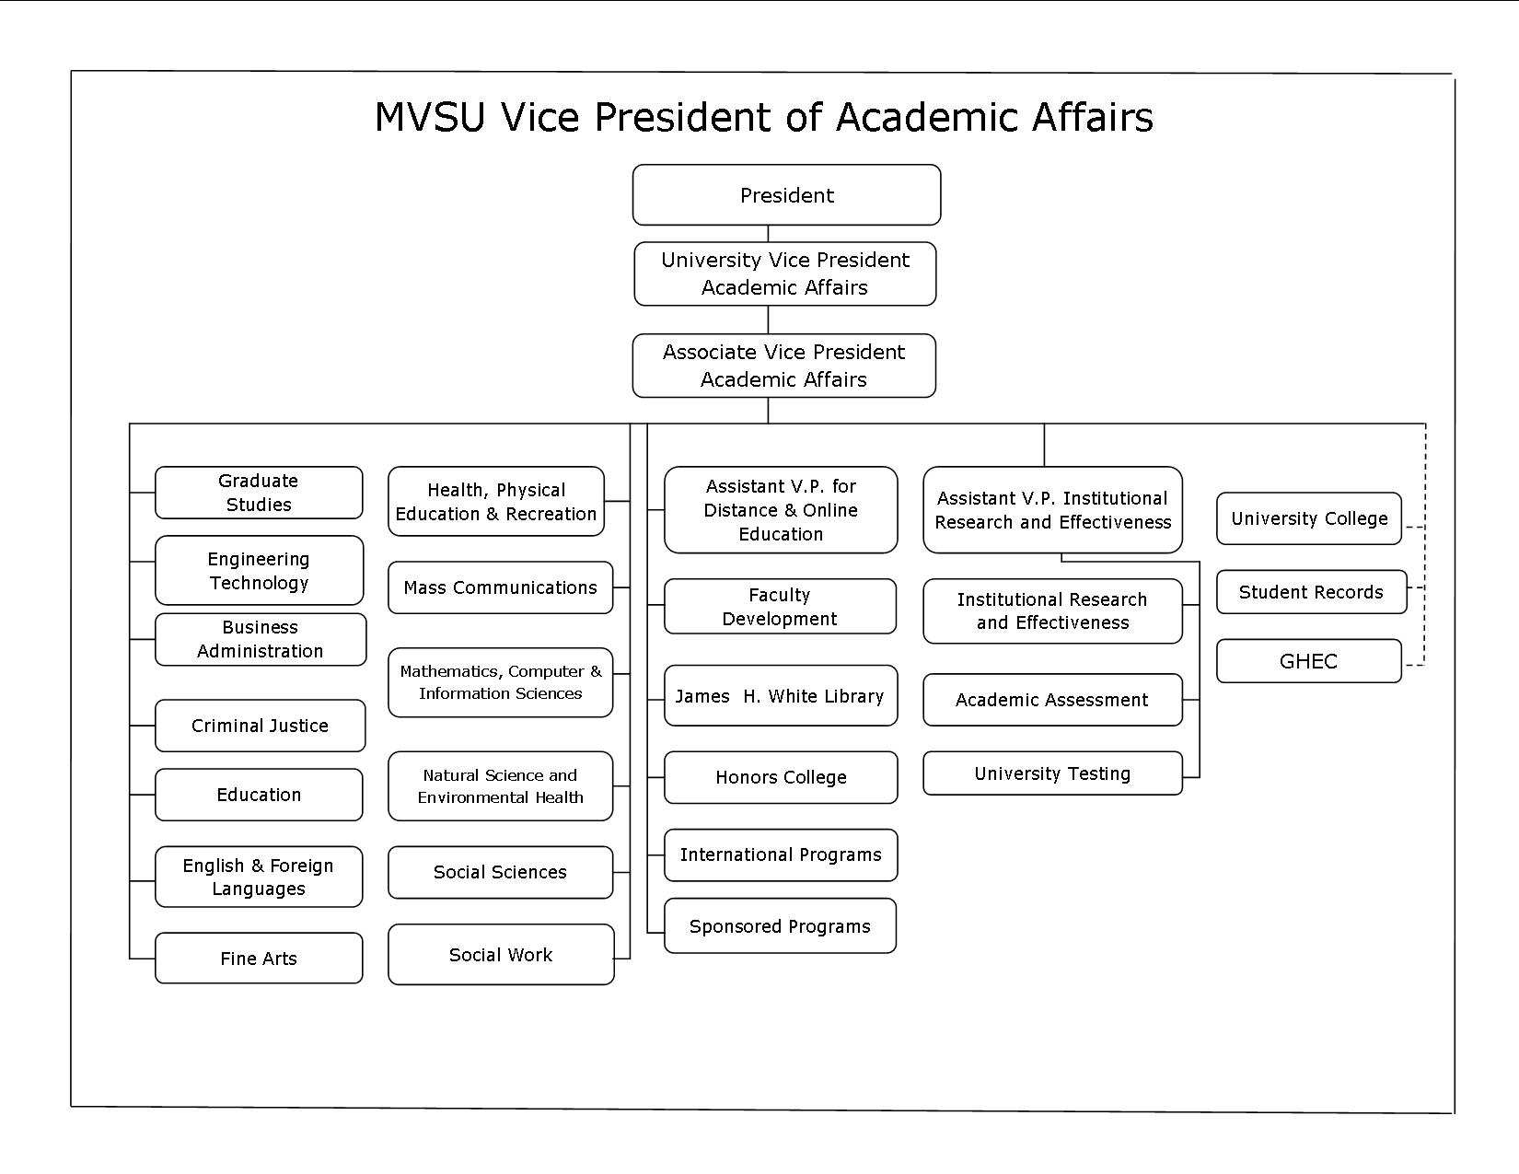

The Department of Social Work is provided the necessary independence to govern itself in accordance with requirements of the Educational Policy and Standards (EPAS) of the Council on Social Work Education (CSWE). Social Work faculty established the departmental mission statement and goals based upon the overall university mission. While faculty work to ensure that mission and goals are consonant with the university’s mission and vision for service in the Mississippi Delta, the BSW Program and the Department of Social Work make all decisions relative to how such mission and purposes are articulated.

A separate budget is provided for departmental operations and the Chair has authority over the expenditure of funds. The Chair likewise appears annually before the university’s budget committee to present a request for funding commensurate with the department’s needs. However, the final decision rest with the Office of Business and Finance. More will be presented below as to the specific autonomy of the department and the BSW program in budgetary and academic matters.

|  |
| --- |
| **AS 3.4.2:** The program describes how the social work faculty has responsibility for defining program curriculum consistent with the Educational Policy and Accreditation Standards and the institution’s policies. |

The social work faculty works jointly on the development of the curriculum. All members of the faculty understand and are committed to defining program curriculum in a manner consistent with the Educational Policy and Accreditation Standards (EPAS) of the Council on Social Work Education. Our curriculum is developed and organized as a coherent and integrated whole consistent with program goals and EPAS 2008 competencies. The professional curriculum is built upon a liberal arts perspective and the major content areas of social work education are integrated throughout. Faculty members work together to ensure that each course is infused with content related to values, diversity, populations-at-risk, including economic and social justice, human behavior in the social environment, social welfare policy and services, practice, research, and field. Students are prepared through our curriculum to become generalist social work practitioners. The program has also developed a conception of generalist social work practice that is consistent with our university and program missions and with EPAS.

Faculty members of the BSW Program maintain authority over the curriculum. The BSW faculty meets on a monthly basis to discuss all program matters however; curricular issues are discussed when necessary. All issues related to changes in the curriculum and program policies are voted on by the entire BSW faculty. When changes in the curriculum are ratified, the Chair of the Department presents the proposed changes before the University’s Academic Policy Council. This group is composed of University faculty and is chaired by the Vice-President for Academic Affairs. Once they give their consent, the change is implemented. Although the Academic Policy Council has veto authority over changes in the curriculum proposed by academic programs, such actions are taken only when a program has failed to produce sound justification for its requests, or when curricular changes would place a program in jeopardy of losing accreditation by the Southern Association for Colleges and Schools (SACS) or specific accrediting bodies such as CSWE. As long as Social Work faculty members propose changes consistent with the university and departmental mission, their collective autonomy is respected.

Faculty of the BSW Program have authority over the evaluation of the effectiveness of the curriculum, the operations of the BSW field program, evaluation of field agencies/instructors and all other matters related to social work education at the baccalaureate level. Decisions related to changes in textbooks, course content, agencies selected as field practicum sites and community projects rest with program faculty. Again, because the department is small and housed within a small rural university, many activities are shared among members of both academic programs. For example, relationships with the social work practice committee are generally handled at the departmental level and include BSW and MSW faculty. Responsibilities and activities that are shared by all persons on the departmental faculty include:

1. The Department’s Advisory Committee – This Committee is composed of various agency directors, elected officials, civic leaders and social workers who live and work in the Mississippi Delta. They meet at least once per semester to advise the Department as a whole on matters related to implementing our mission and goals in the community at large.
2. The Department’s Field Advisory Committee – This committee includes experienced BSW and MSW practitioners who mostly serve in the Mississippi Delta. They advise the field faculty of both the baccalaureate and master programs on knowledge and skills of students preparing to enter into field internships.
3. The faculty as a whole (BSW and MSW) meet regularly to discuss departmental goals and projects. MSW faculty members are involved in providing comments or giving advice on specific curricular issues.
4. Each faculty member develops their syllabi based on the courses they teach and their expertise in their area of teaching however; all syllabi are reviewed by the curriculum committee and feedback is given and changes are made as necessary.

|  |
| --- |
| **AS 3.4.3:** The program describes how the administration and faculty of the social work program participate in formulating and implementing policies related to the recruitment, hiring, retention, promotion, and tenure of program personnel. |

***Recruitment and Hiring of Faculty/Staff***

The Chair of the Department of Social Work in conjunction with departmental faculty members has responsibility for the recruitment of potential faculty and staff. This activity is carried out with the approval of the University’s Office of Academic Affairs and with the assistance of the Office of Human Resources. There is not a standing departmental search committee however; when a position is available a search committee is formed. This committee consists of BSW and MSW faculty/staff. Its members discuss and formulate active recruitment tools for new social work faculty/staff. They then present their recommendations to the departmental faculty. The department advertises for faculty through HigherEdJobs and through direct contact with colleagues who have expressed some interest in a faculty position at MVSU. Faculty positions are also posted on Mississippi Valley State University, Human Resources (HR) website and on HR Bulletin Board located on the 3rd floor of William Sutton Administration Building.

Members of the search committee recommend, arrange, and conduct interviews with potential faculty/staff. Toward this end, they notify potential candidates of necessary application documents, as well as how to submit them. They also review applications and accompanying documents (curriculum vitae, official transcripts and three letters of reference) to decide whether the applicant meets university and CSWE requirements and the needs of the department. The Department Chair, upon the recommendation of the Search Committee invites the candidate for an interview either in person or via telephone interview. Candidates are interviewed by social work search committee and once the interviews have been completed, the faculty votes as to whether a recommendation to hire the candidate should be sent forward. If the vote is affirmative, the Chair then makes the recommendation to the Vice-President for Academic Affairs. The VP of Academic Affairs reviews the recommendation and all qualifying materials and forwards the approved candidate’s application packet to Human Resources. Human Resources staff then signs the transmittal form and sends to the University President for approval. The University President retains the prerogative to interview the candidate and the final authority for hiring new faculty rests with the university president. When the candidate has been approved for hire the department chair is then notified of the decision and Human Resources will contact the candidate and make an offer.

***Retention***

In retaining faculty the university and the department has clear policy and procedures that are spelled out in the Personnel Handbook and Faculty Handbook. The University holds a Faculty Institute and Staff Orientation twice a year at the beginning of each school-term (Fall & Spring) where faculty and staff are formally introduced to the University community. New faculty and staff are also introduced and welcomed through our news publication the CommuniQue’. The university works to support faculty in their career goals, there are clear tenure and promotion criteria, a welcoming and inclusive work environment, and transparent and clearly communicated expectations for tenure and promotion. The department attempts to keep the faculty and staff connected and happy by praising them for a job well done, having lunches, meetings where faculty and staff can discuss their projects and there is a supportive and respectful environment and a sense that each faculty and staff member matters (sense of worthiness).

***Promotion and Tenure***

Tenure and promotion is spelled out in Mississippi Valley State University Faculty Handbook revised May 2013. To apply for tenure a faculty at the professional rank must have serve five full years at their present rank and in the sixth year are eligible to apply for promotion. Candidates must also satisfy the department specific criteria for both promotion and tenure. Each department is required to have a policy for awarding promotion and tenure. The policy is given to new faculty during the first month of employment by the Chair of the Department. A plan for progress towards promotion, tenure, and post-tenure or continue employment is developed. This plan is then given for review and shall be voted on and approved by the Department Tenure and Promotion Committee.

It is the responsibility of the faculty member to inform the department chair in writing of his/her intent to intent to apply for promotion and/or tenure. After a consultation with the Chair, the faculty member submits a dossier divided into sections (cover letter of applicant, faculty vita, graduate transcripts, evaluation materials, teaching competency, scholarly and creative activities, service, continuing growth, and other relevant materials). The Chair then submits the dossier to the Department Tenure and Promotion Committee for review and recommendation. The dossier is sent back to the Chair with recommendation(s). The Chair transmits the recommendations and the dossier to the Vice-Present of Academic Affairs for transmittal to the University Tenure and Promotion Committee for review. The University Tenure and Promotion Committee reviews the dossier and makes a recommendation to the Vice-President of Academic Affairs who then submits the recommendation to the University President.

|  |
| --- |
| **AS 3.4.4 (a):** The program identifies the social work program director. Institutions with accredited BSW and MSW programs appoint a separate director for each. |

The Chief administrator for the Department of Social Work/BSW Program is Dr. Catherine M. Singleton-Walker. She earned her Master’s Degree in Social Work with a concentration in mental health from the University of Alabama, in Tuscaloosa in May 1999. In August 2007, she graduated with the Doctorate in Philosophy in Social Work from Jackson State University, Jackson, Mississippi. Her area of concentration was micro social work practice.

Dr. Singleton-Walker has over nine years post MSW experience in the field of mental health, public health and administration. She served as a Social Services Coordinator for Charter Behavioral Health Systems of Mississippi, LLC from 1999 to 2000 where she managed and supervised staff of the Social Services Department. Dr. Singleton-Walker worked with children, adolescents, and adults with behavioral health issues including substance abuse. She also worked as a School Social Worker at Piney Woods School from 2000 until 2003. Piney Woods School is a boarding school where Dr. Singleton-Walker provided counseling services to students who had emotional and behavioral concerns as well as academic related issues. She provided case management services for students and was also responsible for providing faculty and staff in-services. From December 2004 through August 2008, Dr. Singleton-Walker took a position as a Social Work Supervisor for District V, Mississippi State Department of Health where she served as the supervisor for seven social workers and ten county health departments. She provided case management services for high risk pregnant mothers including teen mothers utilizing the Perinatal High Risk Management/Infant Services System (PHRM/ISS). As the district social work supervisor she was also responsible for any reports made that placed children or adults in medical health danger. An assessment was conducted and referral and consultation made as needed.

Dr. Singleton-Walker began her academic career at MVSU in 2003 as an adjunct faculty at Jackson State University and was hired the fall of 2007 as an Assistant Professor of Social Work at Mississippi Valley State University, a post she held until August 2010 when she assumed the position of MSW Program Director. In February 2013, she was appointed the Interim Chair/Associate Professor of the Department of Social Work. Dr. Singleton-Walker served as Interim Chair from February 2013 to July 2014 when she was named Chair of the department.

Dr. Singleton-Walker is a member of the National Association of Social Workers where she serves on the Mississippi Chapter of NASW Board. She has served as the Chair of the Greenwood Leflore County Red Cross Board, a member of the Leflore County Emergency Planning Committee and a member, and a member of Hope Homeless Shelter Coalition of Leflore County.

Scholarly activities include the following conference presentations over the past four years:

1. Singleton-Walker, C.M. (2016). Understanding the implications of obesity in children and adolescents. Accepted for presentation at the 36th Annual Mississippi Valley State University Social Work Conference in Greenwood, Mississippi.
2. Singleton-Walker, C. M. (2016) Medical and psychosocial implications of child and adolescent obesity. Accepted for presentation National Association of Social Workers (NASW) Mississippi Chapter Annual Program Meeting in Biloxi, Mississippi.
3. Singleton-Walker, C. M. (2015). Obesity: An issue of diversity. Accepted for presentation at the Mississippi Conference on Social Welfare in Biloxi, Mississippi.
4. Singleton-Walker, C. M. (2014). Ethics of spiritual intervention in

social work practice. Accepted for presentation at the 34th Annual Mississippi Valley State University Social Work Conference in Greenwood, Mississippi.

1. Singleton-Walker, C. M. (2014). The helping profession and compassion fatigue.

Accepted for presentation at the National Association of Social Workers (NASW) Mississippi Chapter Annual Program Meeting in Biloxi, Mississippi.

1. Singleton-Walker, C.M. (2013). Obesity: A disease – Disparity for African Americans. Accepted for presentation at Jackson State University 1st Annual Ethics and Diversity One Day Workshop in Jackson, Mississippi.
2. Singleton-Walker, C. M. (2012). Parenting children and teens. Greenwood

Mississippi Citywide Family Life Summit in Greenwood, Mississippi

1. Singleton-Walker, C. M. (2012). Bullying: What can we do? Leflore County School District-Wide Parent Summit in Greenwood, Mississippi
2. Singleton-Walker, C. M. & Jackson, A. (2012). Consequences of teenage maternal obesity on perinatal outcomes. Accepted for presentation at the 32nd Annual Mississippi Valley State University Social Work Conference in Itta Bena, Mississippi.

|  |
| --- |
| **AS 3.4.4 (b):** The program provides documentation that the director has a full-time appointment to the social work program. |

Dr. Singleton-Walker has a twelve month assignment to direct the Department of Social Work. She serves concurrently as the Coordinator of the Baccalaureate Social Work Program until vacant position is filled.

|  |
| --- |
| **AS 3.4.4 (c):** The program describes the procedures for determining the program director’s assigned time to provide educational and administrative leadership to the program. To carry out the administrative functions of the program, a minimum of 25% assigned time is required at the baccalaureate level. The program demonstrates this time is sufficient. |

Dr. Singleton-Walker currently serves concurrently as the Department Chair/Coordinator of the Baccalaureate Social Work Program. The institution supports and respects the required time necessary for educational and administrative leadership, therefore 25% release time is given for administrative leadership to the BSW program. This time is sufficient to provide administrative oversight for the BSW program.

|  |
| --- |
| **AS 3.4.5:** The program identifies the field education director |

Ms. Latosha Ceasar is the BSW Field Education Coordinator. She was hired November 2014 to serve as the BSW Field Education Coordinator.

|  |
| --- |
| **AS 3.4.5 (a):** The program describes the field director’s ability to provide leadership in the field education program through practice experience, field instruction experience, and administrative and other relevant academic and professional activities in social work. |

Ms. Latosha Ceasar is capable of providing leadership in field education. She has a Master degree from a CSWE accredited program and has over two years of practice experience and has served in an administrative position for at least one year. She is resourceful with a great understanding and appreciation for the Mississippi Delta. Ms. Ceasar worked as the Director of Social Services at Mid Delta Home Health & Hospice Adult Daycare where she was responsible for coordination of services, safety regulations, and making sure policies and procedures were being followed including the guidelines for Medicare and Medicaid.

|  |
| --- |
| **AS 3.4.5 (b):** The program documents that the field education director has a master’s degree in social work from a CSWE – accredited program and at least 2 years of post-baccalaureate or postmaster’s social work degree practice experience. |

Ms. Latosha Ceasar is the BSW Field Education Coordinator. She earned a Master of Social Work from Mississippi Valley State University, Itta Bena, in May 2012. Mississippi Valley State University is a CSWE accredited program. She has worked as a Family Protection Specialist at Mississippi Department of Human Services in Yazoo City, Mississippi. In this position she was responsible conducting investigations about abuse/neglect and exploitation and helping to make sure that children were safe within their home/placement environments. She followed up with families to make sure they were compliant with intervention and presented cases in youth court. Ms. Ceasar worked as a Family Service Worker at Friends of Children in Mayersville, Mississippi for six months where she conducted intake and assessment activities, maintained regular contact with families and provided crisis intervention. She then went to work as a Medical Social Worker/Director of Social Services from 2010-2014 at Mid-Delta Home Health and Hospice/Adult Daycare where she assessed patients’ psychological status and developed the plan of care in consultation with the physician and other care team members. Developed and coordinated discharge planning and evaluated the effectiveness and outcomes of care.

|  |
| --- |
| **AS 3.4.5 (c):** The program describes the procedures for determining the field director’s assigned time to provide educational and administrative leadership for field education. To carry out the administrative functions of the field at least 25%assigned time is required for baccalaureate programs. The program demonstrates that this time is sufficient |

The institution supports and respects the accreditation process therefore, program management, academic course scheduling and faculty release time are the responsibility of the department chair. The field education coordinator has a full-time appointment to the BSW program and sufficient assigned time to provide educational and administrative leadership for field education. Ms. Ceasar is assigned to teach SW436 Field Practicum and SW437 Integration Seminar. As such she has 25% reduction in her course load.

**Educational Policy 3.5 Resources**

|  |
| --- |
| **AS 3.5.1:** The program describes the procedures for budget development and administration it uses to achieve its mission and goals. The program submits the budget form to demonstrate sufficient and stable financial supports that permit program planning and faculty development. |

The Department has a separate budget which is managed by the Chair. Currently, the MSW and BSW programs share the Departmental budget. Sufficient funds are allocated and expended on the BSW Program to ensure the achievement of the departmental mission and programmatic goals. The Department maintains autonomy over the use of funds, particularly related to financing faculty travel, hosting conferences and keynote speakers, the purchase of equipment, field training, consultants, office supplies, telephone services and postage.

The Department of Social Work is permitted the opportunity to develop and propose a budget that is sufficient to meet programmatic goals and objectives. During the spring semester the Chair of the Department presents budget requests to the University officers responsible for approving budget allocations. These officers include the President, the Vice-President for Academic Affairs, and the Vice-President of Business and Finance. The Chair is given the opportunity to defend budget requests relative to the mission of the Department and the respective programmatic goals. Once a budget is approved and allocated, the Department Chair manages the budget and ensures that spending is restricted to materials and activities essential to the needs of department operations. The Department’s total budget is allocated from the University. State funds are used for salaries, travel, office supplies, and communications.

The Departmental budget is sufficient in that it provides for four full-time and one part-time BSW faculty members. There is a departmental administrative assistant who provides support services to the Program. Work study students are paid by the university to assist BSW faculty. Adjunct faculty are provided at the department’s request as necessary to teach in the BSW program, however, adjunct salaries are paid out of Academic Affairs’ budget.

The Department of Social Work has one budget that covers both the BSW and MSW programs. The budget is not separated by program. Therefore, the budget has been separated and is presented only for the BSW program. The BSW program total budgets for FY 2015 was $385,205.00 and remains the same for FY 2016. There is no budget change anticipated for FY 2017 therefore, the projected budget is $385,205.00. The budget of $246,068 covers four fulltime and 1 part-time BSW faculty and 25% time for BSW Program Coordinator. The administrative assistant is shared between the BSW and MSW programs; thus, the portion of the salary (50%) charged to the BSW budget is $13,525.00. The budget for program supplies and services is $5,334.00 and travel for the field coordinator is $450.00. Adjunct faculty funds are not directly deposited into the departmental budget because their salary is paid by Academic Affairs. Nevertheless, the budget reflects the cost for adjunct faculty which totals $13,667.00.

There are no funds included in the budget for technological resources but is supported by Title III. The technological resources available to faculty members (computers, internet, and software) strengthen the instructional capacities which in turn help the program to achieve the program’s mission and goals.

See the budget form on next page.

**Program Expense Budget**

**Council on Social Work Education**

**Commission on Accreditation**

**2008 EPAS**

This form is used to evaluate a program’s compliance with Accreditation Standard (AS) 3.5.1.

|  |  |  |  |  |  |  |  |  |  |  |  |
| --- | --- | --- | --- | --- | --- | --- | --- | --- | --- | --- | --- |
| **AS 3.5.1**  The program describes the procedures for budget development and administration it uses to achieve its mission and goals. The program submits the budget form to demonstrate sufficient and stable financial supports that permit program planning and faculty development. | | | | | | | | | | | |
| Provide all of the information requested below. If accredited baccalaureate and master’s programs are being reviewed at the same time, use one form for each program. | | | | | | | | | | | |
| Type of Program: | X | | Baccalaureate | | |  | | Master’s | |  | |
|  | | | | | | | | | | | |
| **Program**  **Expenses** | | **Previous Year**  **2015** | | | **Current Year**  **2016** | | | | **Next Year**  **2017** | | |
|  | | **Dollar Amount** | | **% Hard Money** | **Dollar Amount** | | **% Hard Money** | | **Dollar Amount** | | **% Hard Money** |
| Faculty &  Administrators | | 246,068 | | 100% | 246,068 | | 100% | | 246,068 | | 100% |
| Support Staff | | 13,525 | | 100% | 13,525 | | 100% | | 13,525 | | 100% |
| Temporary or Adjunct Faculty & Field Staff | | 13,667 | | 100% | 13,667 | | 100% | | 13,667 | | 100% |
| Fringe | | 106,162 | | 100% | 106,162 | | 100% | | 106,162 | | 100% |
| Supplies & Services | | 5334 | | 0 | 5334 | | 0 | | 5334 | | 0 |
| Travel | | 450 | | 0 | 450 | | 0 | | 450 | | 0 |
| Student  Financial Aid | | 0 | | 0 | 0 | | 0 | | 0 | | 0 |
| Technological Resources | | 0 | | 0 | 0 | | 0 | | 0 | | 0 |
| Other (Specify) | |  | |  |  | |  | |  | |  |
| **TOTAL** | | 385,205 | | ------- | 385,205 | | ------- | | 385,205 | | ------- |

|  |
| --- |
| **AS 3.5.2:** The program describes how it uses resources to continuously improve the program and address challenges in the program’s context. |

The Program has an adequate budget, faculty and support staff to implement and accomplish its mission and goals. The budget provides sufficient funds to hire program faculty and support staff. Funds are also allocated for faculty members to attend local, state and national conferences through the University Title III funds. This allows for faculty to remain on the cutting edge of developments in the profession’s knowledge and service delivery systems. They are then able to impart such knowledge and skills to students.

The technological resources available to faculty members (computers, internet, and software) strengthen the instructional capacities which in turn help the program to achieve its mission and goals. Faculty members have begun developing a limited number of online courses to look into how cutting edge technologies serve to provide social work education to persons in remote rural areas. The online and distance learning capabilities are available to the Department through the cooperation of the University’s offices of Continuing Education and Academic Computing Services.

|  |
| --- |
| **AS 3.5.3:** The program demonstrates sufficient support staff, other personnel, and technological resources to support itself. |

The Department has a secretary who provides support services. In addition, the University provides work study students and a graduate assistant. All faculty members have their own personal computers. They have access to laptop computers and digital projectors for all classes. Faculty members also have access to two large televisions with built in VCR/DVD players to integrate into classroom instruction. The program has more than adequate collection of DVDs and tapes related to social work practice, diversity and other areas of the social work curriculum. Classrooms are equipped with WI-FI therefore usage of videos from You Tube and other online sites are also available.

|  |
| --- |
| **AS 3.5.4**  **The program submits the library form to demonstrate comprehensive library holdings and/or electronic access and other informational and educational resources necessary for achieving its mission and goals.** |

See Below

|  |
| --- |
| **3.5.4a Holdings of books, monographs, journals and other collection resources pertinent to social work study and research.** |

Mississippi Valley State University (MVSU), through the James H. White (J. H. White) Library, maintains a library collection that is adequate for the Department of Social Work’s graduate and undergraduate degree granting programs. The J. H. White Library’s Collection Development Policy, driven by university and library missions and goals, ensures that the library has a balanced quality core collection in each of its teaching disciplines. The library’s community of users, particularly MVSU faculty and students, are encouraged to make recommendations for titles (books, journals, videos and DVDs) to be included in the collection either in-person or via request forms found online at (for faculty <http://www.mvsu.edu/images/admin/spotedit/attach/194/Faculty_Request_Form.pdf>) and (for students <http://www.mvsu.edu/images/admin/spotedit/attach/194/Student__Request_Form_2.doc>)

The library, through written communication of annual reports, library liaison collection analysis, flyers, emails and memorandums, engage faculty and students in a collaborative process to enhance and strengthen the library’s collections, particularly in electronic books, as reflected in tables 1-4 below.

**Table 1 Social Work Holdings General Collection**

|  |  |  |
| --- | --- | --- |
| Library of Congress | As of 06/30/2012 | As of 06/30/2016 |
| HN - Social history& conditions, Social problems, Social reform | 590 | 1251 |
| HQ - Family, Marriage, Women | 1646 | 1336 |
| HT - Communities, Classes, Races | 390 | 1346 |
| HV - Social Pathology, Social and Public Welfare | 3676 | 5486 |
| RC - Gerontology | 1472 | 2450 |
| **Total** | **7774** | **11,869** |

**Table 2 Social Work Holdings (Reference Collection)**

|  |  |  |
| --- | --- | --- |
| Library of Congress | As of 06/30/2012 | As of 06/30/2016 |
| HN - Social history& conditions, Social problems, Social reform | 16 | 46 |
| HQ - Family, Marriage, Women | 50 | 102 |
| HT - Communities, Classes, Races | 10 | 40 |
| HV - Social Pathology, Social and Public Welfare, Social Work | 206 | 356 |
| RC - Gerontology | 93 | 133 |
| **Total** | **375** | **677** |

**Table 3 Social Work Holdings (Electronic Books)**

|  |  |  |
| --- | --- | --- |
| Library of Congress | As of 06/30/2012 | As of 06/30/2016 |
| HN - Social history& conditions, Social problems, Social reform | 612 | 895 |
| HQ - Family, Marriage, Women | 3042 | 4677 |
| HT - Communities, Classes, Races | 1092 | 2886 |
| HV - Social Pathology, Social and Public Welfare, Social Work | 6636 | 8558 |
| RC – Gerontology | 1430 | 1961 |
| **Total** | **12812** | **18977** |

**Table 4 Social Work Holdings (Media)**

|  |  |  |
| --- | --- | --- |
| Library of Congress | As of 06/30/2012 | As of 06/30/2016 |
| HN - Social history& conditions, Social problems, Social reform | 3 | 3 |
| HQ - Family, Marriage, Women | 37 | 56 |
| HT - Communities, Classes, Races | 4 | 7 |
| HV - Social Pathology, Social and Public Welfare, Social Work | 54 | 65 |
| RC – Gerontology | 60 | 60 |
| **Total** | **158** | **191** |

Due to current economic constraints, the J. H. White Library has reduced its current print journal subscription total to 222 titles. Of those titles, 13 are social work or social work related and wherever possible the print subscription journals are replaced with the electronic versions. Current print and microform subscription of journals and newspapers are supplemented through electronic full-text databases such as Ebscohost, Journal Storage, Article First, Credo Reference, and Lexis-Nexis. In addition, Ebscohost is the statewide database provided to all public institutions by the Mississippi Legislature for MAGNOLIA (Mississippi Alliance for Gaining New Opportunities through Library Information Access). The various databases provided by Ebscohost such as Academic Search Premier, Business Source Elite, ERIC and MLA Bibliography ensure accessibility to more than 15,000 full text journal articles. Moreover, participation in MAGNOLIA has enabled the James H. White Library to improve and offer services that enhance the quality, accessibility and delivery of resources for the Itta Bena campus as well as the Greenville Center.

|  |
| --- |
| **3.5.4b Staffing pertinent to the provision of library services to social work students.** |

The J. H. White Library is staffed by six (6) full-time professional librarian positions, of which two (2) at the time of this report are vacant, thirteen (13) full-time support staff positions, two (2) part-time positions and student workers whose number is dependent upon students with work-study. All professional librarians graduated from an accredited School of Library Science or Information Science with a master’s level degree. The Director is responsible for the overall operations of the library. Moreover, a librarian is assigned to work in conjunction with the Director to serve as liaisons between the library and the Department of Social Work to help articulate the department’s library needs. Additionally, library services, such as library instruction, reference and Interlibrary Loan, for graduate and undergraduate students in the department are facilitated by professional librarians.

|  |
| --- |
| **3.5.4c Budget for social work library resources for the last, current and upcoming academic year.** |

The library purchases resources for its collections based upon a collaborative process with faculty, student and liaison librarians. The Library gives high priority to acquiring materials which faculty request as recommend readings or resources in their course syllabi with the exception of required textbooks.

The Director of the Library allocates funds from the library’s operating budget for materials by subject areas or academic discipline. The percentage of funds allocated to the various subject areas will be determined by the Library Director in consultation with liaison librarians based upon four defined levels:(1) minimal level, (2) the basic level, (3)the instructional/support level, and (4) thesis/advance study level found in the library’s collection development policy.

The Department of Social Work has received marginal funding for the past three years due to stringent economic constraints. Table 5 below best portrays what allocations from the library’s budget have occurred for the past and current academic years with future allocations. As depicted in Table 5, approximately $5,000.00 is allocated for book purchases alone consistently within the past four years. This amount is has remained so due to significant budget cuts and thus funds allocated to purchase resources have remained flat.

The library allocated to the department of social work funds to also cover 13 print journals. Additionally, the print collections are augmented by electronic databases titles. Currently the library has approximately 44 electronic database subscriptions of which 8 are specifically social work or social work related (for example *SocSci Fulltext, Lexis-Nexis, Academic Search Premier, Points of View, Credo Reference, JSTOR, and Mental Measurement Yearbook*)

Table 5 Budget Allocations for Social Work

|  |  |  |  |  |  |
| --- | --- | --- | --- | --- | --- |
| Year | Books (print) | Journals | Number of SW Journals | Electronic Databases | TOTAL |
| 2012-2013 | $5,000.00 | $ 7,369.00 | 15 | $34,861.37 | $47,230.37 |
| 2013-2014 | $5,000.00 | $7,674.00 | 14 | $66,880.93 | $79,554.93 |
| 2014-2015 | $5,000.00 | $7,516.75 | 13 | $73,693.81 | $86,210.56 |
| 2015-2016 | $5,000.00 | $7,102.00 | 13 | $82,127.86 | $94,229.86 |

|  |
| --- |
| **3.5.4d Circulation or utilization data for items relevant to social work.** |

Circulation of print and electronic titles is presented in Table 6. As depicted, print titles receive marginal circulation as students seem to prefer the use of electronic resources. The James H. White Library reserves services are designed to provide assistance to MVSU faculty by placing high demand and specialized materials on limited circulation with restricted loan periods to ensure that every student has equal access to the assigned materials. There are two (2) types of reserve materials, print and electronic. As noted by tables 7 and 8, students much prefer the use of electronic reserves over print. Electronic reserves or Ereserves materials (journal articles, book chapters, lecture notes, Web pages, etc) are made available via Internet through the electronic software Docutek (<http://mvsu.docutek.com/eres/default.aspx>). Traditional reserve or print reserve materials (J. H. White Library books, personal copies of books, compact discs, etc) are available on at the circulation desk. Students must present a valid MVSU ID in order to use the print reserve materials. Faculty members are encourage to complete a reserve form, which is available online, in order to have their reserve request processed in a timely manner (see <http://www.mvsu.edu/images/admin/spotedit/attach/194/Faculty_Reserve_Materials_Form.pdf>) . All materials placed on reserve are solely for the non-commercial, educational use of students.

**Table 6 Social Work Collection Circulation**

|  |  |  |
| --- | --- | --- |
| Year | Books | E-Books |
| 2012-2013 | 87 | No data available |
| 2013-2014 | 108 | No data available |
| 2014-2015 | 145 | 614 |
| 2015-2016 | 169 | 399 |

**Table 7 Social Work Print Reserves Usage**

|  |  |  |
| --- | --- | --- |
| Year | Number of Items on Reserve | Number of Items Used |
| 2012-2013 | 30 | 176 |
| 2013-2014 | 15 | 247 |
| 2014-2015 | 24 | 76 |
| 2015-2016 | 57 | 107 |

**Table 8 Social Work Electronic Reserve Usage**

|  |  |  |
| --- | --- | --- |
| Year | Number of Items on Reserve | Number of Items Used |
| 2012-2013 | 30 | 175 |
| 2013-2014 | 15 | 100 |
| 2014-2015 | 24 | 76 |
| 2015-2016 | 1 | 1 |

|  |
| --- |
| **3.5.4e Equipment and technology available to social work (computers, copiers and printers)** |

Mississippi Valley State University provides facilities that are adequate and directly relevant for faculty and students’ research and information needs. The facilities, services and informational resources of the James Herbert White Library support the research needs for the Social Work program. The James Herbert White Library is a 58,162 square feet facility that has seating capacity for approximately 350 students. In addition, the library has available two (2) group study rooms, six (6) individual research carrels, a 44 seat electronic classroom, a Social Work Reading Room, a 36 seat Computer Commons where students are able to access such software as Microsoft Office, Corel Wordperfect, etc. Additionally, the library has in total 20 computers for general library use on the first and second floor. Moreover, the Learning Resources Center (LRC) has a plethora of DVD’s, videos, State Adopted Textbooks, a presentation room, a conference room and other multimedia equipment relevant to the Department of Social Work for student and faculty use.

There are also general access computers in the Reference Department for student use with the same capabilities as those found in the lab. Also, students have access to wireless Internet capabilities while seated in Circulation or Reference. Two (2) photocopiers and a fax machine are available for faculty and student use throughout the building.

|  |
| --- |
| **3.5.4f Circulation policies and procedures (policy and procedures to ensure that books or materials required or recommended in social work courses are made available to students).** |

The J. H. White Library circulation policies and procedures are articulated in a printed brochure which is handed out during library tours, library instruction and upon registering a new library user. Access to these policies and procedures is also available online at <http://www.mvsu.edu/images/admin/spotedit/attach/194/circulation_rules.pdf>.

The brochure notifies library users of circulation loan periods, eligibility requirements, book return locations, fines and fees policy, reserve policy, and library hours. The circulation policies and procedures state that: graduate and undergraduate students have a three (3) week or twenty-one (21) day loan period. However, graduate students are allowed to check-out up to ten (10) items at one loan period, while undergraduates are only allowed five (5) items. Students also receive a three (3) day grace period before a $.20 per day fine begins to accrue.

Faculty members are allowed to check-out up to twenty (20) items at one time with the exception of reference materials and journals. The loan period for faculty is for one semester. However, items checked-out by faculty are subject to recall if needed by a student.

|  |
| --- |
| **3.5.4g Library’s online catalogue, email, computerized search services, document delivery, interlibrary loan (identify per-fee versus non-fee), media, and other related services available to students (include other libraries outside educational institution to which students have regular access and the appropriateness of each library’s holdings for social work).** |

SirsiDynix is the current provider of the library’s integrated library system, Symphony. Herbie (<http://mvsu.ent.sirsi.net/client/default>) is the library’s online public access card catalog which provides faculty and students twenty-our hour access to the library’s collection of books, journals and media items as it is web-based. Faculty and students have to ability to log on to their library accounts to view items checked out, fines, fees and due dates. However, Herbie is not the only card catalog that social work faculty and students have access to. Through consortia membership with OCLC, faculty and students have access to OCLC’s *WorldCat*, the world's largest and most comprehensive catalog with 194 million bibliographic records that represent more than 1 billion individual items held by participating institutions.

Faculty and students also have access to additional library resources that cannot be found in the James H. White Library through Interlibrary Loan (ILL). Through the use of the software ILLiad, faculty and students can request materials, track the status of that material, edit their requests and also renew their request online. Users of ILLiad are authenticated through the library’s SirsiDynix integrated library system. ILLiad users must be registered patrons with the James H. White Library. ILL is a non-fee based service provided by the library. However, lending charges can occur for faculty and students when items are requested from other libraries usually outside the state of Mississippi or when there is no consortia agreement in place.

However, through consortia memberships with Lyrasis and OCLC for interlibrary loans, students and faculty have access to the collections of 57, 081 libraries in the United States with a combined collection total of 28.4 million books and other materials. Furthermore, through membership with the Mississippi Library Consortium the library participates in the state of Mississippi’s cooperative lending and borrowing program. The James H. White Library can borrow at no cost from all public and private institutions in the state such as Mississippi State University (the state’s flagship), University of Mississippi, Jackson State University, University of Southern Mississippi, Tougaloo College, etc.

Through such consortia agreements, faculty and students in the Social Work programs have access to the library collections of such schools as the University of Michigan-Ann Arbor, which was listed as having one of the top social work programs in 2011 by *U. S. News and World Report*.

|  |
| --- |
| **3.5.4h Reference coverage and related services (comment on the availability of library staff to provide reference help on social work topics to faculty and students).** |

The library operates eighty-three and a half (83.5) hours seven (7) days a week. Thus, the library has a sufficient accompaniment of professional librarians who provide reference services to all library users via various methods. This is inclusive of 2 reference librarians, 2 reference assistants and two (2) other professional librarians who share reference duties and responsibilities. Librarians assist faculty, staff, students, community patrons and visitors with a wide variety of reference questions as well as providing instruction in the use of library resources. Librarians are available to provide one-on-one instructions to individuals students or group library orientations. The librarians provide assistance in person during regular hours of operation, by telephone, by email or chat sessions or by appointment. The librarians provide instruction in various ways which are inclusive of bibliographic instruction classes, Faculty Friday workshops for faculty, consultations and virtual reference chat sessions.

Reference services are located on the second floor of the library and provide bibliographic instruction for students in groups or one-to-one individualized direct assistance. The User Access Education Program is the method used to orientate students in the use of library resources. Faculty members may request electronically or by phone to schedule their classes for bibliographic instruction (see <http://www.mvsu.edu/images/admin/spotedit/attach/194/User_Access_Education_Flyer.pdf> for User Access Education flyer). Also, continues to conduct a series of Faculty Friday Workshops to introduce teaching faculty to new library resources and the latest electronic databases. The series is 12 one hour sessions per semester (see **Appendix B**).

|  |
| --- |
| **3.5.4i Is there a library staff member assigned to a liaison role for the social work program? (If yes, describe the nature of this role vis-à-vis the social work program).** |

The library through its Library Liaison Program engages Social Work faculty members in a collaborative venue to strengthen the library’s services and collections. Librarians are assigned to each academic department as a liaison to serve as a link between the library and the academic departments in articulating the needs of the department of the library. James Herbert White librarians are knowledgeable of the subject areas for which they are assigned as well as evolving and emerging trends in librarianship. Librarians are chosen as liaisons based upon academic degrees and library experience. The role of the librarian as liaison, assigned to Social Work, is to enhance collection development of the print and non-print Social Work collections; assist in promoting and articulating the needs of the library and the Social Work department; enhance library services for Social Work faculty and students; and foster a collaborative and cohesive relationship between the library and the Social Work department.

|  |
| --- |
| **3.5.4j Is there a librarian (or librarians) with a specific social work designation, such as social work librarian, social work bibliographer, or social work liaison? Describe the job responsibilities of these librarians and other activities. In addition, is there involvement by librarians in (a) social work courses or in course management programs (such as Blackboard, WebCT) for social work students; (b) library instruction provided through distance education, continuing education; (c) library services for alumni, outreach, or community services; (d) development of the program’s strategic planning, technology development and curriculum revision; and (e) activities providing opportunities for professional development?** |

Currently, there is no librarian with a specific designation of social work librarian or social work bibliographer, however, through its library liaison program, the library engages Social Work faculty in a collaborative process to help strengthen library services to the Social Work department as well as its collections.

(a) The James H. White Library will make available via the Blackboard portal the following self-paced library resources and instructional guides to any MVSU student, online and/or continuing education student. Students will have the ability to self-assess their knowledge and understanding of library resources and services through a library designed pre-test and post-test activity. Student should access and read the following before taking either test: Library Brochures (Circulation, Interlibrary Loan, Reference and the Library) – designed to give students general knowledge about library services which they should view first; Libguides – designed as how-to guides for understanding and use of the print collections of the James H. White Library, the card catalog, the electronic databases, how to conduct research, and how to search the electronic databases (using this url <http://libguides.mvsu.edu/content.php?pid=211842> )

(b) The library collections and library instruction at MVSU’s Itta Bena campus are open and accessible to all students at the Greenville Center. The Greenville Center has a library located on the first floor of the Greenville Higher Education Center (GHEC). The GHEC library provides resources for students of two colleges and/or universities (Mississippi Delta Community College (MDCC) and Mississippi Valley State University (MVSU). MDCC has the controlling interest in the facility and thus provides three personnel for the library (1 full-time professional librarian, 1 part-time professional librarian who serves as an outreach librarian and 1 library-support staff person). Although employed by MDCC, the library personnel are available to assist students of MVSU providing they have registered and are taking for credit courses at MVSU. However, specialized library instruction sessions as well as library orientation will be conducted by MVSU’s Instructional Services Librarian who will visit GHEC twice a week.

(c) Professional librarians, inclusive of reference librarians, are available to provide assistance with the identification of the most appropriate resources for research at the Reference Desk to the entire library’s community of users. This is inclusive of MVSU alumni. In addition to phone, email and face-to-face assistance, the library provides virtual reference (Ask-A-Librarian) assistance as selected hours. In addition the library, as part of our service to the community, will loan materials to community patrons. Community patrons are those persons who are not enrolled at Mississippi Valley State University nor are they affiliated with any of the consortia with whom we share reciprocal borrowing privileges. Community patrons must adhere to all the James H. White Library policies and procedures. This means that community patrons are subject to fines/fees as any other library patron. For all community patrons, there is a $25.00 non-refundableregistration fee. There is also a $100.00 depositthat allows the patron to check out a maximum of three (3) books per loan for a one (1) year time period. At the end of that year or when the patron no longer requires the use of library materials, the deposit will be refunded to the patron and their account will be considered closed. Once the account is closed, the only way for that patron to check out library materials is for him/her to register once again. Furthermore, the library honors all consortia with who we are affiliated (Mississippi Library Consortium and Dancing Rabbit Library Consortium). Consortia patrons, some of which are MVSU alumni, must adhere to all James H. White Library rules.

(d) The Director of the Library is a member of the university’s Academic Policy Committee. This committee is charged with vetting curriculum changes by degree programs. The committee makes recommendations to the Chief Academic Officer regarding the curricular changes but is not have the authority for final approval.

(e) Also, in Fall 2014 the library began to conduct a series of Faculty Friday Workshops to introduce teaching faculty to new library resources and the latest electronic databases. The series is 12 one hour sessions per semester.

|  |
| --- |
| **3.5.4k Is there a procedure used by social work faculty to recommend items for purchase? If yes, how are such faculty recommendations handled by library staff.** |

The acquisition of materials is an essential priority of the James H. White Library’s goal of meeting student and faculty needs. The library’s Collection Development Policy clearly articulates the priorities and scope of acquiring library resources. Faculty recommendations for collection enhancement are given first priority.

The library welcomes suggestion of titles, by faculty in their teaching discipline, to be added to the library’s collection. Faculty are encouraged to submit recommendations for books, journals, videos or DVDs via a form found online at <http://www.mvsu.edu/images/admin/spotedit/attach/194/Faculty_Request_Form.pdf> or complete the form in the library. Upon completion, the form can either be returned in person to the Reference/Collection Development Librarian (254-3497) or it can be saved and sent as an attachment via email to [mlhenderson@mvsu.edu](mailto:mlhenderson@mvsu.edu). The Reference/Collection Development Librarian or the Director will then work with the assigned library liaison for that department to ensure that the titles are ordered. Once the titles have been ordered and processed by Technical Services, liaison librarians send an email communication to the requestor indicating that the titles recommended have arrived and are available for use.

|  |
| --- |
| **3.5.4l How often are new acquisitions in social work listed and reported to program faculty?** |

New acquisitions for the department of Social Work are listed in the Herbie card catalog as soon as they are purchased and processed by Technical Services. Once the titles have been ordered and processed, liaison librarians receive notice from Technical Services indicating that titles recommended by one of their liaison departments have arrived and have been processed. The liaison librarian then sends an email communication to the requestor indicating that the titles recommended have arrived and are available for use. This process is on-going as titles and recommendations are received throughout the year.

|  |
| --- |
| **3.5.4m Traffic or other counts of users of social work collection or social work resources.** |

The library utilizes a number of resources that will allow us to track patron usage. Although, not specific to Social Work, the library uses a gate counter to library visits as well as an electronic counter to track use of the library’s webpage (see table 9).

Other services in which the library counts its users are Virtual and In-house Reference Queries (see table 10). Those services that can specifically count users of social work resources are: print and electronic reserve usage (see table 7 & 8) and social work database usage (see table 11) and books circulated (see table 6).

**Table 9 Library Visits**

|  |  |  |
| --- | --- | --- |
| Year | Face-to-Face Visits | Virtual Visits |
| 2012-2013 | 55883 | 17308 |
| 2013-2014 | 45913 | 13525 |
| 2015-2015 | 62579 | 14528 |
| 2015-2016 | 67149 | 122573 |

**Table 10 Reference Queries**

|  |  |  |
| --- | --- | --- |
| Year | Virtual Reference Queries | In-house Reference Queries |
| 2012-2013 | 62 | 7743 |
| 2013-2014 | 101 | 5507 |
| 2014-2015 | 99 | 9660 |
| 2015-2016 | 110 | 7249 |

**Table 11 Specific Social Work Database Usage**

|  |  |  |  |  |
| --- | --- | --- | --- | --- |
| Database | 2012-2013 (sessions/searches) | 2013-2014 (sessions/searches | 2014-2015 (sessions/searches) | 2015-2016 (sessions/searches) |
| JSTOR | 6272/7217 | 8386/8426 | 4428/5675 | 3701/4657 |
| Lexis-Nexis | 158/283 | 174/559 | 124/567 | 70/708 |
| SocSci full-text | 1256/2658 | 1488/4880 | 1491/6035 | 1420/5956 |
| Points of View | 62/45 | 81/118 | 109/181 | 319/750 |
| Credo Reference | 168/331 | 921/1305 | 1245/1576 | 257/384 |

|  |
| --- |
| **3.5.4n Instructional sessions (number and type of presentations, number of participants, evaluation data).** |

In support of the academic programs of Mississippi Valley State University (MVSU), the library provides training to meet the teaching and research needs of faculty, students, staff and the surrounding community. This includes individualized and group class instruction sessions, workshops, tours and research consultation appointments.

University faculty may request to have a user access instruction session to enhance classroom instruction and to introduce various research sources to students. To schedule a User Access session, faculty members are encouraged to contact the Reference Department (254-3497), as soon as a date has been selected for the session. Faculty members are asked to schedule classes at least two (2) weeks in advance of the desired date to allow time for session preparation an online version of this form can be found at <http://www.mvsu.edu/images/admin/spotedit/attach/194/Library_Instruction_Request_Form.pdf>. In addition to library instruction classes, librarians provide research consultation by appointment to the faculty and students. The Reference Department will develop a session that will accommodate the faculty members’ and students’ research needs based on the information given. For convenience, an online version of the form is available through the library’s website at <http://www.mvsu.edu/images/admin/spotedit/attach/194/Research_Consultation_Form.pdf>.

The James H. White Library offers access to a broad range of print, non-print and electronic resources to its users, thus library instruction is provided in various ways. Introduction to basic library services is included in the User Access Education Program. The User Access Education Program recognizes the need for student and faculty to become ‘information literate’, therefore the program encapsulates the ACRL standards for Information Literacy as well as a Research 101 level. The Basic Introduction Level is designed to introduce students to the James H. White Library and its resources, the Information Literacy level is designed to empower the information literate student to determine the nature and extent of information needed and the Research 101 level is designed to provide guidance in the preparation of short and long research papers and other forms of writing that require critical evaluation of journals, books, Internet resources and the correct citations for those sources as well as why a works cited/reference list is needed in research (see Table 12 Library Instruction Sessions).

**Table 12 Library Instruction Sessions**

|  |  |  |  |
| --- | --- | --- | --- |
| Year | Number of Classes | Type of Presentation | Number of Participants |
| 2012-2013 | 47 | Basic Library Instruction, Research and Information Literacy | 1385 |
| 2013-2014 | 72 | Basic Library Instruction, Research and Information Literacy | 1514 |
| 2014-2015 | 95 | Basic Library Instruction, Research and Information Literacy | 2118 |
| 2015-2016 | 107 | Basic Library Instruction, Research and Information Literacy | 2213 |

The User Access Education Program undergoes continual assessment. Each level of instruction comes with an accompanying exam to ascertain the quality and effectiveness of instruction. A scoring rubric is utilized to gauge whether students are effectively able to utilize the information that is being taught.

|  |
| --- |
| **3.5.4o Location of library/social work collection relative to classroom and other social work student services.** |

The James H. White Library was built in 1971, occupied in 1973, renovated in 2011 is named in honor of the university’s founding father and first president. The library is the heart of the university campus, physically and figuratively. The library plays a vital role in teaching and learning but has not undergone any major enhancements or renovations since its original construction. However, in 2009, the library began a massive renovation project.

Physically, the Library lies at the crossroads of the campus, making it a significant focal point. It is an opportunity to make a design statement that reflects the character of the campus. The planned, renovated library was a comprehensive renovation of the existing James H. White Library. This renovation fully addresses the needs and aspirations identified in the programming phase.

The library construction was planned to occur in two phases to keep the library functioning. The first phase utilizes the recently renovated, existing Academic Skills Building (immediately adjacent to the library) to create a temporary library. The second phase fully renovates the James H. White Library.

The exterior of the building will be strategically renovated to improve the facility’s energy performance by increasing insulation and harvesting natural light. The largely enclosed exterior will be opened with new, two-story glass bays which increase visual accessibility and engage the library into the campus center.

In 2013, renovations were completed. The newly renovated James H. White Library includes accessible collection stacks intermingled with ample study areas, accessible circulation and information desks, and multiple computer access points among the stack and study areas. All of the librarian and library support spaces are arranged for ease of use and to increase accessibility for library users. A computer classroom, a 24-hour computer laboratory, a learning resource center, accessible special collections and archives, children's reading area, a larger Social Work Reading Room, a Music Listening Room and a coffee lounge are included to draw people into the library.

|  |
| --- |
| **3.5.4p Library hours for the main library and social work collection library for the full calendar year. (Are there requests for additional hours from social work students? If yes, discuss the library’s response).** |

Currently, the library operates eighty-three (83) and a half hours, seven (7) days a week. The library hours for the regular academic year are Monday through Thursday 7:30am to 10:00pm, Friday 7:30am to 7:00pm, Saturday 10:00am to 4:00pm, and Sunday 2:00pm to 10:00pm. During final exam week, the Library extends its hours of operation until 12:00 midnight. The library computer lab hours of operation are comparable to those of the library. The computer lab hours are Monday through Thursday 7:30am to 9:45pm, Friday 7:30am to 6:45pm, Saturday 10:00am to 3:45pm, and Sunday 2:00pm to 9:45pm. The computer lab’s hours are also extended to midnight during final exam week. The operational hours of the library are posted online as well as on the front door of the library. Upon return to the main library, the Social Work Reading Room hours of operation will also be comparable to regular library hours of operation.

|  |
| --- |
| **3.5.4q Samples and results of assessment/evaluation surveys of library services.** |

The library utilizes survey results to access customer satisfaction regarding adequacy of it resources and services. The adequacy of the library’s collections and electronic resources is recognized by the faculty and students of Mississippi Valley State University. The library conducts an annual “How Are We Doing Survey” to gage the quality, adequacy and effectiveness of library collections and services. The most recent survey was conducted in 2014 and when asked about the types of services, building/facilities (space and temperature), book collection (adequate number of books), hours of operation, printing cost, assistance provided by staff and overall customer service the faculty, staff and students indicated that they are satisfied with the overall quality of the current collection and services of the James H. White Library. Evidence of satisfaction can also be found in other annual surveys conducted such as the one conducted in 2014-2015 through the “How Are We Doing?” link found on the library’s webpage and 2015-2016 survey of the library’s hours of operation.

In the 2009-2010 academic year, the James H. White Library performed a collection analysis utilizing WorldCat Collection Analysis, a web-based service, to ensure the adequacy of its collections. The James H. White Library obtained permission from five (5) peer institutions in which to compare collection sizes based upon uniqueness and overlaps. The peer institutions were chosen based upon similarity in mission statement; enrollment size and Carnegie classification. WorldCat Collection Analysis provided a comprehensive analysis and comparison of the James H. White Library collection to peer institutions within the states of Mississippi, Georgia, Tennessee and Alabama. The James H. White Library’s print and electronic book collection holdings were submitted to OCLC WorldCat by October 1, 2009. This data was then analyzed and compared against at least 5 other peer institutions (both regional and national) that are comparable in student enrollment and collection size. The institutions that were used for comparison were: Delta State University –DSU (regional), Elizabeth City State University-ECSU (national), Alcorn State University-ASU (regional), Mississippi University for Women-MUW (regional) and Albany State University (national). The National Center of Educational Statistics was used to help determine the comparability of student enrollment size and OCLC WorldCat was used to determine collection size comparability.

The results indicated that the library is comparable in size, uniqueness and overlap with 3 out of 5 institutions used for collection analysis. The information ascertained through the assessment of the collection was utilized to help the James H. White Library build a more robust collection, specifically to compare favorably with the 2 institutions that data revealed we were not comparable with (Delta State University and Alcorn State University).

The library has several years of practice assessing its collections, resources and services. As far back as 2001, the library assessed the adequacy of its collections and resources via assessment instruments issued from the Office of Institutional Effectiveness. Commencing in 2007, the library began to use outcome based assessment to gage the adequacy of it collections and resources. Not only does the library rely on internal assessment but, accreditation reviews provide opportunities for the library to focus on collections and services in specific disciplines. MVSU has hosted recent accreditation visits by the Commission on Colleges Southern Association of Colleges and Schools (SACS) and the Association for Business Engineering and Technology (ABET). In each case the library successfully demonstrated the adequacy of its collections and information resources.

|  |
| --- |
| **3.5.4r Strengths, Areas of Concern, Projections for and Assessment plans for social work collection.** |

The library views as one of its strengths, its ability to provide library users with access to need materials. Whether in our current collections or borrowed through Interlibrary Loan or retrieved from an electronic database, the library works hard to ensure efficient and effective access to resources. However, as library funds continue to shrink, the library must endeavor to discover unique and innovative ways in which to fund those resources needed and/or required not only by the Social Work Department, but for all other teaching disciplines as well. With these thoughts in mind, the library will perform annual collection assessment analysis for the Social Work Department and all other teaching disciplines to ensure that funding is available for those core resources and that the collection development policy is revised to ensure that each discipline receives an adequate allotment of funds. Furthermore, the library must begin to work diligently with the Social Work Department is securing funds for their resources. To receive these funds from the department, will free up library funds to purchase new and innovative databases and other technology pertinent to the department.

|  |
| --- |
| **AS 3.5.5:** The program describes and demonstrates sufficient office and classroom space and/or computer – mediated access to achieve its mission and goals. |

The Department of Social Work is housed on the second floor of the William Sutton Administration Building (WSA). Social Work is the only academic department located in the WSA building. The department is located on the east end of the hall in Suite 218 where the administrative assistant’s office is located. There are eleven private offices in the social work suite that house the chair and faculty members. Each faculty member has a desktop computer in their office and has access to a laptop and projector for use in the classroom. There is also a computer laboratory for use by students located on the west end of the hall. On this floor there is sufficient classroom space to accommodate students and provide an appropriate learning environment.

|  |
| --- |
| **AS 3.5.6:** The program describes its access to assistive technology, including materials in alternative formats (e.g., Braille, large print, books on tape, assistive learning systems). |

The program has access to assistive technology including materials in alternative formats such as Braille, large print, books on tape, assistive learning systems. These technologies are available through Mississippi Valley State University’s Library services and University College Service for Students with Disabilities (SSD).

**Educational Policy and Standard 4.0**

**Assessment**

|  |
| --- |
| **4.0.1** *The program presents its plan to assess the attainment of its competencies. The plan specifies procedures, multiple measures, and benchmarks to assess the attainment of each of the program's competencies* |

**The Assessment Plan**

Assessment remains one of the largest challenges and productive activities of the Baccalaureate Social Work Program. Faculty members work in unison to ensure that we are meeting the core competencies of EPAS, through coursework, rubrics and field internships. We are especially mindful of issues concerning relevance of the methods we use, the most effective means of examining the data gathered and the validity of our findings. These findings are useful for improving our implicit and explicit curricula. Faculty members of the BSW Program have therefore decided upon a multi-dimensional approach that will permit us to assess how well we have accomplished competencies through various measures.

The Department of Social Work has established an evaluation committee to ensure that there is an ongoing assessment relative to accomplishment of all program objectives. Our plan shows how the faculty members utilize findings for continuous program improvement. Dr. Vincent Venturini, a member of the BSW Faculty, chairs the committee. He brings experience in program assessment and evaluation to the table, as well as years of experience as an instructor in research and statistics.

BSW faculty members remain involved in the ongoing process of program evaluation. This is especially critical as we are a small program and all instructors serve on the BSW curriculum committee. Findings from the program evaluation committee will be presented to all faculty members through meetings, memoranda, reports, retreats and special planning sessions.

Our plan for ongoing program assessment and evaluation includes various methods. Each has been selected based upon its usefulness as a measure of discrete practice behaviors. The instruments we have selected are relevant to the competencies and behaviors, and should provide an acceptable level of accuracy when assessing accomplishment of specific outcomes. In fact, we have carefully chosen measures that are consistent with our ability to determine and control their respective content. The use of various respondents and raters provide us with uniformity in outcome assessments. As such, our plan for assessment and evaluation will give us a viable means of ensuring that program goals and competencies are met and in pointing to areas of needed improvements in the curriculum.

For almost all of the measures, the benchmark will be determined using an aggregate mean. A mean of 4.0 is the benchmark. Because several competencies are measured using a five point Likert scale, we follow the example given in the Holloway article and calculate the mean of all of the students' scores for each practice behavior. A minimum score of four is selected because that would indicate a benchmark equivalent to 80% for satisfactory achievement.

**ASSESSMENT PLAN**

| **Competency** | **Competency**  **Benchmark** | **Practice**  **Behavior** | **Measures** | **Analysis**  **Procedures** |
| --- | --- | --- | --- | --- |
| **EP 2.1.1 Conduct and Identity of Professional Social Work** | Mean of 4.0:  (For each practice behavior an average score of measures is computed. The mean of those average scores constitutes the statistic employed to address the benchmark) | A. Advocate for client access to services  B. Practice personal reflection and self-correction for continued professional development  C. Attend to Professional roles and boundaries  D. Demonstrate professional demeanor in behavior, appearance and communication  E. Engage in Career Long Learning  F. Use Supervision and Consultation | 1. Field Evaluations  2. Employer Evaluation  1. Items on student survey  2. Class Assignment  1. Field Evaluations  2. Employer Survey  1. Field Evaluations  1. Employer Survey  1. Items from Student Surveys  2. Employer Surveys  1. Field Evaluations  2. Employer Surveys | 1. Aggregate Mean  2. Aggregate Mean  1. Aggregate Mean  2. Aggregate Mean  1. Aggregate Mean  2. Aggregate Mean  1. Aggregate Mean  2. Aggregate Mean  1. Aggregate Mean  2. Aggregate Mean  1. Aggregate Mean  2. Aggregate Mean |
| **EP2.1.2**  **Apply Social Work Ethical Principles to Guide Professional Practice** | Mean of 4.0:  (For each practice behavior an average score of measures is computed. The mean of those average scores constitutes the statistic employed to address the benchmark) | A. Recognize and manage personal values in a way that allows professional values to guide practice  B. Make ethical decisions by applying professional standards of the social work profession  C. Tolerate ambiguity in resolving ethical conflicts  D. Apply strategies of ethical reasoning to arrive at principled decisions | 1. Class Assignment  2. Items on Student Survey  1. Class assignment  2. Items on Student Survey  1. Field Evaluations  2. Employer Survey  1. Field Evaluations  2. Employer Survey | 1. Aggregate Mean  2. Aggregate Mean  1. Aggregate Mean  2. Aggregate Mean  1. Aggregate Mean  2. Aggregate Mean  1. Aggregate Mean  2.Aggregate Mean |
| **EP2.1.3**  **Apply Critical Thinking to inform and communicate professional judgments** | Mean of 4.0:  (For each practice behavior an average score of measures is computed. The mean of those average scores constitutes the statistic employed to address the benchmark) | A. Distinguish, appraise and use multiple sources of knowledge, including research based knowledge and practice wisdom  B. Analyze Models of Assessment, prevention, intervention and evaluation   |  | | --- | | C. Demonstrate effective oral and written communication with client systems of all sizes and with colleagues | | 1. Class Assignment  2. Items on Student Survey  1. Class Assignment  2. Field Evaluations  1. Class Assignments  2. Field Evaluations | 1. Aggregate Mean  2. Aggregate Mean  1. Aggregate Mean  2. Aggregate Means  1. Aggregate Mean  2. Aggregate Mean |
| **EP2.1.4**  **Engage Diversity and Difference in Practice** | Mean of 4.0:  (For each practice behavior an average score of measures is computed. The mean of those average scores constitutes the statistic employed to address the benchmark) | A. Recognize extent to which a culture's structures and values oppress, marginalize and create distinctions of power and privilege  B. Gain sufficient self-awareness to eliminate influence of one's own personal biases and values in working with diverse groups  C. Recognize and communicate an understanding of the importance of differences in shaping life experiences  D. View oneself as a learner who engages those with whom s/he works as an informant | 1. Class Assignments  2. Items on Student Survey  1. Class Assignments  2. Items on Student Survey  1. Class Assignments  2. Items on Student Survey  1. Class Assignments  2. Items on Student Survey | 1. Aggregate Mean  2. Aggregate Mean  1. Aggregate Mean  2. Aggregate Mean  1. Aggregate Mean  2. Aggregate Mean  1. Aggregate Mean  2. Aggregate Mean |
| **EP2.1.5**  **Advance human rights and social and economic justice** | Mean of 4.0:  (For each practice behavior an average score of measures is computed. The mean of those average scores constitutes the statistic employed to address the benchmark) | A. Understand the forms and mechanisms of oppression and discrimination  B. Advocate for human rights and social and economic justice  C. Engage in practices that advance social and economic justice | 1. Class Assignments  2. Items on Student Survey  1. Field Evaluations  2. Class assignments  1. Field Evaluations  2. Employer Survey | 1. Aggregate Mean  2. Aggregate Mean  1. Aggregate Mean  2. Aggregate Mean  1. Aggregate Mean  2. Aggregate Mean |
| **EP2.1.6**  **Engage in research-informed practice and practice-informed research** | Mean of 4.0:  (For each practice behavior an average score of measures is computed. The mean of those average scores constitutes the statistic employed to address the benchmark) | A. Use practice experience to inform scientific inquiry  B. Use research evidence to inform practice | 1. Class Assignment  2. Items on Student Survey  1. Class Assignment  2. Items on Student Survey | 1. Aggregate Mean  2. Aggregate Mean  1. Aggregate Mean  2. Aggregate Mean |
| **EP2.1.7**  **Apply knowledge of human behavior and the social environment** | Mean of 4.0:  (For each practice behavior an average score of measures is computed. The mean of those average scores constitutes the statistic employed to address the benchmark) | A. Utilize conceptual frameworks to guide the process of assessment, intervention, and evaluation  B. Critique and apply knowledge to understand person and environment | 1. Class Assignments  2. Items on Student Survey  1. Class Assignments  2. Items on Student Survey | 1. Aggregate Mean  2. Aggregate Mean  1. Aggregate Mean  2. Aggregate Mean |
| **EP2.1.8**  **Engage in policy practice to advance social and economic well-being and to deliver effective social work services** | Mean of 4.0:  (For each practice behavior an average score of measures is computed. The mean of those average scores constitutes the statistic employed to address the benchmark) | A. Analyze, formulate and advocate for policies that advance social well-being  B. Collaborate with colleagues and clients for effective policy action. | 1. Class Assignments  2. Items on Student Survey  1. Class Assignments  2. Field Evaluations | 1. Aggregate Mean  2. Aggregate Mean  1. Aggregate Mean  2. Aggregate Mean |
| **EP2.1.9**  **Respond to Contexts that Shape Practice** | Mean of 4.0:  (For each practice behavior an average score of measures is computed. The mean of those average scores constitutes the statistic employed to address the benchmark) | A. Continuously discover, appraise, and attend to changing locales, populations, technological changes and societal trends to provide relevant services  B. Provide leadership in promoting sustainable changes in service delivery and practice for improvement of social services | 1. Class Assignments  2. Items on Student Survey  1. Field Evaluations  2. Employer Surveys | 1. Aggregate Mean  2. Aggregate Mean  1. Aggregate Mean  2. Aggregate Mean |
| **EP2.1.10**  **Engage, assess, intervene, and evaluate with clients at micro, mezzo and macro levels of practice** | Mean of 4.0:  (For each practice behavior an average score of measures is computed. The mean of those average scores constitutes the statistic employed to address the benchmark) | A. Engagement  1. Substantively prepare for action with clients at Micro, Mezzo and Mezzo levels  2. Use interpersonal skills, including empathy  3. Develop a contract with client system  B. Assessment  1. Collect, organize and interpret client data  2. Assess client strengths and limitations  3. Develop mutually agreed-on intervention goals and objectives with clients  4. Select appropriate intervention strategies  C. Intervention  1. Initiate actions to achieve organizational goals  2. Implement prevention interventions that enhance client capacities  3. Help clients resolve problems  4. Negotiate, mediate, and advocate for clients  5. Facilitate transitions and endings  D. Evaluation  Critically analyze, monitor, and evaluate interventions | 1. Field Evaluations  2. Employer Surveys  1. Field Evaluations  2. Employer Surveys  1. Field Evaluations  2. Employer Surveys  1. Class Assignment  2. Items on Student Survey  1. Class Assignment  2. Items on an Student Survey  1. Field Evaluations  2. Employer Surveys  1. Class Assignment  2. Employer Surveys  1. Field Evaluations  2. Employer Surveys  1. Field Evaluations  2. Employer Surveys  1. Field Evaluations  2. Employer Surveys  1. Field Evaluations  2. Employer Surveys  1. Field Evaluations  2. Employer Surveys  1. Class Assignments  2. Employer Surveys  1. Class Assignments  2. Field Evaluations | 1. Aggregate Mean  2. Aggregate Mean  1. Aggregate Mean  2. Aggregate Mean  1. Aggregate Mean  2. Aggregate Mean  1. Aggregate Mean  2. Aggregate Mean  1. Aggregate Mean  2. Aggregate Mean  1. Aggregate Mean  2. Aggregate Mean  1. Aggregate Mean  2. Aggregate Mean  1. Aggregate Mean  2. Aggregate Mean  1. Aggregate Mean  2. Aggregate Mean  1. Aggregate Mean  2. Aggregate Mean  1. Aggregate Mean  2. Aggregate Mean  1. Aggregate Mean  2. Aggregate Mean  1. Aggregate Mean  2. Aggregate Mean  1. Aggregate Mean  2. Aggregate Mean |

Various measures are used in assessing the accomplishment of program objectives. Each is applied as deemed relevant to a specific practice behavior. These methods are subject to change and further development as they are implemented. The instruments include:

1. Final Field Evaluations
2. Specific class assignments
3. Student Surveys
4. Employers Surveys

**FINAL FIELD EVALUATIONS**

Field evaluations conducted as the student completes the field internship should reflect the level of achievement related to the practice behaviors. Selected items from the evaluation instrument are applied to particular practice behaviors as indicators of performance. Field instructors are trained in the use of the instrument so as to provide reliable measures.

5.0 A Performance is exceptionally high on performance of task

4.0 B Performance is generally high on performance of task

3.0 C Performance meets minimal expectations

2.0 D Performance falls below what is minimally expected

1.0 F Performance in unacceptable related to expectations

**SPECIFIC CLASS ASSIGNMENTS**

Specific class assignments may refer to 1) A community or agency profile in SW420 or 2) a case study assigned to students in SW437, Integrated Seminar. Class assignments may be used as a measure for practice behaviors in which a direct observation of the knowledge base is required in order to provide a reliable and valid measure. While the field evaluations may be useful in tandem with class assignments on some practice behaviors, they may prove less helpful in others. An example would be behaviors related to the Agency or Community Profiles assigned in SW420, Methods of Social Work Practice III. Opportunities for such an activity are not available in many of our field agencies and so field evaluations as a measurement is not appropriate. The use of a class assignment, in which students are expected to prepare and execute an Agency Profile or Community Profile, does provide a direct and reliable measure.

This Class Assignment uses a five point rubric. The rubric is as follows:

**5** The Profile is very comprehensive, detailed and covers all questions with depth and clarity. The score of 5 is equivalent to a grade of A

**4** The Profile is comprehensive and detailed to a high degree. It covers all questions with a high degree of depth and clarity. The score of 4 is equivalent to a grade of B

**3** The Profile is comprehensive and detailed at no more than an acceptable level. It covers all questions with an intermediate degree of depth and clarity. The score of 3 is equivalent to a grade of C

**2** The Profile demonstrates no more than a poor level related to being comprehensive and detailed. Depth and clarity are judged to be poor. A score of 2 is equivalent to a grade of D

**1**  The Profile is neither comprehensive nor detailed. There is likewise no discernible depth or clarity. A score of 1 means that the student receives an F

The level of achievement is determined by the instructor based upon completion of assignments and the quality of the work. It should be noted that the benchmark score of 4 indicates that the student has met the minimal expectation for an "exemplary" level of achievement. This corresponds with a score of at least 80% which is commensurate with a grade of B. Should that cohort score close to a 5.0, this would be commensurate with a grade of A.

**Community/Agency Profiles**

Students are expected to complete either an Agency Profile or a Community Profile while enrolled in SW420, Methods of Social Work Practice III. Those students who are simultaneously enrolled in SW436, Field Internship, typically complete the profile of the agency in which they are placed. Those who are not enrolled in field complete the Community Profile. These profiles measure the students’ skills and knowledge related to understanding the structure and dynamics of macro settings as well as practice activities within those settings.

**STUDENT SURVEY**

The Student Survey is constructed around the core of the BSW Program. It is designed to measure student learning outcomes related to these competencies using a Likert Scale. The scoring of the instrument is weighted in the direction of achievement of the competencies, so that the higher the mean score the higher the level of achievement. Questions/statements move in different directions. For those questions/statements that move in the direction of accomplishment of competencies (e.g, #s 3 and 5), the answer selections begin with SA (Strongly Agree) on the left and continues to SD or Strongly Disagree) on the right. For the questions/statements that move in the opposite director of accomplishment of the competencies (e.g #s1 & 4) the sequence is reversed. The use of mis-direction is intended to control for issues of students falling into response set of using the same answer for each question. The benchmark for achievement is an aggregate mean of at least 3.2, which is commensurate with a score of 80%.

**EMPLOYER SURVEY**

Employer surveys allow the Program to assess outcomes related to competencies after the student has graduated and has entered professional practice at the entry level. There are some practice behaviors such as "engages in career long learning" that cannot accurately be measured while students are still enrolled in the Program. While student surveys conducted just prior to graduation from the BSW Program can tease out the behavior as a value or intention held by the student, an employer survey can best be used to provide a concrete measure of its achievement. Surveys of employers also help to show whether graduates are engaging in a level of practice that is reflective of several of the practice behaviors that are attached to the core and concentration competencies.

While Employer Surveys are similar in some ways to the final field evaluation form, particularly in that social work supervisors are assessing performance, there are major differences. The Employer Survey is administered not to students, but to former students of the Program who are now working in professional practice. The bar is set higher for performance of job duties.

Employer surveys will be sent every three years to area social service agencies that employ graduates of the BSW Program. The Survey is scheduled for mailing in the Fall of 2015. The cohort that will be assessed includes alumni who graduated from 2012 to 2014, inclusive. The survey consists of a sample of questions contained in the foundation and concentration field internship evaluation forms. The language has been changed so that the instrument becomes employee rather than student focused. Questions will be added related to the level of participation by graduates in continued learning. The Respondents are asked to rate graduates of our program on each item using the same four point scale used in the field instrument. This survey permits agency directors/supervisors the opportunity to provide feedback into how well our program is succeeding in accomplishing its objectives. Members of the Program Evaluation Committee will collect, compute and analyze the data. They will report their findings to the entire program faculty.

**Meetings to Discuss Data and Planned Changes in Explicit and Implicit Curricula**

The BSW faculty will hold a curriculum meeting early in the Fall 2016 Semester during which time they discuss data related to field evaluations, classroom surveys and agency/community profiles. All data will be examined and a determination made as to their relevance to the explicit and implicit curricula. Faculty members will vote on how to use data during the 2015-16 academic year. Meetings will be held as needed in order to discuss possible changes in curricular areas.

|  |
| --- |
| **4.0.2:** The program provides summary data and outcomes for the assessment of each of its competencies, identifying the percentage of students achieving each benchmark. |

**Assessment Results for 2014-2015 Academic Year**

1. Field Evaluation Forms Spring of 2015:

Those items on the field evaluation form that best correspond with individual EPAS competencies are listed below each competency. **The benchmark for success in each practice behavior is a mean score of 4.0 or higher out of a possible high score of 5.0.** The mean scores for each practice behavior are reported along with the individual practice behaviors. N = 35; Their means scores are also recorded there.

**2.1.1 Identify as a professional social worker and conduct one-self accordingly**

a. Advocate for client access to services of social work.

Two items from the field evaluation instrument are used to measure performance on this practice behavior: Understands relationships of social policies to social work practice in field agency

1. Critically analyze the impact of agency and social policies on clients, agency workers, the community and other organizations. **The Mean Score for this Practice Behavior is 4.17. A total of four scores below the benchmark of 4.0 were recorded. The Benchmark for success was met.**
2. Works within agency policies, guidelines, and operational realities to recognize gaps in services or other needs for community and/or organizational change to meet client needs. **The Mean Score for this Practice Behavior is 4.2. A total of four scores below the benchmark were recorded. The Benchmark for success was met.**
3. Practice personal reflection and self-correction to assure continual professional development

Three items from the field evaluation instrument are used to measure performance on this competency:

1. Demonstrates knowledge of professional self. **The Mean score for this Practice Behavior is 4.24. The Benchmark for success was met.**
2. Integrates new knowledge and/or suggestions given by field supervisor into practice. **The Mean score this Practice Behavior is 4.1. The Benchmark for success was met.**
3. Participates in professional development activities. **The Mean Score for this Practice Behavior is 4.4. The Benchmark for success was met.**
4. Attend to professional roles and boundaries

Six items from the field evaluation instrument are used to measure performance on this competency:

1. Recognizes the role of the agency as it relates to social work. **The Mean Score for this Practice Behavior is 4.37. The Benchmark for success was met.**
2. Meets agency/professional standards for attendance, appointments and meetings. **The Mean Score for this Practice Behavior is 4.17. The Benchmark for success was met.**
3. Interacts with clients, colleagues, agency personnel and others in an ethical and professional manner. **The Mean Score for this Practice Behavior is 4.42. The Benchmark for success was met.**
4. Integrates into agency’s organizational structure. **The Mean Score for this Practice Behavior is 4.31. The Benchmark for success was met.**
5. Understands and operates within agency service delivery structure. **The Mean Score for this Practice Behavior is 4.23. The Benchmark for success was met.**
6. Establishes and maintains appropriate boundaries. **The Mean Score for this Practice Behavior is 4.42. The Benchmark for success was met.**
7. Demonstrate professional demeanor in behavior, appearance and communication

Four items from the field evaluation instrument are used to measure performance on this competency:

1. Establishes rapport with client. **The Mean Score for this Practice Behavior is 4.25. The Benchmark for success was met.**
2. Demonstrates professional use of oral communication skills when working with diverse client systems. **The Mean Score for this Practice Behavior is 4.2. The Benchmark for success was met.**
3. Demonstrates a professional level of written communication (e.g. organize and express basic ideas and summarize relevant data in case recordings, reports, letters, etc.). **The Mean Score for this Practice Behavior is 4.2. The Benchmark for success was met.**
4. Interacts with clients, colleagues, agency personnel and others in an ethical and professional manner. **The Mean Score for this Practice Behavior is 4.4. The Benchmark for success was met.**
5. Engage in career long learning

Two items from the field evaluation instrument are used to measure performance on this competency:

* 1. Integrates new knowledge and/or suggestions given by field supervisor in practice. **The Mean Score for this Practice Behavior is 4.1. The Benchmark for Success was met.**
  2. Participates in professional development activities. **The Mean Score for this Practice Behavior is 4.4. The Benchmark for Success was met.**

1. Use supervision and consultation

Three items from the field evaluation instrument are used to measure performance on this competency:

* 1. Prepares for supervisory conference with planned agenda. **The Mean Score for this item is 4.0. The Benchmark for Success was met with the minimum score.**
  2. Reports promptly to supervisory conferences, meetings, etc. **The Mean Score for this item is 4.37. The Benchmark for success was met.**
  3. Uses supervision and consultation to facilitate constructive problem solving. **The Mean Score for this item is 4.33. The Benchmark for Success was met.**
     1. **Apply Social Work Ethical Principles to Guide Professional Practice**

a. Recognize and manage personal values in a way that allows professional values to guide practice.

Five items from the field evaluation instrument are used to measure performance on this competency:

1. Demonstrates knowledge of values, principles and theories that guide effective interventions. **The Mean Score for this item is 4.23. The Benchmark for Success was met.**
2. Recognizes and discusses personal values and any conflicts that may arise in the practice setting. **The Mean Score for this item is 4.17. The Benchmark for Success was met.**
3. Establishes and maintains appropriate boundaries. **The Mean Score for this item is 4.43. The Benchmark for Success was met.**
4. Exhibits professional social work values when working with diverse populations. **The Mean Score for this item is 4.48. The Benchmark for Success was met.**
5. Identifies key social work and ethical principles and is able to discuss some practice implications. **The Mean Score for this item is 4.14. The Benchmark for Success was met.**
6. Make ethical decisions by applying standards of the National Association of Social Workers and as applicable of the International Federation of Social Workers/International Association of Schools of Social Work ethics in social work, statement in principles

One item from the field evaluation form measures this performance:

1. Identifies key social work values and ethical principles and is able to discuss some practice implications. **The Mean Score for this item is 4.14. The Benchmark for Success was met.**
2. Tolerate ambiguity in resolving ethical conflicts

One item from the field evaluation form measures this performance:

1. Recognizes and discusses personal values and any conflicts that may arise in the practice setting. **The Mean Score for this Item is 4.17. The Benchmark for Success was met.**
2. Apply strategies of ethical reasoning to arrive at principled decisions

One item from the field evaluation form measures this performance:

1. Recognizes and discusses personal values and any conflicts that may arise in the practice setting. **The Mean Score for this Item is 4.17. The Benchmark for Success was met.**

One item from the field evaluation form measures this performance:

1. Recognizes and discusses personal values and any conflicts that may arise in the practice setting. **The Mean Score for this Item is 4.17. The Benchmark for Success was met.**

**2.1.3 Apply Critical Thinking to Inform and Communicate Professional Judgment**

* 1. Distinguish, appraise and integrate multiple sources of knowledge, including research based knowledge, and practice wisdom

Four items from the field evaluation instrument measures this performance:

1. Demonstrates ability to make assessments and identify appropriate interventions when working with clients. **The Mean Score for this Item is 4.17. The Benchmark for Success was met.**
2. Identifies theoretical underpinnings for interventions. **The Mean Score for this Item is 4.17. The Benchmark for Success was met.**
3. Defines, understands and applies biological, emotional, cognitive, and behavioral dimensions in assessment of the client and presenting problems. **The Mean Score for this Item is 4.2. The Benchmark for Success was met.**
4. Evaluates the implications of research for client population and/or service delivery. **The Mean Score for this Item is 4.0. The Benchmark For Success was met.**
   1. Analyze models of assessment, prevention , intervention and evaluation

Four items from the field evaluation instrument measures performance on this competency:

1. Demonstrates ability to make assessments and identify appropriate interventions when working with clients. **The Mean Score for this item is 4.17. The Benchmark for Success was met.**
2. Illustrates use of problem solving process in case reports/records. **The Mean Score for this Item is 3 .97 The Benchmark for Success was NOT met.**
3. Appropriately incorporates theories of human behavior and development into agency. **The Mean Score for this Item is 4.17. The Benchmark for Success was met.**
4. Differentiates between roles of person and environment when assessing causes of problems. **The Mean Score for this Item is 3.97. The Benchmark for Success was NOT met. (Technically, the mean score could be rounded to a 4.0 but given the precise score here, the Program acknowledges problems in this area.)**
   1. Demonstrate effective oral and written communication in working with individuals, families, groups, organizations, communities and colleagues

Three items from the field evaluation instrument measures performance on this competency:

* + - 1. Demonstrates professional use of oral communication skills when working with diverse client system. **The Mean Score for this Item is 4.2. The Benchmark for Success was met.**
      2. Establishes appropriate and satisfactory relationships with clients/consumers, supervisors, colleagues, and community members including those of diverse backgrounds. **The Mean Score for this Item is 4.35. The Benchmark for Success was met.**
      3. Demonstrates a professional level of written communication (e.g. organize and express basic ideas and summarize relevant data in case recordings, reports, letters, etc.). **The Mean Score for this Item is 4.3. The Benchmark for Success was met.**
    1. **Engage Diversity and Difference in Practice**

1. Recognize the extent to which a culture’s structures and values may oppress , marginalize, alienate or create or enhance privilege and power

Four items from the field evaluation instrument measures performance on this competency:

1. Understands issues of inequality and power related to race, gender, age, income and sexual orientation. **The Mean Score for this Item is 4.31. The Benchmark for Success was met.**
2. Understands forms and mechanisms of oppression and discrimination as they relate to specific client systems. **The Mean Score for this Item is 4.6. The Benchmark for Success was met.**
3. Understands strategies and skills needed for change (advancement of social and economic justice). **The Mean Score for this Item is 4.2. The Benchmark for Success was met.**
4. Formulates intervention plans that are responsive to the client’s racial background, gender, sexual orientation and socioeconomic status. **The Mean Score for this item is 4.1. The Benchmark for Success was met.**
5. Gain sufficient self-awareness to eliminate the influences of personal biases and values in working with diverse groups

Two items from the field evaluation instrument measure performance on this competency:

1. Recognizes and discusses personal values and conflicts that may arise in the practice setting. **The Mean Score for this item is 4.1. The Benchmark for Success was met.**
2. Exhibits professional social work values when working with diverse populations. **The Mean Score for this item is 4.5. The Benchmark for Success was met.**
3. Recognize and communicate their understanding of the importance of the difference in shaping life experiences

Three items from the field evaluation instrument measure performance on this competency:

1. Understands the impact of rural environment on diverse populations such as disabled, poor, minority, women, gays/lesbians, religious minorities and the elderly. **The Mean Score for this Item is 4.3. The Benchmark for Success was met.**
2. Formulates intervention plans that are responsive to the client’s racial background, gender, sexual orientation and socioeconomic status. **The Mean Score for this Item is 4.11. The Benchmark for Success was met.**
3. Understands forms and mechanisms of oppression and discrimination as they relate to specific client systems. **The Mean Score for this Item is 4.6. The Benchmark for Success was met.**
4. View themselves as learners and engage those with whom they work as informants

Two items on field evaluation form measure performance on this competency:

1. Locates research materials that apply to the client population and/or service delivery. **The Mean Score for this Item is 4.35. The Benchmark for Success was met.**
2. Establishes appropriate and satisfactory relationship with clients/consumers, supervisors, colleagues, and community members including those of diverse backgrounds. **The Mean Score for this Item is 4.08. The Benchmark for Success was met.**

**2.1.5 Advance Human Rights and Social and Economic Justice**

1. Understand the forms and mechanisms of oppression and discrimination

Three items from the field evaluation instrument measure performance on this competency:

1. Understands forms and mechanisms of oppression and discrimination as they relate to specific client systems. **The Mean Score for this Item is 4.6. The Benchmark for Success was met.**
2. Understands strategies and skills needed for change (advancement of social and economic justice. **The Mean Score for this Item is 4.2. The Benchmark for Success was met.**
3. Work cooperatively with peers and other professionals to advocate for client and for more humane and just services. **The Mean Score for this Item is 4.14. The Benchmark for Success was met.**
4. Advocate for human rights and social and economic justice

Three items from field evaluation instrument measure performance on this competency:

1. Understands forms and mechanisms of oppression and discrimination as they relate to specific client systems. **The Mean Score for this Item is 4.6. The Benchmark for Success was met.**
2. Understands strategies and skills needed for change (advancement of social and economic justice. **The Mean Score for this Item is 4.2. The Benchmark for Success was met.**
3. Work cooperatively with peers and other professionals to advocate for client and for more humane and just services. **The Mean Score for this Item is 4.14. The Benchmark for Success was met.**
4. Engage in practices that advance social and economic justice

Three items on field evaluation instrument measure performance on this competency:

1. Understands strategies and skills needed for change (advancement of social and economic justice). **The Mean Score for this Item is 4.2. The Benchmark for Success was met.**
2. Works cooperatively with peers and other professionals to advocate for client and for more humane and justice services. **The Mean Score for this Item is 4.14. The Benchmark for Success was met.**
3. Includes relevant factors of diversity as they relate to needs of client. **The Mean Score for this Item is 4.2. The Benchmark for Success was met.**

**2.1.6 Engage in Research Informed Practice and Practice Informed Research**

1. Use practice experience to inform scientific inquiry

Two items from the field evaluation instrument measures performance on this competency:

1. Locates research materials that apply to the client population and/or service delivery. **The Mean Score for this Item is 4.35. The Benchmark for Success was met.**
2. Evaluates the implications of research for client population and/or service delivery. **The Mean Score for this Item is 4.05. The Benchmark for Success was met.**
3. Use research evidence to inform practice

Two items from the field evaluation instrument measures performance on this competency:

1. Locates research materials that apply to the client population and/or service delivery. **The Mean Score for this Item is 4.35. The Benchmark for Success was met.**
2. Evaluates the implications of research for client population and/or service delivery. **The Mean Score for this Item is 4.05. The Benchmark for Success was met.**
   * 1. **Apply Knowledge of Human Behavior and Social Environment**
3. Utilize conceptual frameworks to guide the processes of assessment, intervention and evaluation

Two items from field evaluation instrument measure this performance:

1. Identifies theoretical underpinnings for interventions. **The Mean Score for this Item is 4.17. The Benchmark for Success was met.**
2. Defines, understands and applies biological, emotional, cognitive, and behavioral dimensions in assessment of the client and presenting problem. **The Mean Score for this Item is 4.35. The Benchmark for Success was met.**
3. Critique and apply knowledge to understand person and environment

Three items from field evaluation instrument measure performance on this competency:

1. Differentiates between roles of person and environment when assessing causes of problems. **The Mean Score for this Item is 3.97. The Benchmark for Success was NOT met. (Technically, the mean score could be rounded to a 4.0 but given the precise score here, the Program acknowledges problems in this area.)**
2. Locates sources of strength necessary for problem solving in both person and environment. **The Mean Score for this Item is 3.9. The Benchmark for Success was NOT met.**
3. Understands the impact of rural environment on diverse populations, such as disabled, poor, minority, women, gay/lesbians, religious minorities and elderly. **The Mean Score for this Item is 4.3. The Benchmark for Success was met.**
   * 1. **Engage in Policy Practice to Advance Social and Economic well-being and to deliver effective social work services**
4. analyze formulate and advocate for policies that advance social well-being

Three items from field evaluation instrument measure performance on this competency:

1. Understands relationships of social policies to social work practice in field agency. **The Mean Score for this Item is 4.22. The Benchmark for Success was met.**
2. Critically analyze the impact of agency and social policies on clients, agency workers, the community and other organizations. **The Mean Score for this Item is 4.08. The Benchmark for Success was met.**
3. Works within agency policies, guidelines, and operational realities to recognize gaps in services or other needs for community and/or organization change to meet client needs. **The Mean Score for this Item is 4.3. The Benchmark for Success was met.**
4. Collaborate with colleagues and clients for effective policy action

Three items from field evaluation instrument measure performance on this competency:

1. Understands relationships of social policies to social work practice in field agency. **The Mean Score for this Item is 4.22. The Benchmark for Success was met.**
2. Critically analyze the impact of agency and social policies on clients, agency workers, the community and other organizations. **The Mean Score for this Item is 4.08. The Benchmark for Success was met.**
3. Works within agency policies, guidelines, and operational realities to recognize gaps in services or other needs for community and/or organization change to meet client needs. **The Mean Score for this Item is 4.3. The Benchmark for Success was met.**
   * 1. **Respond to Contexts that Shape Practice**
4. continuously discover, appraise and attend to changing locales, scientific and technological development, and emerging societal trends to provide relevant services

Four items from field evaluation instrument measures performance on this competency:

1. Applies specific knowledge and skills necessary for advanced practice with clients in rural areas. **The Mean Score for this Item is 4.05. The Benchmark for Success was met.**
2. Understands the impact of the rural environment on the ability of the social worker to intervene successfully at an advanced level of practice with clients. **The Mean Score for this Item is 4.35. The Benchmark for Success was met.**
3. Understands the impact of rural environment on diverse populations such as disabled, poor, minority, women, gays/lesbians, religious minorities and elderly. **The Mean Score for this Item is 4.3. The Benchmark for Success was met.**
4. Develops resources to assist in providing advanced interventions to diverse clients in rural areas. **The Mean Score for this Item is 3.97. The Benchmark for Success was NOT met.**
5. Provide leadership in promoting sustainable changes in service delivery and practice to improve the quality of social services

One item from field evaluation instrument measures performance on this competency:

1. Develops resources to assist in providing advanced interventions to diverse clients. **The Mean Score for this Item is 3.97. The Benchmark for Success was NOT met.**

**2.1.0A Engage, Assess, Intervene with Individuals, Families, Groups, Organizations and Communities**

1. Substantively and affectively prepare for action with individual groups families organizations and communities

One item from Field Evaluation Instrument measures Performance on this Competency:

1. Establishes rapport with client. **The Mean Score for this Item is 4.17. The Benchmark for Success was met.**
2. Use empathy and other interpersonal skills

One item from Field Evaluation instrument measures performance on this competency:

1. Establishes appropriate and satisfactory relationship with clients/consumers, supervisors, colleagues, and community members including those of diverse backgrounds. **The Mean Score for this Item is 4.08. The Benchmark for Success was met.**
2. Develop a mutually agreed on focus of work and desired outcomes

One item from Field Evaluation instrument measures performance on this competency:

1. Establishes appropriate and satisfactory relationship with clients/consumers, supervisors, colleagues, and community members including those of diverse backgrounds. **The Mean Score for this Item is 4.08. The Benchmark for Success was met.**

1. Collect, organize and interpret data

Three items on field evaluation instrument measures performance on this competency:

1. Demonstrates the ability to make assessments and identify appropriate interventions when working with clients. **The Mean Score for this Item is 4.14. The Benchmark for Success was met.**
2. Defines, understands and applies biological, emotional, cognitive, and behavioral dimensions in assessment of the client and presenting problems. **The Mean Score for this Item is 4.2. The Benchmark for Success was met.**
3. Locates research materials that apply to the client population and/or service delivery. **The Mean Score for this Item is 4.35. The Benchmark for Success was met.**
4. Assess client strengths and limitations

Two items on field evaluation instrument measures performance on this competency:

1. Demonstrates the ability to make assessments and identify appropriate interventions when working with clients. **The Mean Score for this Item is 4.14. The Benchmark for Success was met.**
2. Defines, understands and applies biological, emotional, cognitive, and behavioral dimensions in assessment of the client and presenting problems. **The Mean Score for this Item is 4.2. The Benchmark for Success was met.**
3. develop mutually agreed on goals and objectives

Two items on field evaluation instrument measures performance on this competency:

1. Formulates intervention plans that are responsive to the client’s racial background, gender, sexual orientation and socioeconomic status. **The Mean Score for this Item is 4.2. The Benchmark for Success was met.**
2. Develops an array of intervention options based on client assessment. **The Mean Score for this Item is 3.94. The Benchmark for Success was NOT met.**
3. Select appropriate intervention strategies

Two items on field evaluation instrument measures performance on this competency:

1. Formulates intervention plans that are responsive to the client’s racial background, gender, sexual orientation and socioeconomic status. **The Mean Score for this Item is 4.2. The Benchmark for Success was met.**
2. Develops an array of intervention options based on client assessment. **The Mean Score for this Item is 3.94. The Benchmark for Success was NOT met.**
3. Initiate actions to achieve organizational goals

Two items on field evaluation instrument measure performance on this competency:

1. Identifies current issues facing social work agencies (e.g. privatization, staffing). **The Mean Score for this Item is 4.3. The Benchmark for Success was met.**
2. Understands and interprets history of social work profession and social work agencies as it applies to the relevant and current structures and issues. **The Mean Score for this Item is 4.14. The Benchmark for Success was met.**
3. Implement prevention interventions that enhance client capabilities

Three items from field evaluation instrument measure performance on this competency:

1. Supports the client, family, group, community/organization in advocating for client and for more humane and just services. **The Mean Score for this Item is 4.3. The Benchmark for Success was met.**
2. Understands strategies and skills needed for change (advancement of social and economic justice). **The Mean Score for this Item is 4.3. The Benchmark for Success was met.**
3. Formulates intervention plans that are responsive to the client’s racial background, gender, sexual orientation and socioeconomic status. **The Mean Score for this Item is 4.2. The Benchmark for Success was met.**
4. Help clients resolve problems

Three items from field evaluation instrument measure performance on this competency:

1. Formulates intervention plans that are responsive to the client’s racial background, gender, sexual orientation and socioeconomic status. **The Mean Score for this Item is 4.2. The Benchmark for Success was met.**
2. Locates sources of strength necessary for problem solving in both person and environment. **The Mean Score for this Item is 3.9. The Benchmark for Success was NOT met.**
3. Works cooperatively with peers and other professionals to advocate for client and for more humane and just services. **The Mean Score for this Item is 4.14. The Benchmark for Success was met.**
4. Negotiate, mediate and advocate for clients

Four items from field evaluation instrument measure performance on this competency:

1. Works cooperatively with peers and other professionals to advocate for client and for more humane and just services. **The Mean Score for this Item is 4.14. The Benchmark for Success was met.**
2. Formulates intervention plans that are responsive to the client’s racial background, gender, sexual orientation and socioeconomic status. **The Mean Score for this Item is 4.2. The Benchmark for Success was met.**
3. Illustrates use of problem solving process in case reports, records. **The Mean Score for this Item is 3.97. The Benchmark for Success was met.**
4. Identifies key social work and ethical principles and is able to discuss some practice implications. **The Mean Score for this Item is 4.3. The Benchmark for Success was met.**
5. Facilitate transitions and endings

One item from field evaluation instrument measures performance on this competency:

1. Is familiar with agency’s protocol for feedback. **Because of a flaw in the instrument, it is not possible to assess this issue.**
2. Social workers critically analyze, monitor and evaluate interventions.

One item from the field evaluation instrument measures performance on this competency:

1. Illustrates use of problem solving process in case reports/records. **The Mean Score for this Item is 3.97. The Benchmark for Success was NOT met.**
2. Develops an array of intervention options based on client assessment. **The Mean Score for this Item is 3.94 The Benchmark for Success was NOT met.**

**PROGRAM’S RURAL COMPETENCIES:**

Utilize knowledge of rural communities to develop appropriate interventions and services for clients

**The Community Services Profile indicates an average level of knowledge related to the knowledge possessed by students related to rural community. The Aggregate Mean score for the Community Service Profile was slightly better than a 3.0. The Benchmark was a 4. The Benchmark was therefore NOT Met for this rural learning outcome.**

Four items from the Field Evaluation Instrument were used to measure this student learning outcome. They are as follows:

1. Applies specific knowledge and skills necessary for advanced practice with clients in rural areas. **The Mean Score for this Item is 4.05. The Benchmark for Success was met.**
2. Understands the impact of rural environment on the ability of the social worker to intervene successfully at a generalist level of practice. **The Mean Score for this Item is 4.17. The Benchmark for Success was met.**
3. Understands the impact of rural environment on diverse populations such as the disabled, poor, minority, women, gay/lesbian, religious minorities and elderly. **The Mean Score for this Item is 4.3. The Benchmark for Success was met.**
4. Develops resources to assist in providing advanced interventions to diverse clients in rural areas. **The Mean Score for this Item is 3.97. The Benchmark for Success was NOT met.**

Use Knowledge, values and skills of social work practice to perform generalist practice in rural areas:

Four items from the Field Evaluation Instrument were used to measure this student learning outcome. They are as follows:

1. Applies specific knowledge and skills necessary for advanced practice with clients in rural areas. **The Mean Score for this Item is 4.05. The Benchmark for Success was met.**
2. Understands the impact of rural environment on the ability of the social worker to intervene successfully at a generalist level of practice. **The Mean Score for this Item is 4.17. The Benchmark for Success was met.**
3. Understands the impact of rural environment on diverse populations such as the disabled, poor, minority, women, gay/lesbian, religious minorities and elderly. **The Mean Score for this Item is 4.3. The Benchmark for Success was met.**
4. Develops resources to assist in providing advanced interventions to diverse clients in rural areas. **The Mean Score for this Item is 3.97. The Benchmark for Success was NOT met.**

**Results on Social Work Comprehensive Exam**

A comprehensive social work examination was administered to seniors during the Fall Semester of 2014. The examination consisted of 150 questions and covered the curricular content mandated by the Educational Policy and Standards published by the Council on Social Work Education. The results of the Comprehensive Examination are as follows:

Number of Correct Answers: 84 56%

Number of Correct Answers: 83 55%

Number of Correct Answers: 78 52%

Number of Correct Answers: 77 51%

Number of Correct Answers: 75 50%

Number of Correct Answers: 72 48%

Number of Correct Answers: 72 48%

Number of Correct Answers: 72 48%

Number of Correct Answers: 71 47%

Number of Correct Answers: 71 47%

Number of Correct Answers: 69 46%

Number of Correct Answers: 64 43%

Number of Correct Answers: 63 42%

Number of Correct Answers: 61 41%

Number of Correct Answers: 58 39%

Number of Correct Answers: 55 37%

Number of Correct Answers: 54 36%

Number of Correct Answers: 53 35%

Number of Correct Answers: 49 33%

N=19

Median Number of Correct Answers: 69

Mode Number of Correct Answers: 72

Mean Number of Correct Answers: 67

Mean Test Score 45

Range (Test Scores) 23

A review of the Comprehensive Examination results show that five or 26% of students who took this test correctly answered half or more than half of the questions. The Benchmark for Success was 70%. Given that even the best scores fell below 60% indicates that benchmarks were not reached using this test as a measure of outcomes.

**2.1.1 Identify as a professional social worker and conduct one-self accordingly**

a. Advocate for client access to services of social work. **The Benchmark for Success was a minimum mean number of 105 correct answers on the Comprehensive Examination which would be equivalent to a test score of 70. The mean test score was 45 and the conclusion is that the Benchmark for Success was not met.**

1. Practice personal reflection and self-correction to assure continual professional development. **The Benchmark for Success was a minimum mean number of 105 correct answers on the Comprehensive Examination which would be equivalent to a test score of 70. The mean test score was 45 and the conclusion is that the Benchmark for Success was not met.**
2. Attend to professional roles and boundaries. **The Benchmark for Success was a minimum mean number of 105 correct answers on the Comprehensive Examination which would be equivalent to a test score of 70. The mean test score was 45 and the conclusion is that the Benchmark for Success was not met.**
3. Demonstrate professional demeanor in behavior, appearance and communication

Four items from the field evaluation instrument are used to measure performance on this competency: **The Benchmark for Success was a minimum mean number of 105 correct answers on the Comprehensive Examination which would be equivalent to a test score of 70. The mean test score was 45 and the conclusion is that the Benchmark for Success was not met.**

1. Engage in career long learning. **The Benchmark for Success was a minimum mean number of 105 correct answers on the Comprehensive Examination which would be equivalent to a test score of 70. The mean test score was 45 and the conclusion is that the Benchmark for Success was not met.**
2. Use supervision and consultation. **The Benchmark for Success was a minimum mean number of 105 correct answers on the Comprehensive Examination which would be equivalent to a test score of 70. The mean test score was 45 and the conclusion is that the Benchmark for Success was not met.**

**2.1.2 Apply Social Work Ethical Principles to Guide Professional Practice**

a. Recognize and manage personal values in a way that allows professional values to guide practice. **The Benchmark for Success was a minimum mean number of 105 correct answers on the Comprehensive Examination which would be equivalent to a test score of 70. The mean test score was 45 and the conclusion is that the Benchmark for Success was not met.**

b. Make ethical decisions by applying standards of the National Association of Social Workers and as applicable of the International Federation of Social Workers/International Association of Schools of Social Work ethics in social work, statement in principles. **The Benchmark for Success was a minimum mean number of 105 correct answers on the Comprehensive Examination which would be equivalent to a test score of 70. The mean test score was 45 and the conclusion is that the Benchmark for Success was not met.**

1. Tolerate ambiguity in resolving ethical conflicts. **The Benchmark for Success was a minimum mean number of 105 correct answers on the Comprehensive Examination which would be equivalent to a test score of 70. The mean test score was 45 and the conclusion is that the Benchmark for Success was not met.**
2. Apply strategies of ethical reasoning to arrive at principled decisions. **The Benchmark for Success was a minimum mean number of 105 correct answers on the Comprehensive Examination which would be equivalent to a test score of 70. The mean test score was 45 and the conclusion is that the Benchmark for Success was not met.**
   * 1. **Apply Critical Thinking to Inform and Communicate Professional Judgment**
3. Distinguish, appraise and integrate multiple sources of knowledge, including research based knowledge, and practice wisdom. **The Benchmark for Success was a minimum mean number of 105 correct answers on the Comprehensive Examination which would be equivalent to a test score of 70. The mean test score was 45 and the conclusion is that the Benchmark for Success was not met.**
4. Analyze models of assessment, prevention, intervention and evaluation. **The Benchmark for Success was a minimum mean number of 105 correct answers on the Comprehensive Examination which would be equivalent to a test score of 70. The mean test score was 45 and the conclusion is that the Benchmark for Success was not met.**
5. Demonstrate effective oral and written communication in working with individuals, families, groups, organizations, communities and colleagues. **The Benchmark for Success was a minimum mean number of 105 correct answers on the Comprehensive Examination which would be equivalent to a test score of 70. The mean test score was 45 and the conclusion is that the Benchmark for Success was not met.**
   * 1. **Engage Diversity and Difference in Practice**
6. Recognize the extent to which a culture’s structures and values may oppress, marginalize, alienate or create or enhance privilege and power. **The Benchmark for Success was a minimum mean number of 105 correct answers on the Comprehensive Examination which would be equivalent to a test score of 70. The mean test score was 45 and the conclusion is that the Benchmark for Success was not met.**
7. Gain sufficient self-awareness to eliminate the influences of personal biases and values in working with diverse groups. **The Benchmark for Success was a minimum mean number of 105 correct answers on the Comprehensive Examination which would be equivalent to a test score of 70. The mean test score was 45 and the conclusion is that the Benchmark for Success was not met.**
8. Recognize and communicate their understanding of the importance of the difference in shaping life experience. **The Benchmark for Success was a minimum mean number of 105 correct answers on the Comprehensive Examination which would be equivalent to a test score of 70. The mean test score was 45 and the conclusion is that the Benchmark for Success was not met.**
9. View themselves as learners and engage those with whom they work as informants. **The Benchmark for Success was a minimum mean number of 105 correct answers on the Comprehensive Examination which would be equivalent to a test score of 70. The mean test score was 45 and the conclusion is that the Benchmark for Success was not met.**
   1. **Advance Human Rights and Social and Economic Justice**
10. Understand the forms and mechanisms of oppression and discrimination. **The Benchmark for Success was a minimum mean number of 105 correct answers on the Comprehensive Examination which would be equivalent to a test score of 70. The mean test score was 45 and the conclusion is that the Benchmark for Success was not met.**
11. Advocate for human rights and social and economic justice. **The Benchmark for Success was a minimum mean number of 105 correct answers on the Comprehensive Examination which would be equivalent to a test score of 70. The mean test score was 45 and the conclusion is that the Benchmark for Success was not met.**
12. Engage in practices that advance social and economic justice. **The Benchmark for Success was a minimum mean number of 105 correct answers on the Comprehensive Examination which would be equivalent to a test score of 70. The mean test score was 45 and the conclusion is that the Benchmark for Success was not met.**
    1. **Engage in Research Informed Practice and Practice Informed Research**
13. Use practice experience to inform scientific inquiry. **The Benchmark for Success was a minimum mean number of 105 correct answers on the Comprehensive Examination which would be equivalent to a test score of 70. The mean test score was 45 and the conclusion is that the Benchmark for Success was not met.**
14. Use research evidence to inform practice. **The Benchmark for Success was a minimum mean number of 105 correct answers on the Comprehensive Examination which would be equivalent to a test score of 70. The mean test score was 45 and the conclusion is that the Benchmark for Success was not met.**
    * 1. **Apply Knowledge of Human Behavior and Social Environment**
15. Utilize conceptual frameworks to guide the processes of assessment, intervention and evaluation. **The Benchmark for Success was a minimum mean number of 105 correct answers on the Comprehensive Examination which would be equivalent to a test score of 70. The mean test score was 45 and the conclusion is that the Benchmark for Success was not met.**
16. Critique and apply knowledge to understand person and environment. **The Benchmark for Success was a minimum mean number of 105 correct answers on the Comprehensive Examination which would be equivalent to a test score of 70. The mean test score was 45 and the conclusion is that the Benchmark for Success was not met.**
    * 1. **Engage in Policy Practice to Advance Social and Economic well-being and to deliver effective social work services**
17. Analyze formulate and advocate for policies that advance social well-being. **The Benchmark for Success was a minimum mean number of 105 correct answers on the Comprehensive Examination which would be equivalent to a test score of 70. The mean test score was 45 and the conclusion is that the Benchmark for Success was not met.**
18. Collaborate with colleagues and clients for effective policy action. **The Benchmark for Success was a minimum mean number of 105 correct answers on the Comprehensive Examination which would be equivalent to a test score of 70. The mean test score was 45 and the conclusion is that the Benchmark for Success was not met.**
    * 1. **Respond to Contexts that Shape Practice**
19. Continuously discover, appraise and attend to changing locales, scientific and technological development, and emerging societal trends to provide relevant services. **The Benchmark for Success was a minimum mean number of 105 correct answers on the Comprehensive Examination which would be equivalent to a test score of 70. The mean test score was 45 and the conclusion is that the Benchmark for Success was not met.**
20. Provide leadership in promoting sustainable changes in service delivery and practice to improve the quality of social services. **The Benchmark for Success was a minimum mean number of 105 correct answers on the Comprehensive Examination which would be equivalent to a test score of 70. The mean test score was 45 and the conclusion is that the Benchmark for Success was not met.**

**2.1.0A Engage, Assess, Intervene with Individuals, Families, Groups, Organizations and Communities**

1. Substantively and affectively prepare for action with individual groups families organizations and communities. **The Benchmark for Success was a minimum mean number of 105 correct answers on the Comprehensive Examination which would be equivalent to a test score of 70. The mean test score was 45 and the conclusion is that the Benchmark for Success was not met.**
2. Use empathy and other interpersonal skills. **The Benchmark for Success was a minimum mean number of 105 correct answers on the Comprehensive Examination which would be equivalent to a test score of 70. The mean test score was 45 and the conclusion is that the Benchmark for Success was not met.**
3. Develop a mutually agreed on focus of work and desired outcomes. **The Benchmark for Success was a minimum mean number of 105 correct answers on the Comprehensive Examination which would be equivalent to a test score of 70. The mean test score was 45 and the conclusion is that the Benchmark for Success was not met.**
4. Collect, organize and interpret data. **The Benchmark for Success was a minimum mean number of 105 correct answers on the Comprehensive Examination which would be equivalent to a test score of 70. The mean test score was 45 and the conclusion is that the Benchmark for Success was not met.**
5. Assess client strengths and limitations. **The Benchmark for Success was a minimum mean number of 105 correct answers on the Comprehensive Examination which would be equivalent to a test score of 70. The mean test score was 45 and the conclusion is that the Benchmark for Success was not met.**
6. Develop mutually agreed on goals and objectives. **The Benchmark for Success was a minimum mean number of 105 correct answers on the Comprehensive Examination which would be equivalent to a test score of 70. The mean test score was 45 and the conclusion is that the Benchmark for Success was not met.**
7. Select appropriate intervention strategies. **The Benchmark for Success was a minimum mean number of 105 correct answers on the Comprehensive Examination which would be equivalent to a test score of 70. The mean test score was 45 and the conclusion is that the Benchmark for Success was not met.**
8. Initiate actions to achieve organizational goals. **The Benchmark for Success was a minimum mean number of 105 correct answers on the Comprehensive Examination which would be equivalent to a test score of 70. The mean test score was 45 and the conclusion is that the Benchmark for Success was not met.**
9. Implement prevention interventions that enhance client capabilities. **The Benchmark for Success was a minimum mean number of 105 correct answers on the Comprehensive Examination which would be equivalent to a test score of 70. The mean test score was 45 and the conclusion is that the Benchmark for Success was not met.**
10. Help clients resolve problems. **The Benchmark for Success was a minimum mean number of 105 correct answers on the Comprehensive Examination which would be equivalent to a test score of 70. The mean test score was 45 and the conclusion is that the Benchmark for Success was not met.**
11. Negotiate, mediate and advocate for clients. **The Benchmark for Success was a minimum mean number of 105 correct answers on the Comprehensive Examination which would be equivalent to a test score of 70. The mean test score was 45 and the conclusion is that the Benchmark for Success was not met.**
12. Facilitate transitions and endings. **The Benchmark for Success was a minimum mean number of 105 correct answers on the Comprehensive Examination which would be equivalent to a test score of 70. The mean test score was 45 and the conclusion is that the Benchmark for Success was not met.**
13. Social workers critically analyze, monitor and evaluate interventions. **The Benchmark for Success was a minimum mean number of 105 correct answers on the Comprehensive Examination which would be equivalent to a test score of 70. The mean test score was 45 and the conclusion is that the Benchmark for Success was not met.**

**Discussion of Comprehensive Exam**

The results of the comprehensive examination indicate a need for the program to require more competency based exercises related to curricular areas in social work. Granted, the comprehensive examination was weighted in the direction of a higher level of difficulty than typical in-class examinations present in order to help students sharpen their experiences in further expanding their individual knowledge bases. As CSWE has moved from a learning objective assessment model to one based upon competencies, the comprehensive examination cannot be considered a holistic approach. Students have indicated an ability to perform social work generalist tasks in field settings to the satisfaction of their supervisors. The problem here is to help students strengthen their abilities to articulate practice/policy/value issues in a cognitive sense and to concurrently demonstrate their competencies in agency settings.

A further review of the results on the comprehensive examination shows a correlation between those who scored 50 or higher on the test. Those scores correlated with higher cumulative grade point averages. These students also were rated highly by their field instructors. The comprehensive examination does demonstrate some value as one tool in a holistic model of assessment.

**Assessment Results for 2015-2016 Academic Year**

The first section of the 2015-2016 Academic Year Assessment measures performance of students on competencies and attendant practice behaviors using ratings by Agency Field Instructors of students in field internships. The Mean Scores are as follows for each separate practice behavior.

1. Field Evaluation Forms Spring of 2016:

Those items on the field evaluation form that best correspond with individual EPAS competencies are listed below each competency. Their means scores are also recorded there.

* + 1. **Identify as a professional social worker and conduct one-self accordingly**

1. Advocate for client access to services of social work.

Three items from the field evaluation instrument are used to measure performance on this competency:

1. Understands relationships of social policies to social work practice in field agency. **The Mean Score for this Item is 4.3. The Benchmark for Success has been Met.**
2. Critically analyze the impact of agency and social policies on clients, agency workers, the community and other organizations. **The Mean Score for this Item is 4.31. The Benchmark for Success has been Met.**
3. Works within agency policies, guidelines, and operational realities to recognize gaps in services or other needs for community and/or organizational change to meet client needs. **The Mean Score for this Item is 4.42. The Benchmark for Success has been Met.**
4. Practice personal reflection and self-correction to assure continual professional development

Three items from the field evaluation instrument are used to measure performance on this competency:

1. Demonstrates knowledge of professional self. **The Mean Score for this Item is 4.31. The Benchmark for Success has been Met.**
2. Integrates new knowledge and/or suggestions given by field supervisor into practice. **The Mean Score for this Item is 4.63. The Benchmark for Success has been Met.**
3. Participates in professional development activities. **The Mean Score for this Item is 4.73. The Benchmark for Success has been Met.**
4. Attend to professional roles and boundaries

Six items from the field evaluation instrument are used to measure performance on this competency:

1. Recognizes the role of the agency as it relates to social work. **The Mean Score for this Item is 4.73. The Benchmark for Success has been Met.**
2. Meets agency/professional standards for attendance, appointments and meetings. **The Mean Score for this Item is 4.68. The Benchmark for Success has been Met.**
3. Interacts with clients, colleagues, agency personnel and others in an ethical and professional manner. **The Mean Score for this Item is 4.63. The Benchmark for Success has been Met.**
4. Integrates into agency’s organizational structure. **The Mean Score for this Item is 4.73. The Benchmark for Success has been Met.**
5. Understands and operates within agency service delivery structure. **The Mean Score for this Item is 4.63. The Benchmark for Success has been Met.**
6. Establishes and maintains appropriate boundaries. **The Mean Score for this Item is 4.42. The Benchmark for Success has been Met.**
7. Demonstrate professional demeanor in behavior, appearance and communication

Four items from the field evaluation instrument are used to measure performance on this competency:

1. Establishes rapport with client. **The Mean Score for this Item is 4.73. The Benchmark for Success has been Met.**
2. Demonstrates professional use of oral communication skills when working with diverse client systems. **The Mean Score for this Item is 4.63. The Benchmark for Success has been Met.**
3. Demonstrates a professional level of written communication (e.g. organize and express basic ideas and summarize relevant data in case recordings, reports, letters, etc.). **The Mean Score for this Item is 4.47. The Benchmark for Success has been Met.**
4. Interacts with clients, colleagues, agency personnel and others in an ethical and professional manner. **The Mean Score for this Item is 4.63. The Benchmark for Success has been Met.**
5. Engage in career long learning

Two items from the field evaluation instrument are used to measure performance on this competency:

* 1. Integrates new knowledge and/or suggestions given by field supervisor in practice. **The Mean Score for this Item is 4.63. The Benchmark for Success has been Met.**
  2. Participates in professional development activities. **The Mean Score for this Item is 4.73. The Benchmark for Success has been Met.**

1. Use supervision and consultation

Three items from the field evaluation instrument are used to measure performance on this competency:

* 1. Prepares for supervisory conference with planned agenda. **The Mean Score for this Item is 4.5. The Benchmark for Success has been Met.**
  2. Reports promptly to supervisory conferences, meetings, etc. **The Mean Score for this Item is 4.8. The Benchmark for Success has been Met.**
  3. Uses supervision and consultation to facilitate constructive problem solving. **The Mean Score for this Item is 4.6. The Benchmark for Success has been Met.**
     1. **Apply Social Work Ethical Principles to Guide Professional Practice**

a. Recognize and manage personal values in a way that allows professional values to guide practice.

Five items from the field evaluation instrument are used to measure performance on this competency:

1. Demonstrates knowledge of values, principles and theories that guide effective interventions. **The Mean Score for this Item is 4.5. The Benchmark for Success has been Met.**
2. Recognizes and discusses personal values and any conflicts that may arise in the practice setting. **The Mean Score for this Item is 4.5. The Benchmark for Success has been Met.**
3. Establishes and maintains appropriate boundaries. **The Mean Score for this Item is 4.42. The Benchmark for Success has been Met.**
4. Exhibits professional social work values when working with diverse populations. **The Mean Score for this Item is 4.57. The Benchmark for Success has been Met.**
5. Identifies key social work and ethical principles and is able to discuss some practice implications. **The Mean Score for this Item is 4.52. The Benchmark for Success has been Met.**
6. Make ethical decisions by applying standards of the National Association of Social Workers and as applicable of the International Federation of Social Workers/International Association of Schools of Social Work ethics in social work, statement in principles

One item from the field evaluation form measures this performance:

1. Identifies key social work and ethical principles and is able to discuss some practice implications. **The Mean Score for this Item is 4.52. The Benchmark for Success has been Met.**

f. Tolerate ambiguity in resolving ethical conflicts

One item from the field evaluation form measures this performance:

2. Tolerates ambiguity in resolving ethical conflicts. **The Mean Score for this Item is 4.7. The Benchmark for Success has been Met.**

g. Apply strategies of ethical reasoning to arrive at principled decisions

One item from the field evaluation form measures this performance:

1. Recognizes and manages personal values in a way that allows professional values to guide practices. **The Mean Score for this Item is 4.42. The Benchmark for Success has been Met.**

* + 1. **Apply Critical Thinking to Inform and Communicate Professional Judgment**
  1. distinguish, appraise and integrate multiple sources of knowledge, including research based knowledge, and practice wisdom

Four items from the field evaluation instrument measures this performance:

1. Demonstrates ability to make assessments and identify appropriate interventions when working with clients. **The Mean Score for this Item is 4.36. The Benchmark for Success has been Met.**
2. Identifies theoretical underpinnings for interventions. **The Mean Score for this Item is 4.4. The Benchmark for Success has been Met.**
3. Defines, understands and applies biological, emotional, cognitive, and behavioral dimensions in assessment of the client and presenting problems. **The Mean Score for this Item is 4.0. The Benchmark for Success has been Met.**
4. Evaluates the implications of research for client population and/or service delivery. **The Mean Score for this Item is 4.1. The Benchmark for Success has been Met.**
   1. Analyze models of assessment, prevention , intervention and evaluation

Four items from the field evaluation instrument measures performance on this competency:

1. Demonstrates ability to make assessments and identify appropriate interventions when working with clients. **The Mean Score for this Item is 4.36. The Benchmark for Success has been Met.**
2. Illustrates use of problem solving process in case reports/records. **The Mean Score for this Item is 4.26. The Benchmark for Success has been Met.**
3. Appropriately incorporates theories of human behavior and development into agency. **The Mean Score for this Item is 4.5. The Benchmark for Success has been Met.**
4. Differentiates between roles of person and environment when assessing causes of problems. **The Mean Score for this Item is 4.42. The Benchmark for Success has been Met.**
   1. Demonstrate effective oral and written communication in working with individuals, families, groups, organizations, communities and colleagues

Three items from the field evaluation instrument measures performance on this competency:

* + - 1. Demonstrates professional use of oral communication skills when working with diverse client systems. **The Mean Score for this Item is 4.63. The Benchmark for Success has been Met.**
      2. Establishes appropriate and satisfactory relationships with clients/consumers, supervisors, colleagues, and community members including those of diverse backgrounds. **The Mean Score for this Item is 4.57. The Benchmark for Success has been Met.**
      3. Demonstrates a professional level of written communication (e.g. organize and express basic ideas and summarize relevant data in case recordings, reports, letters, etc.). **The Mean Score for this Item is 4.47. The Benchmark for Success has been Met.**
    1. **Engage Diversity and Difference in Practice**

1. Recognize the extent to which a culture’s structures and values may oppress , marginalize, alienate or create or enhance privilege and power

Four items from the field evaluation instrument measures performance on this competency:

1. Understands issues of inequality and power related to race, gender, age, income and sexual orientation. **The Mean Score for this Item is 4.42. The Benchmark for Success has been Met.**
2. Understands forms and mechanisms of oppression and discrimination as they relate to specific client systems. **The Mean Score for this Item is 4.0. The Benchmark for Success has been Met.**
3. Understands strategies and skills needed for change (advancement of social and economic justice). **The Mean Score for this Item is 4.36. The Benchmark for Success has been Met.**
4. Formulates intervention plans that are responsive to the client’s racial background, gender, sexual orientation and socioeconomic status. **The Mean Score for this Item is 4.4. The Benchmark for Success has been Met.**
5. Gain sufficient self-awareness to eliminate the influences of personal biases and values in working with diverse groups

Two items from the field evaluation instrument measure performance on this competency:

1. Gain sufficient self awareness to eliminate the influence of personal biases and values in working with diverse groups. **The Mean Score for this Item is 4.42. The Benchmark for Success has been Met.**
2. Exhibits professional social work values when working with diverse populations. **The Mean Score for this Item is 4.6. The Benchmark for Success has been Met.**
3. Recognize and communicate their understanding of the importance of the difference in shaping life experiences

Three items from the field evaluation instrument measure performance on this competency:

1. Understands the impact of rural environment on diverse populations such as disabled, poor, minority, women, gays/lesbians, religious minorities and the elderly. **The Mean Score for this Item is 4.36. The Benchmark for Success has been Met.**
2. Formulates intervention plans that are responsive to the client’s racial background, gender, sexual orientation and socioeconomic status. **The Mean Score for this Item is 4.4. The Benchmark for Success has been Met.**
3. Understands forms and mechanisms of oppression and discrimination as they relate to specific client systems. **The Mean Score for this Item is 4.0. The Benchmark for Success has been Met.**
4. View themselves as learners and engage those with whom they work as informants

Two items on field evaluation form measure performance on this competency:

1. Locates research materials that apply to the client population and/or service delivery. **The Mean Score for this Item is 4.1. The Benchmark for Success has been Met.**
2. Establishes appropriate and satisfactory relationship with clients/consumers, supervisors, colleagues, and community members including those of diverse backgrounds. **The Mean Score for this Item is 4.57. The Benchmark for Success has been Met.**
   1. **Advance Human Rights and Social and Economic Justice**
3. Understand the forms and mechanisms of oppression and discrimination

Three items from the field evaluation instrument measure performance on this competency:

1. Understands forms and mechanisms of oppression and discrimination as they relate to specific client systems. **The Mean Score for this Item is 4.42. The Benchmark for Success has been Met.**
2. Understands strategies and skills needed for change (advancement of social and economic justice. **The Mean Score for this Item is 4.36. The Benchmark for Success has been Met.**
3. Work cooperatively with peers and other professionals to advocate for client and for more humane and just services. **The Mean Score for this Item is 4.52. The Benchmark for Success has been Met.**
4. Advocate for human rights and social and economic justice

Three items from field evaluation instrument measure performance on this competency:

1. Understands forms and mechanisms of oppression and discrimination as they relate to specific client systems. **The Mean Score for this Item is 4.42. The Benchmark for Success has been Met.**
2. Understands strategies and skills needed for change (advancement of social and economic justice. **The Mean Score for this Item is 4.36. The Benchmark for Success has been Met.**
3. Work cooperatively with peers and other professionals to advocate for client and for more humane and just services. **The Mean Score for this Item is 4.52. The Benchmark for Success has been Met.**
4. Engage in practices that advance social and economic justice

Three items on field evaluation instrument measure performance on this competency:

1. Understands strategies and skills needed for change (advancement of social and economic justice). **The Mean Score for this Item is 4.36. The Benchmark for Success has been Met.**
2. Works cooperatively with peers and other professionals to advocate for client and for more humane and justice services. **The Mean Score for this Item is 4.52. The Benchmark for Success has been Met.**
3. Engage in practice that advances social and economic justice. **The Mean Score for this Item is 4.31. The Benchmark for Success has been Met.**
4. Advocate for human rights and social and economic justice. **The Mean Score for this Item is 4.47. The Benchmark for Success has been Met.**
   1. **Engage in Research Informed Practice and Practice Informed Research**
5. Use practice experience to inform scientific inquiry

Two items from the field evaluation instrument measures performance on this competency:

1. Locates research materials that apply to the client population and/or service delivery. **The Mean Score for this Item is 4.1. The Benchmark for Success has been Met.**
2. Uses Practice experience to inform scientific inquiry. **The Mean Score for this Item is 4.27. The Benchmark for Success has been Met.**
3. Use research evidence to inform practice

Two items from the field evaluation instrument measures performance on this competency:

1. Locates research materials that apply to the client population and/or service delivery. **The Mean Score for this Item is 4.1. The Benchmark for Success has been Met.**
2. Uses research evidence to inform practice. **The Mean Score for this Item is 4.27. The Benchmark for Success has been Met.**
   * 1. **Apply Knowledge of Human Behavior and Social Environment**
3. utilize conceptual frameworks to guide the processes of assessment, intervention and evaluation

Two items from field evaluation instrument measure this performance:

1. Identifies theoretical underpinnings for interventions. **The Mean Score for this Item is 4.4. The Benchmark for Success has been Met.**
2. Defines, understands and applies biological, emotional, cognitive, and behavioral dimensions in assessment of the client and presenting problem. **The Mean Score for this Item is 4.0. The Benchmark for Success has been Met.**
3. Critique and apply knowledge to understand person and environment

Three items from field evaluation instrument measure performance on this competency:

1. Differentiates between roles of person and environment when assessing causes of problems. **The Mean Score for this Item is 4.42. The Benchmark for Success has been Met.**
2. Locates sources of strength necessary for problem solving in both person and environment. **The Mean Score for this Item is 4.42. The Benchmark for Success has been Met.**
3. Understands the impact of rural environment on diverse populations, such as disabled, poor, minority, women, gay/lesbians, religious minorities and elderly. **The Mean Score for this Item is 4.63. The Benchmark for Success has been Met.**
   * 1. **Engage in Policy Practice to Advance Social and Economic well-being and to deliver effective social work services**
4. Analyze formulate and advocate for policies that advance social well-being

Three items from field evaluation instrument measure performance on this competency

1. Understands relationships of social policies to social work practice in field agency. **The Mean Score for this Item is 4.3. The Benchmark for Success has been Met.**
2. Critically analyze the impact of agency and social policies on clients, agency workers, the community and other organizations. **The Mean Score for this Item is 4.3. The Benchmark for Success has been Met.**
3. Works within agency policies, guidelines, and operational realities to recognize gaps in services or other needs for community and/or organization change to meet client needs. **The Mean Score for this Item is 4.4. The Benchmark for Success has been Met.**
4. Collaborate with colleagues and clients for effective policy action

Three items from field evaluation instrument measure performance on this competency:

1. Understands relationships of social policies to social work practice in field agency. **The Mean Score for this Item is 4.3. The Benchmark for Success has been Met.**
2. Critically analyze the impact of agency and social policies on clients, agency workers, the community and other organizations. **The Mean Score for this Item is 4.3. The Benchmark for Success has been Met.**
3. Works within agency policies, guidelines, and operational realities to recognize gaps in services or other needs for community and/or organization change to meet client needs. **The Mean Score for this Item is 4.4. The Benchmark for Success has been Met.**
   * 1. **Respond to Contexts that Shape Practice**
4. Continuously discover, appraise and attend to changing locales, scientific and technological development, and emerging societal trends to provide relevant services

Four items from field evaluation instrument measures performance on this competency:

1. Applies specific knowledge and skills necessary for advanced practice with clients in rural areas. **The Mean Score for this Item is 4.38. The Benchmark for Success has been Met.**
2. Understands the impact of the rural environment on the ability of the social worker to intervene successfully at an advanced level of practice with clients. **The Mean Score for this Item is 4.36. The Benchmark for Success has been Met.**
3. Understands the impact of rural environment on diverse populations such as disabled, poor, minority, women, gays/lesbians, religious minorities and elderly. **The Mean Score for this Item is 4.1. The Benchmark for Success has been Met.**
4. Develops resources to assist in providing advanced interventions to diverse clients in rural areas. **The Mean Score for this Item is 4.1. The Benchmark for Success has been Met.**
5. Provide leadership in promoting sustainable changes in service delivery and practice to improve the quality of social services

One item from field evaluation instrument measures performance on this competency:

1. Develops resources to assist in providing advanced interventions to diverse clients. **The Mean Score for this Item is 4.1. The Benchmark for Success has been Met.**

**2.1.0A Engage, Assess, Intervene with Individuals, Families, Groups, Organizations and Communities**

1. Substantively and affectively prepare for action with individual groups families organizations and communities

One item from Field Evaluation Instrument measures Performance on this Competency:

1. Establishes rapport with client. **The Mean Score for this Item is 4.73. The Benchmark for Success has been Met.**
2. Use empathy and other interpersonal skills

One item from Field Evaluation instrument measures performance on this competency:

1. Establishes appropriate and satisfactory relationship with clients/consumers, supervisors, colleagues, and community members including those of diverse backgrounds. **The Mean Score this Item is 4.57. The Benchmark for Success has been Met.**
2. Develop a mutually agreed on focus of work and desired outcomes

One item from Field Evaluation instrument measures performance on this competency:

1. Establishes appropriate and satisfactory relationship with clients/consumers, supervisors, colleagues, and community members including those of diverse backgrounds. **The Mean Score for this Item is 4.57. The Benchmark for Success has been Met.**
2. Collect, organize and interpret data

Three items on field evaluation instrument measures performance on this competency:

1. Demonstrates the ability to make assessments and identify appropriate interventions when working with clients. **The Mean Score for this Item is 4.5. The Benchmark for Success has been Met.**
2. Defines, understands and applies biological, emotional, cognitive, and behavioral dimensions in assessment of the client and presenting problems. **The Mean Score for this Item is 4.0. The Benchmark for Success has been Met.**
3. Locates research materials that apply to the client population and/or service delivery. **The Mean Score for this Item is 4.1. The Benchmark for Success has been Met.**
4. Assess client strengths and limitations

Two items on field evaluation instrument measures performance on this competency:

1. Demonstrates the ability to make assessments and identify appropriate interventions when working with clients. **The Mean Score for this Item is 4.5. The Benchmark for Success has been Met.**
2. Defines, understands and applies biological, emotional, cognitive, and behavioral dimensions in assessment of the client and presenting problems. **The Mean Score for this Item is 4.0. The Benchmark for Success has been Met.**
3. Develop mutually agreed on goals and objectives

Two items on field evaluation instrument measures performance on this competency:

1. Formulates intervention plans that are responsive to the client’s racial background, gender, sexual orientation and socioeconomic status. **The Mean Score for this Item is 4.4. The Benchmark for Success has been Met.**
2. Develops an array of intervention options based on client assessment. **The Mean Score for this Item is 4.3. The Benchmark for Success has been Met.**
3. Select appropriate intervention strategies

Two items on field evaluation instrument measures performance on this competency:

1. Formulates intervention plans that are responsive to the client’s racial background, gender, sexual orientation and socioeconomic status. **The Mean Score for this Item is 4.4. The Benchmark for Success has been Met.**
2. Develops and array of intervention options based on client assessment. **The Mean Score for this Item is 4.3. The Benchmark for Success has been Met.**
3. Initiate actions to achieve organizational goals

Two items on field evaluation instrument measure performance on this competency:

1. Identifies current issues facing social work agencies (e.g. privatization, staffing). **The Mean Score for this Item is 4.3. The Benchmark for Success has been Met.**
2. Understands and interprets history of social work profession and social work agencies as it applies to the relevant and current structures and issues. **The Mean Score for this Item is 4.1. The Benchmark for Success has been Met.**
3. Implement prevention interventions that enhance client capabilities

Three items from field evaluation instrument measure performance on this competency:

1. Supports the client, family, group, community/organization in advocating for client and for more humane and just services. **The Mean Score for this Item is 4.5. The Benchmark for Success has been Met.**
2. Understands strategies and skills needed for change (advancement of social and economic justice). **The Mean Score for this Item is 4.4. The Benchmark for Success has been Met.**
3. Formulates intervention plans that are responsive to the client’s racial background, gender, sexual orientation and socioeconomic status. **The Mean Score for this Item is 4.4. The Benchmark for Success has been Met.**
4. Help clients resolve problems

Three items from field evaluation instrument measure performance on this competency:

1. Formulates intervention plans that are responsive to the client’s racial background, gender, sexual orientation and socioeconomic status. **The Mean Score for this Item is 4.4. The Benchmark for Success has been Met.**
2. Locates sources of strength necessary for problem solving in both person and environment. **The Mean Score for this Item is 4.42. The Benchmark for Success has been met.**
3. Works cooperatively with peers and other professionals to advocate for client and for more humane and just services. **The Mean Score for this Item is 4.52. The Benchmark for Success has been met.**
4. Negotiate, mediate and advocate for clients

Four items from field evaluation instrument measure performance on this competency:

1. Works cooperatively with peers and other professionals to advocate for client and for more humane and just services. **The Mean Score for this Item is 4.52. The Benchmark for Success has been met.**
2. Formulates intervention plans that are responsive to the client’s racial background, gender, sexual orientation and socioeconomic status. **The Mean Score for this Item is 4.4 The Benchmark for Success has been Met.**
3. Illustrates use of problem solving process in case reports, records. **The Mean Score for this Item is 4.26. The Benchmark for Success has been Met.**
4. Identifies key social work and ethical principles and is able to discuss some practice implications. **The Mean Score for this Item is 4.52. The Benchmark for Success has been Met.**
5. Facilitate transitions and endings

Three items from field evaluation instrument measures performance on this competency:

1. Facilitates transitions and endings. **The Mean Score for this Item is 4.2. The Benchmark for Success was Met.**
2. Negotiate, mediate and advocate for clients. **The Mean Score for this Item is 4.0. The Benchmark for Success was Met.**
3. Critically analyzes, monitors and evaluates interventions. **The Mean Score for this Item is 4.0. The Benchmark for Success was Met.**
4. Social workers critically analyze, monitor and evaluate interventions.

Three items from the field evaluation instrument measures performance on this competency:

1. Illustrates use of problem solving process in case reports/records. **The Mean Score for this Item is 4.26. The Benchmark for Success has been Met.**
2. Critically analyzes, monitors and evaluates interventions. **The Mean Score for this Item is 4.0. The Benchmark for Success has been Met.**
3. Develops an array of intervention options based on client assessment. **The Mean Score for this Item is 4.3. The Benchmark for Success has been Met.**

Four items from the Field Evaluation Instrument were used to measure this student learning outcome. They are as follows:

1. Applies specific knowledge and skills necessary for advanced practice with clients in rural areas. **The Mean Score for this Item is 4.05. The Benchmark for Success was met.**
2. Understands the impact of rural environment on the ability of the social worker to intervene successfully at a generalist level of practice. **The Mean Score for this Item is 4.17. The Benchmark for Success was met.**
3. Understands the impact of rural environment on diverse populations such as the disabled, poor, minority, women, gay/lesbian, religious minorities and elderly. **The Mean Score for this Item is 4.3. The Benchmark for Success was met.**
4. Develops resources to assist in providing advanced interventions to diverse clients in rural areas. **The Mean Score for this Item is 3.97. The Benchmark for Success was NOT met.**

**RURAL COMPETENCIES:**

**Utilize knowledge of rural communities to develop appropriate interventions and services for clients**

Four items from the Field Evaluation Instrument were used to measure this student learning outcome. They are as follows:

1. Applies specific knowledge and skills necessary for advanced practice with clients in rural areas. **The Mean Score for this Item is 4.38. The Benchmark for Success was met.**
2. Understands the impact of rural environment on the ability of the social worker to intervene successfully at a generalist level of practice. **The Mean Score for this Item is 4.36. The Benchmark for Success was met.**
3. Understands the impact of rural environment on diverse populations such as the disabled, poor, minority, women, gay/lesbian, religious minorities and elderly. **The Mean Score for this Item is 4.1. The Benchmark for Success was met.**
4. Develops resources to assist in providing advanced interventions to diverse clients in rural areas. **The Mean Score for this Item is 4.1. The Benchmark for Success was met.**

**Use Knowledge, values and skills of social work practice to perform generalist practice in rural areas:**

1. Applies specific knowledge and skills necessary for advanced practice with clients in rural areas. **The Mean Score for this Item is 4.38. The Benchmark for Success was met.**
2. Understands the impact of rural environment on the ability of the social worker to intervene successfully at a generalist level of practice. **The Mean Score for this Item is 4.36. The Benchmark for Success was met.**
3. Understands the impact of rural environment on diverse populations such as the disabled, poor, minority, women, gay/lesbian, religious minorities and elderly. **The Mean Score for this Item is 4.1. The Benchmark for Success was met.**
4. Develops resources to assist in providing advanced interventions to diverse clients in rural areas. **The Mean Score for this Item is 4.1. The Benchmark for Success was met.**

The Second Section of the Assessment of Outcomes for the 2015-2016 Academic Years Measures Student Perceptions of their Accomplishment of EPAS Competencies and Practice Behaviors. The Benchmark for Success on each Item is to have achieved a composite percentile of no less than 80% for the responses SA and A for each of the items. The results are as follows:

**FOCUS GROUP**

**SPRING SEMESTER 2016 BSW GRADUATES**

**Educational Policy 2.1.1   
Identify as a professional social worker and conduct oneself accordingly.**

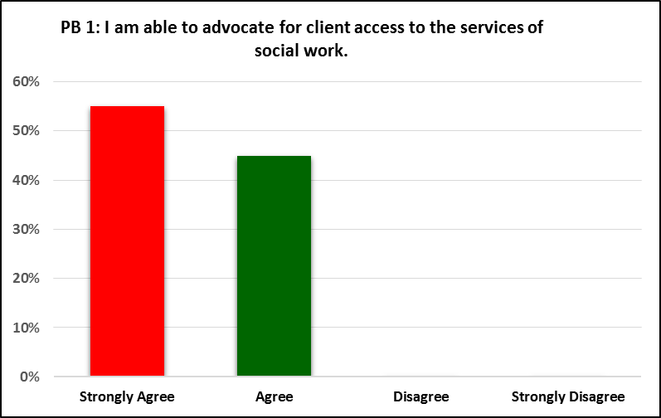

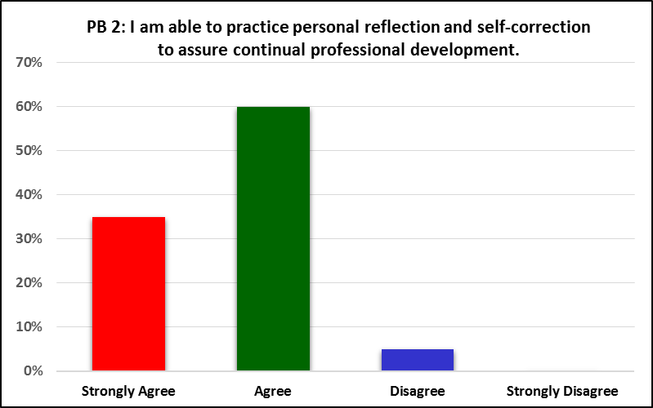

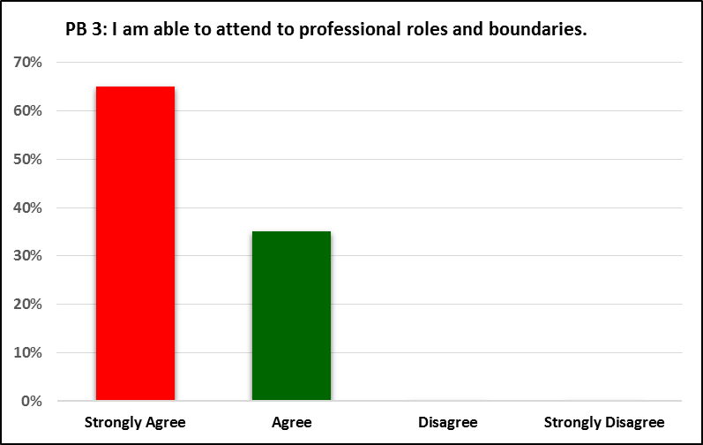

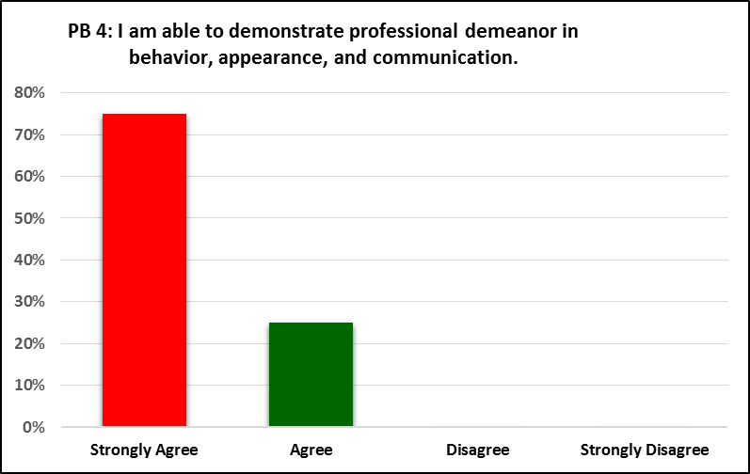

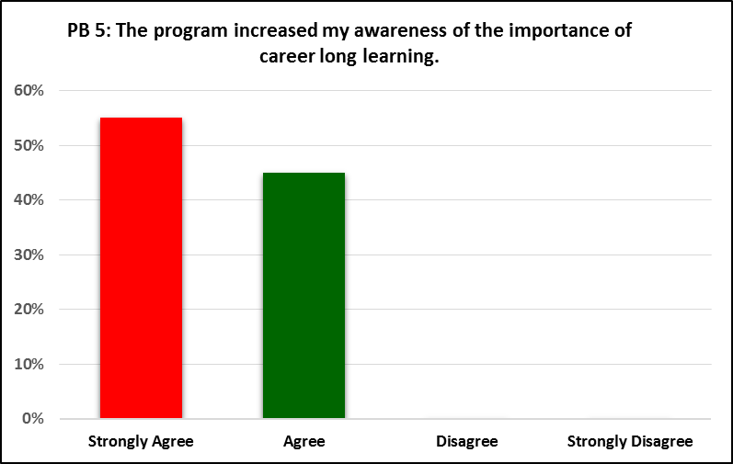

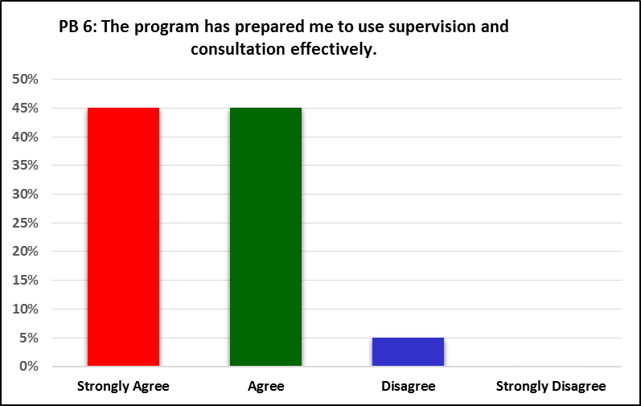

**Educational Policy 2.1.2  
Apply social work ethical principles to guide professional practice.**

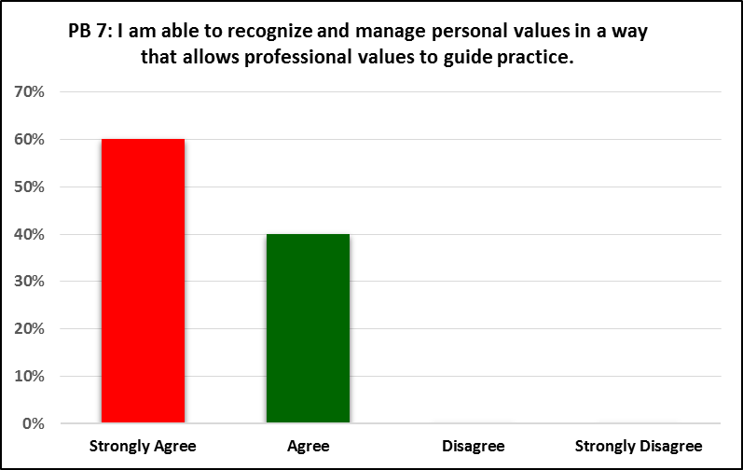

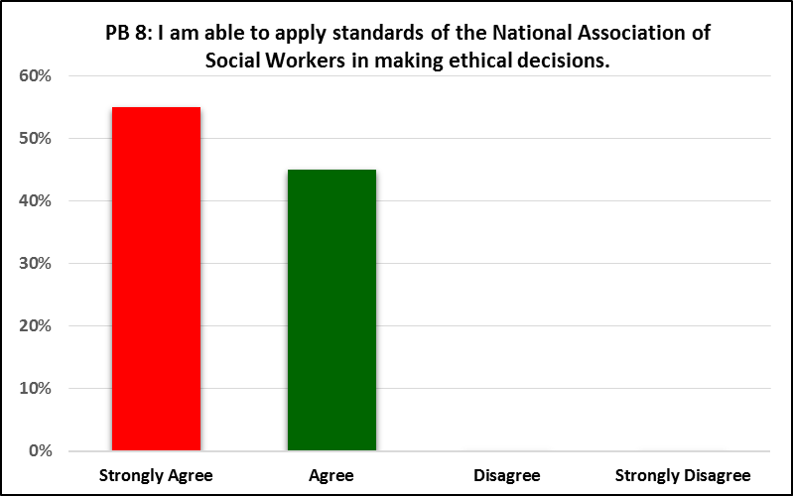

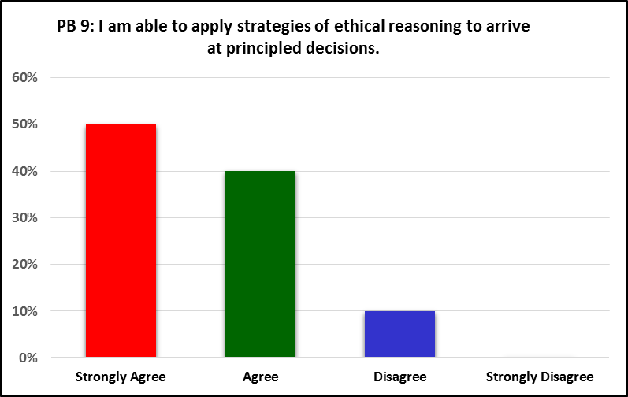

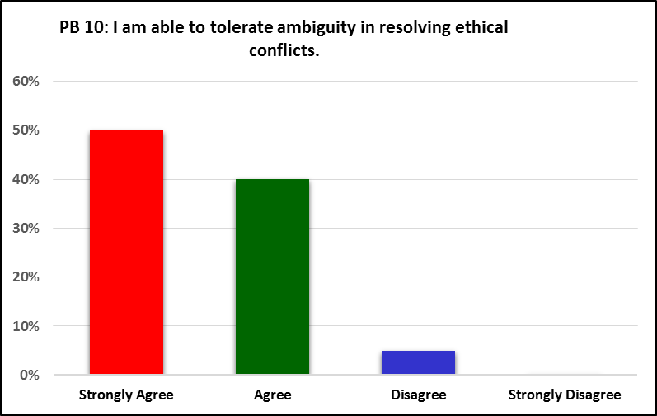

**Educational Policy 2.1.3  
Apply critical thinking to inform and communicate professional judgments.**

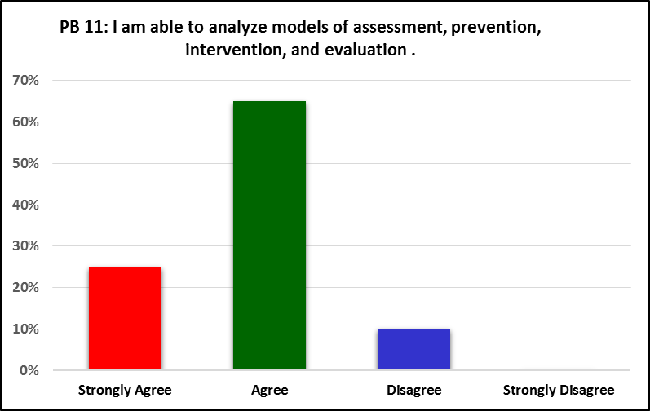

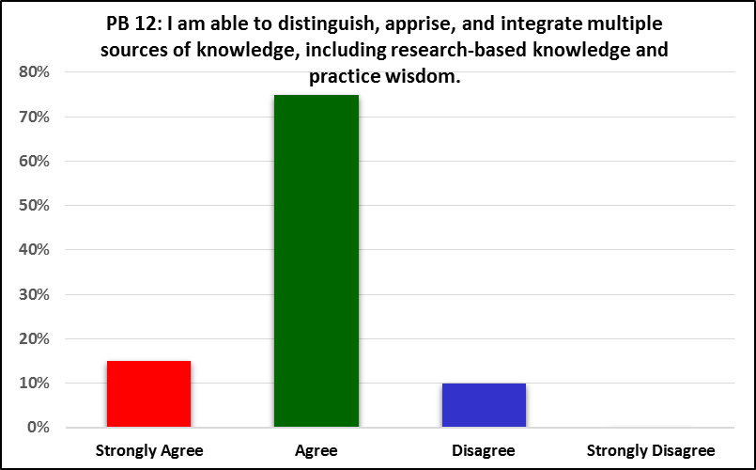

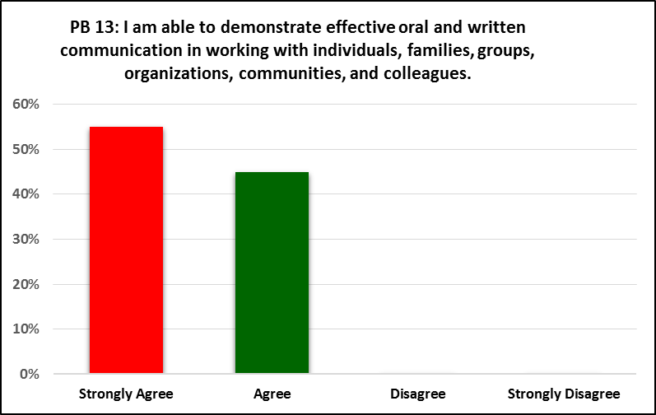

**Educational Policy 2.1.4  
Engage diversity and difference in practice.**

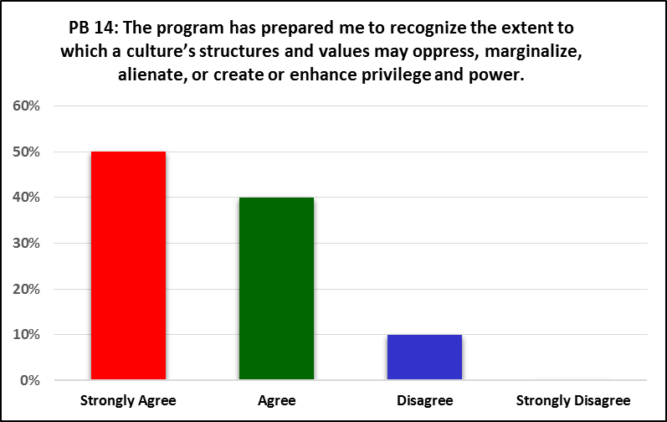

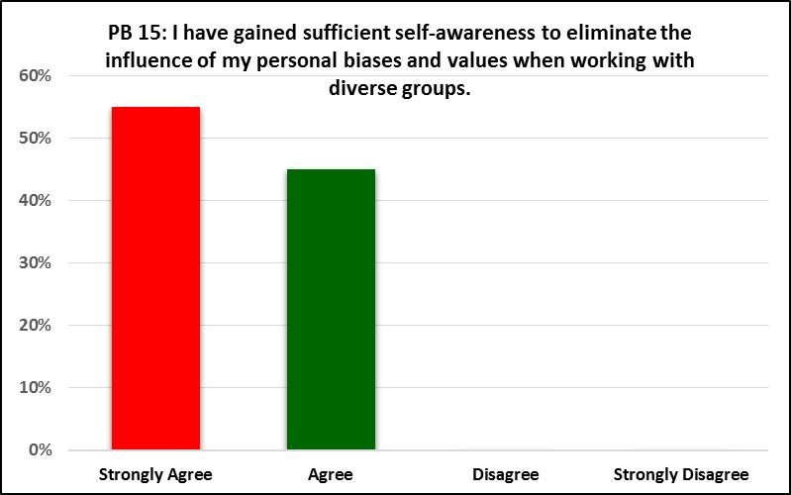

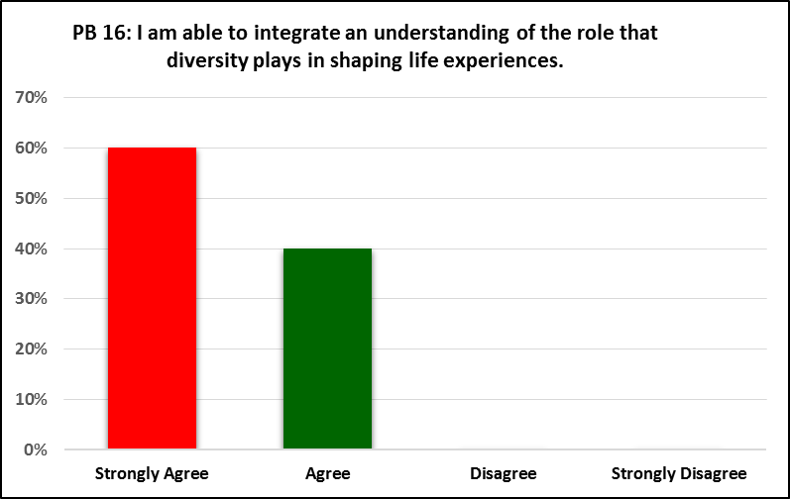

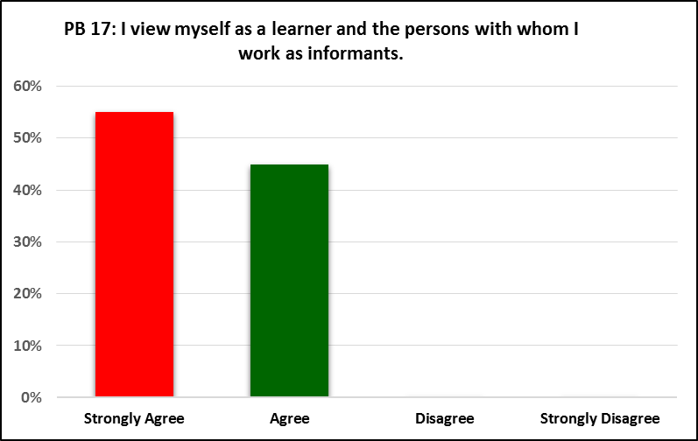

**Educational Policy 2.1.5  
Advance human rights and social and economic justice.**

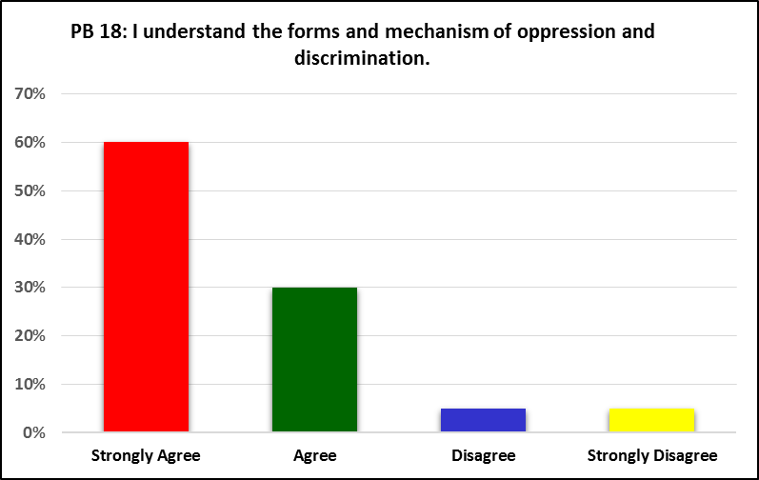

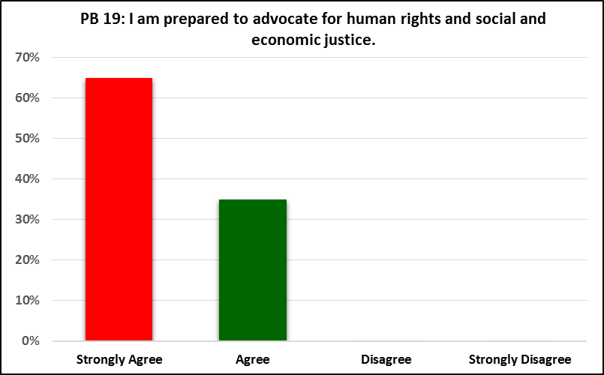

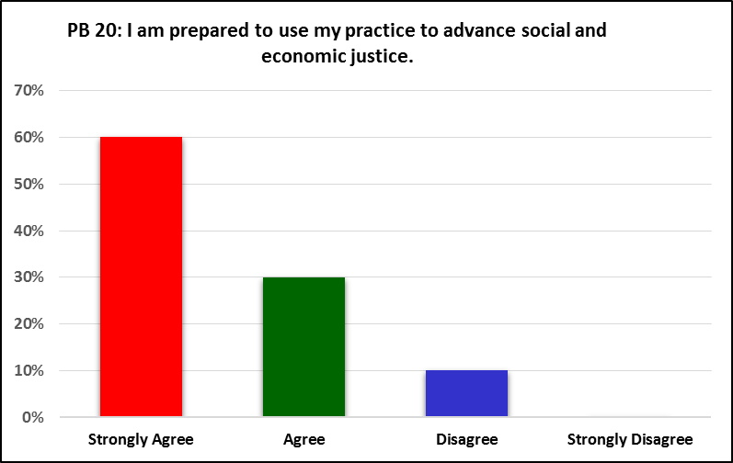

**Educational Policy 2.1.6  
Engage in research-informed practice and practice-informed research.**

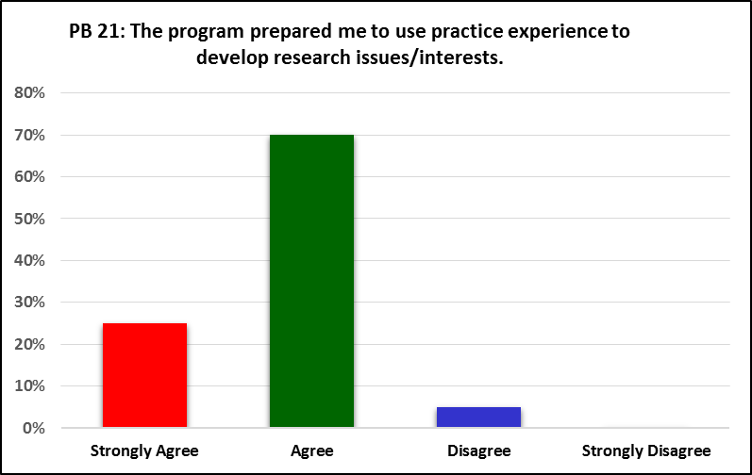

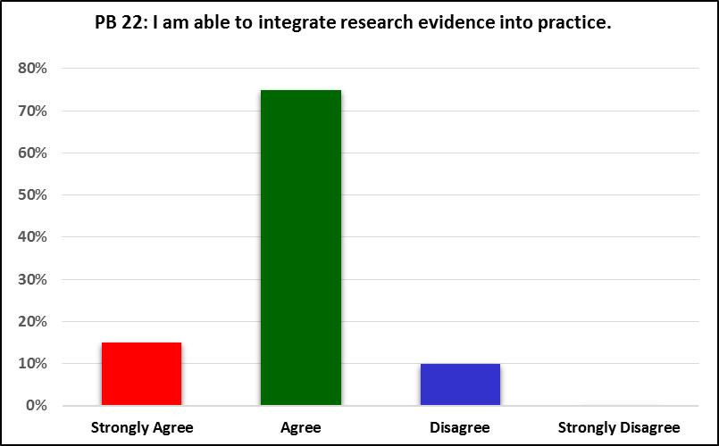

**Educational Policy 2.1.7  
Apply knowledge of human behavior and the social environment.**

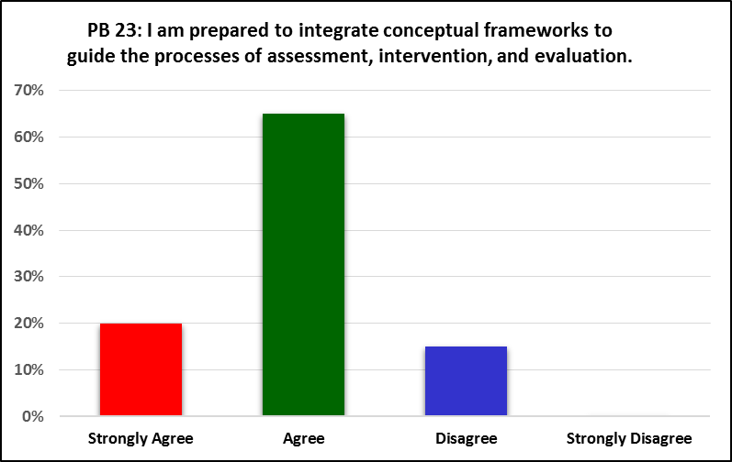

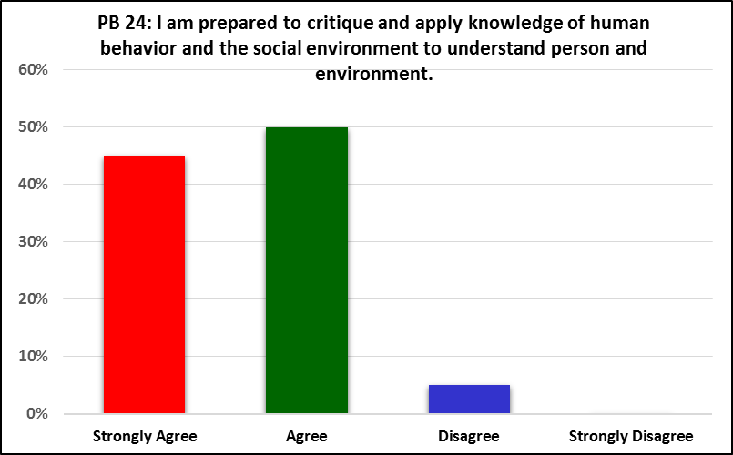

**Educational Policy 2.1.8  
Engage in policy practice to advance social and economic well-being and to deliver effective social work services.**

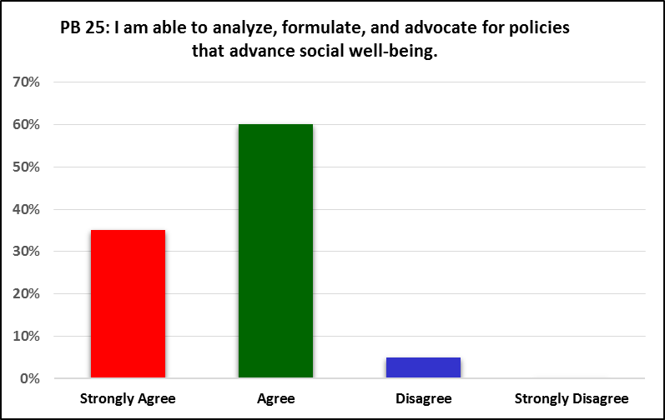

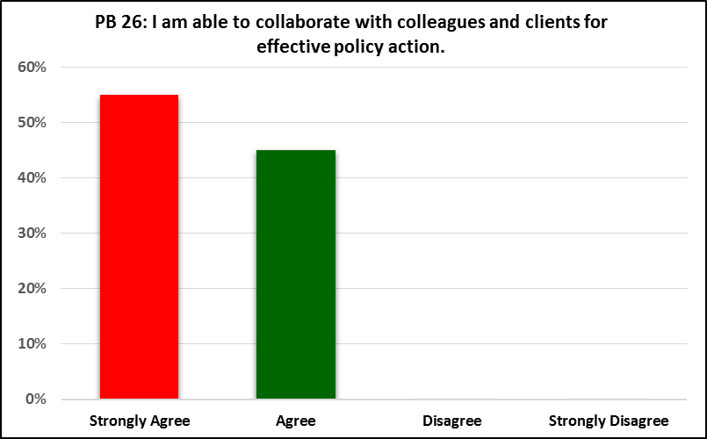

**Educational Policy 2.1.9  
Respond to contexts that shape practice.**

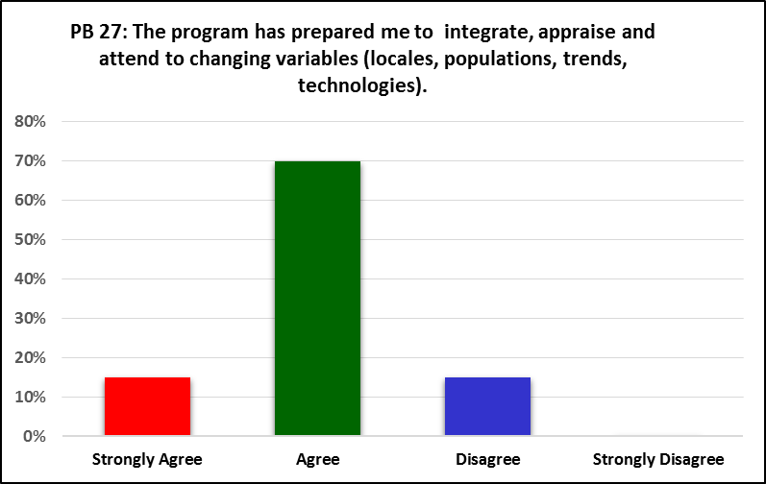

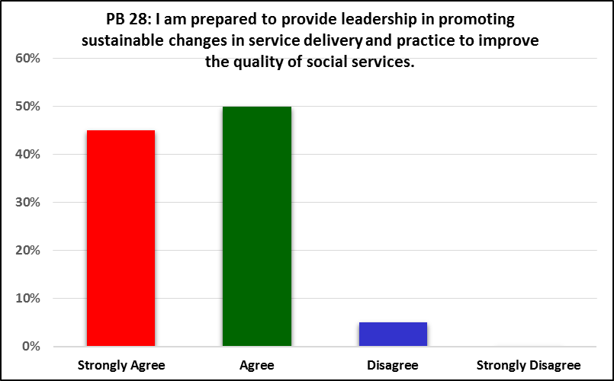

**Educational Policy 2.1.10(a)   
Engage with individuals, families, groups, organizations, and communities.**

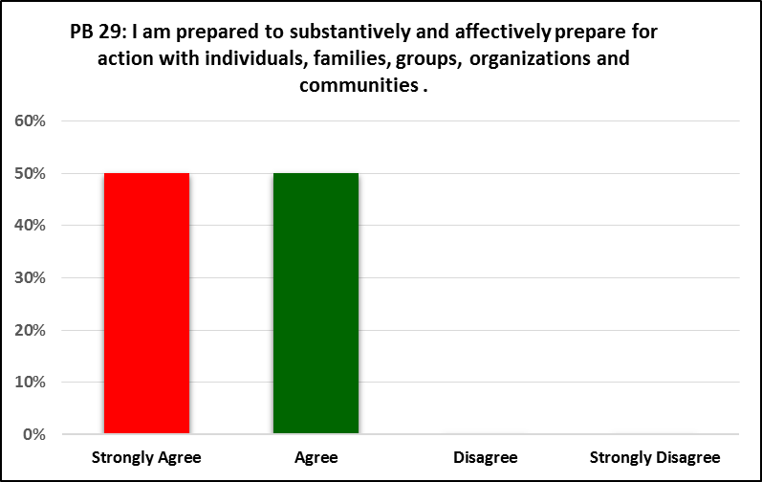

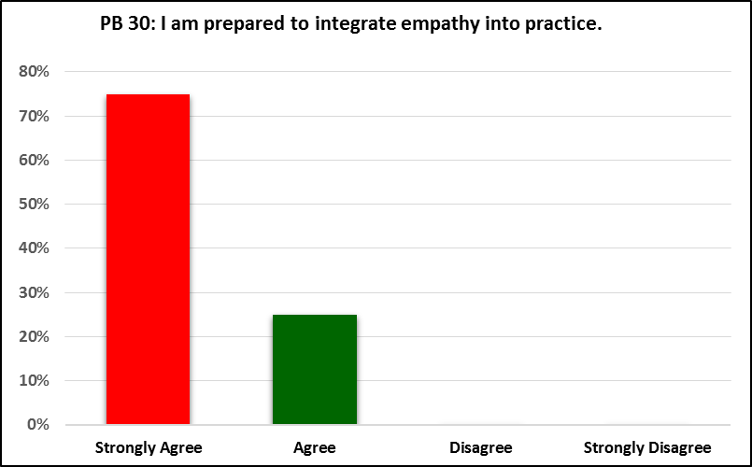

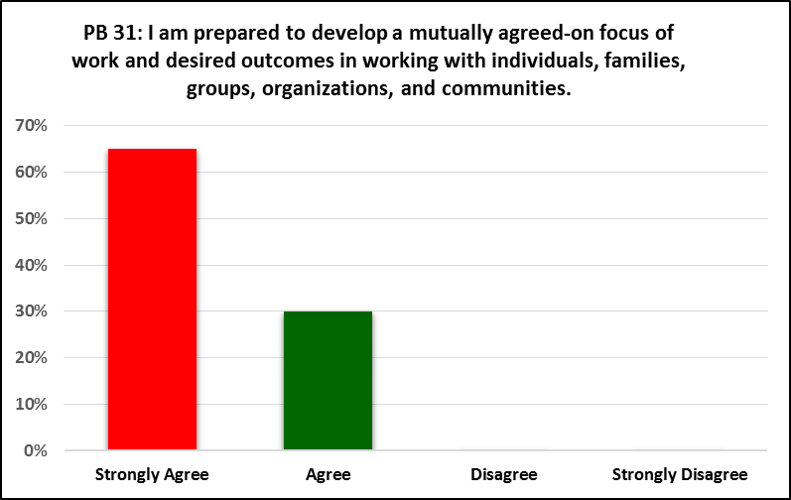

**Educational Policy 2.1.10(b)   
Assess individuals, families, groups, organizations, and communities.**

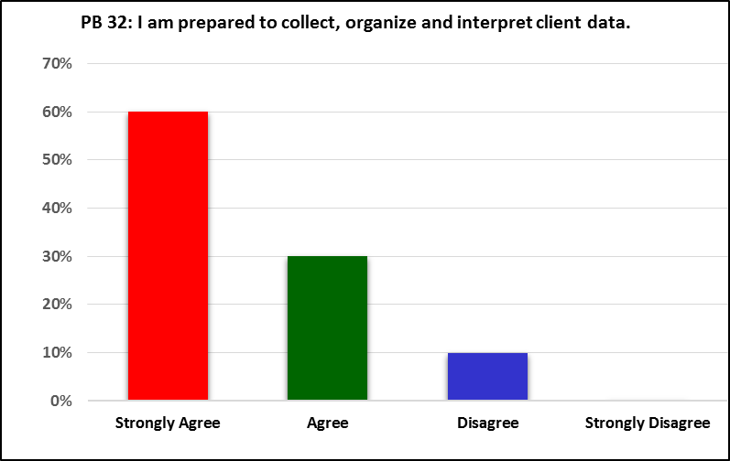

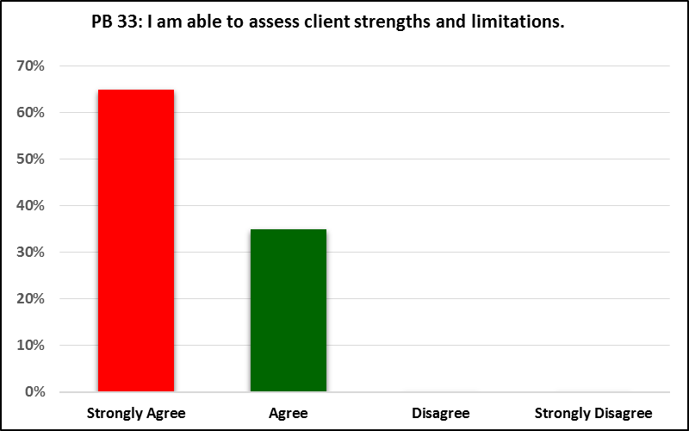

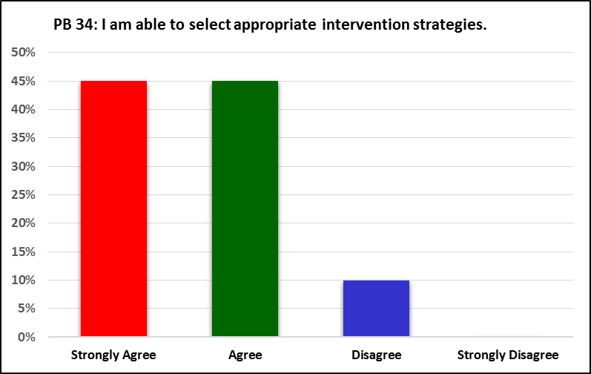

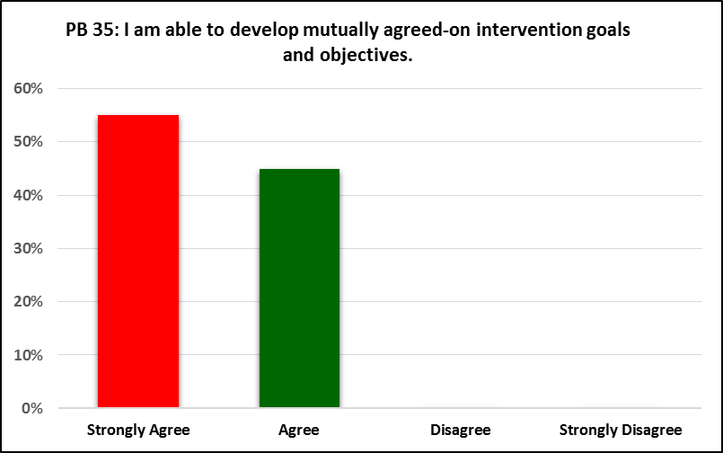

**Educational Policy 2.1.10(c)   
Intervene with individuals, families, groups, organizations, and communities.**

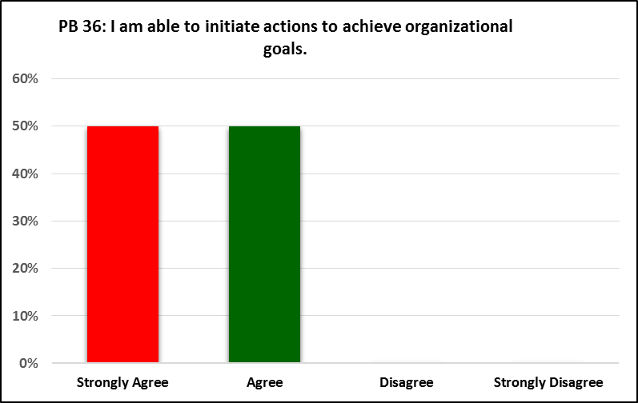

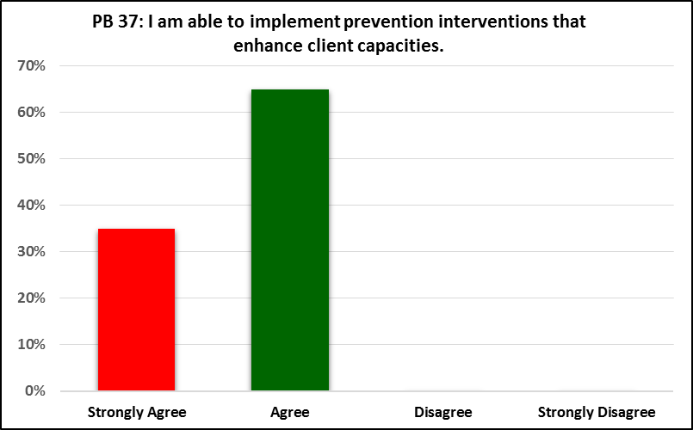

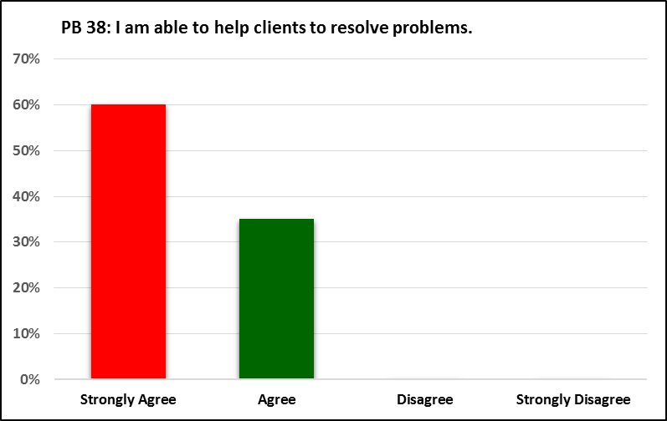

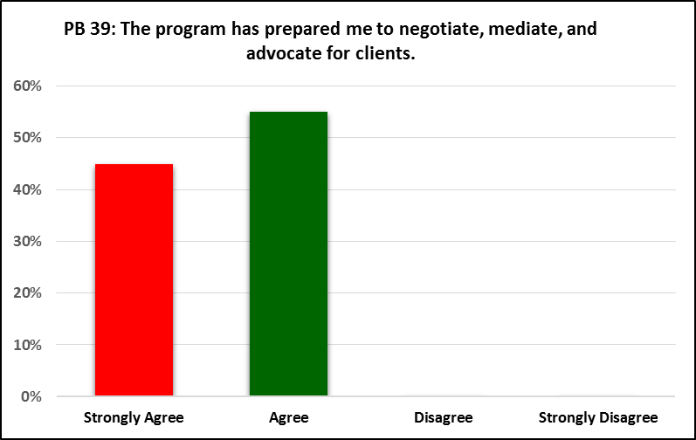

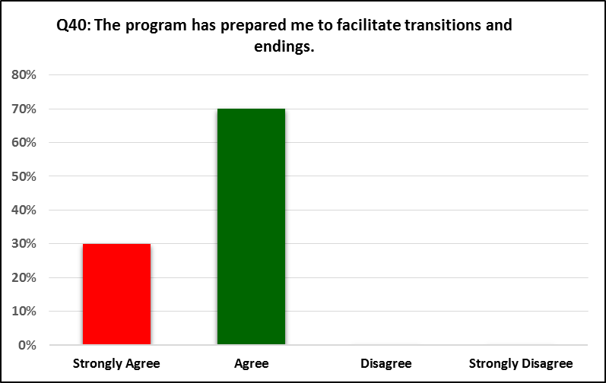

**Educational Policy 2.1.10(d)   
Evaluate individuals, families, groups, organizations, and communities.**

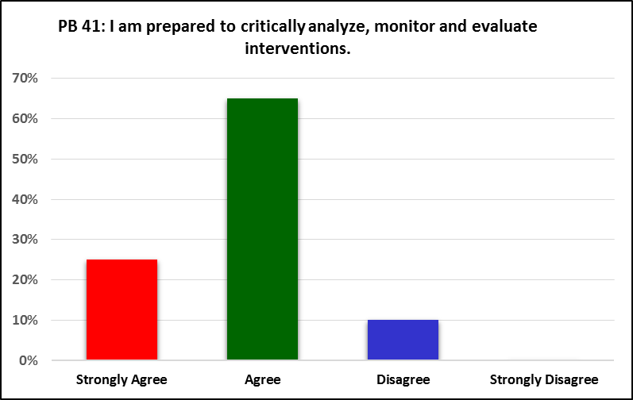

**Core Competency 11  
Utilize appropriate practice intervention within a rural setting.**

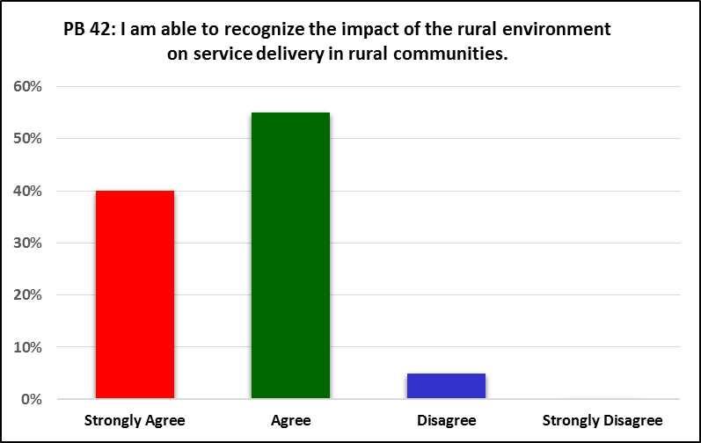

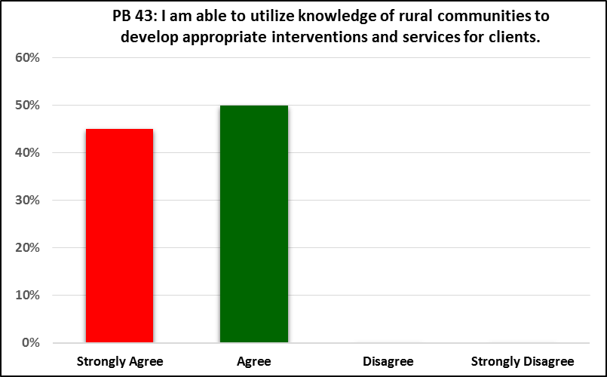

**Core Competency 12  
Demonstrate knowledge and skills in applying a bio-psychosocial-cultural-spiritual perspective in advanced social work practice with children and families.**

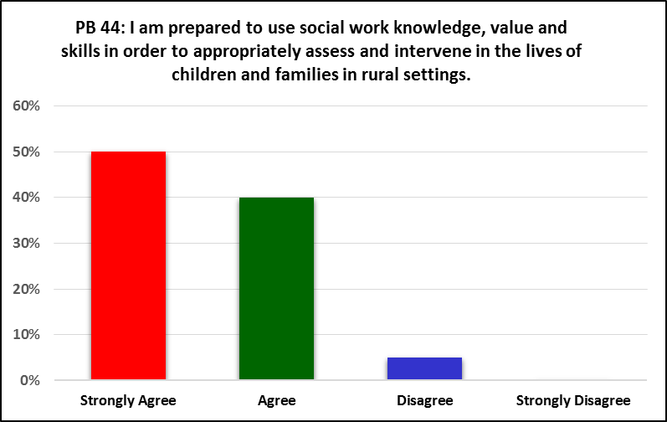

A review of the Focus Group responses shows that the benchmark was reached for each individual practice behavior.

**BELOW IS AN ADDITIONAL PRESENTATION FOR THE 2016 ASSESSMENT FINDINGS**

Department of Social Work

Baccalaureate Social Work Program Assessment Findings

2015-2016 Academic Year

|  | **Benchmark** | **Practice Behaviors** | **Measures** | **Assessment Procedures** | **Outcome Measure Benchmark** | **Assessment Procedures Competency** |
| --- | --- | --- | --- | --- | --- | --- |
| **2.1.1 –**  **Identify as a professional social worker and conduct oneself accordingly** | 80% of students will demonstrate this competency on measure 1 and 70% on measure 2 | Advocate for client access to services of social work | Measure 1: Final Field Evaluations  Three items from field evaluation form were used  Measure 2: The Senior Focus Group Sessions | Student must score a minimum of 4 out of a 5 point scale on field rating measure  A minimum of 80% of students must score a rating of at least Agree on a four point Likert Scale. | The Mean scores were 4.3, 4.31 and 4.42.  More than 80% of students agreed that they had accomplished this practice behavior | The benchmark was met for this practice behavior on both measures |
|  |  | Practice personal reflection and self-correction to assure continual professional development | Measure 1: Final Field Evaluations  Three items from field evaluation form were used  Measure 2: The Senior Focus Group Sessions | Student must score a minimum of 4 out of a 5 point field rating scale  A minimum of 80% of students must score a rating of at least Agree on a four point Likert Scale. | The mean scores on the three field items were 4.31, 4.63 and 4.73.  More than 80% of students agreed that they had accomplished this practice behavior | The benchmark was met for this practice behavior based upon the field evaluations.  The benchmark was met for this measure |
|  |  | Attend to professional roles and boundaries | Measure 1: Final Field Evaluations  Six items from field evaluation form were used  Measure 2: The Senior Focus Group Sessions | Student must score a minimum of 4 out of a 5 point field rating scale  A minimum of 80% of students must score a rating of at least Agree on a four point Likert Scale. | The mean scores on the six items were 4.73, 4.68, 4.63, 4.73, 4.63 and 4.42.  More than 80% of students agreed that they had accomplished this practice behavior | The benchmark was met for this practice behavior based upon the field evaluations.  The benchmark was met for this measure |
|  |  | Demonstrates professional demeanor in behavior, appearance and communication. | Measure 1: Final Field Evaluations  Four Items from field evaluation form were used  Measure 2: The Senior Comprehensive Examination | Student must score a minimum of 4 out of a 5 point field rating scale  A minimum of 80% of students must score a rating of at least Agree on a four point Likert Scale. | The mean scores on the four items were 4.73, 4.63, 4.47 and 4.63.  More than 80% of students agreed that they had accomplished this practice behavior | The benchmark was met for this practice behavior based upon the field evaluations.  The benchmark was met for this measure |
|  |  | Engage in Career Long Learning  Use supervision and consultation | Measure 1: Final Field Evaluations  Two- Items from field evaluation form were used  Measure 2: The Senior Focus Group Sessions  Measure 1: Final Field Evaluations  Three Items from field evaluation form were used  Measure 2: The Senior Focus Group Sessions | Student must score a minimum of 4 out of a 5 point field rating scale  A minimum of 80% of students must score a rating of at least Agree on a four point Likert Scale.  Student must score a minimum of 4 out of a 5 point field rating scale  A minimum of 80% of students must score a rating of at least Agree on a four point Likert Scale. | The mean scored on the two field items were 4.63 and 4.73.  More than 80% of students agreed that they had accomplished this practice behavior  The mean scores on the three field items were 4.5, 4.8 and 4.6.  More than 80% of students agreed that they had accomplished this practice behavior | The benchmark was met for this practice behavior based upon the field evaluations.  The benchmark was met for this measure  The benchmark was met for this practice behavior based upon the field evaluations.  The benchmark was met for this measure |
| **2.1.2 Apply Social Work Ethical Principles to Guide Professional Practice** | 80% of students will demonstrate this competency on measure 1 and 70% on measure 2 | Recognizes and manages personal values in a way that allows professional values to guide practice | Measure 1: Final Field Evaluations  Five Items from field evaluation form were used  Measure 2: The Senior Focus Group Sessions | Student must score a minimum of 4 out of a 5 point field rating scale  A minimum of 80% of students must score a rating of at least Agree on a four point Likert Scale. | The mean scores for the five field items were 4.5, 4.5, 4.42, 4.57 and 4.52.  More than 80% of students agreed that they had accomplished this practice behavior | The benchmark was met for this practice behavior based upon the field evaluations.  The benchmark was met for this measure |
|  |  | Makes ethical decisions by applying standards of the National Association of Social Workers and as applicable of the International Federation of Social Workers/International Association of Schools of Social Work Ethics in Social Work statement in Principle | Measure 1: Final Field Evaluations  One items from field evaluation form was used  Measure 2: The Senior Focus Group Sessions | Student must score a minimum of 4 out of a 5 point field rating scale  A minimum of 80% of students must score a rating of at least Agree on a four point Likert Scale. | The Mean score was 4.52. The benchmark was met for this measure  More than 80% of students agreed that they had accomplished this practice behavior | The benchmark was met for this practice behavior based upon the field evaluations.  The benchmark was met for this measure |
|  |  | Tolerates ambiguity in resolving ethical conflicts | Measure 1: Final Field Evaluations  One items from field evaluation form was used  Measure 2: The Senior Focus Group | Student must score a minimum of 4 out of a 5 point field rating scale  A minimum of 80% of students must score a rating of at least Agree on a four point Likert Scale. | The Mean score was 4.7. The benchmark was met for this measure  More than 80% of students agreed that they had accomplished this practice behavior | The benchmark was met for this practice behavior based upon the field evaluations.  The benchmark was met for this measure |
|  |  | Applies strategies of ethical reasoning to arrive at principled decisions | Measure 1: Final Field Evaluations  One items from field evaluation form was used  Measure 2: The Senior Focus Group Sessions | Student must score a minimum of 4 out of a 5 point field rating scale  A minimum of 80% of students must score a rating of at least Agree on a four point Likert Scale. | The Mean score was 4.42. The benchmark was met for this measure  More than 80% of students agreed that they had accomplished this practice behavior | The benchmark was met for this practice behavior based upon the field evaluations.  The benchmark was met for this measure |
| **2.1.3 Apply Critical Thinking to Inform and Communicate Professional Judgment** | 80% of students will demonstrate this competency on measure 1 and 70% on measure 2 | Distinguish, appraise and integrate multiple sources of knowledge, including research based knowledge and practice wisdom | Measure 1: Final Field Evaluations  Four items from field evaluation form were used  Measure 2: The Senior Focus Group | Student must score a minimum of 4 out of a 5 point field rating scale  A minimum of 80% of students must score a rating of at least Agree on a four point Likert Scale. | The mean score for the four items were 4.36, 4.4, 4.0 and 4.1.  More than 80% of students agreed that they had accomplished this practice behavior | The benchmark was met for this practice behavior based upon the field evaluations.  The benchmark was met for this measure |
|  |  | Analyze models of assessment, prevention, intervention and evaluation | Measure 1: Final Field Evaluations  Four items from field evaluation form were used  Measure 2: The Senior Focus Group Sessions | Student must score a minimum of 4 out of a 5 point field rating scale  A minimum of 80% of students must score a rating of at least Agree on a four point Likert Scale. | The mean scores were 4.36, 4.26, 4.5 and 4.42.  More than 80% of students agreed that they had accomplished this practice behavior | The benchmark was met for this practice behavior based upon the field evaluations.  The benchmark was met for this measure |
|  |  | Demonstrate effective oral and written communication in working with individuals, families, groups, organizations, communities and colleagues | Measure 1: Final Field Evaluations  Three items from field evaluation form were used  Measure 2: The Senior Focus Group Sessions | Student must score a minimum of 4 out of a 5 point field rating scale  A minimum of 80% of students must score a rating of at least Agree on a four point Likert Scale. | The mean scores were 4.63, 4.57 and 4.47.  More than 80% of students agreed that they had accomplished this practice behavior | The benchmark was met for this practice behavior based upon the field evaluations.  The benchmark was met for this measure |
| **2.1.4 Engage Diversity and Difference in Practice** | 80% of students will demonstrate this competency on measure 1 and 70% on measure 2 | Recognize the extent to which a culture’s structures and values may oppress, marginalize, alienate or create or enhance privilege and power | Measure 1: Final Field Evaluations  Four items from field evaluation form were used  Measure 2: The Senior Focus Group Sessions | Student must score a minimum of 4 out of a 5 point field rating scale  A minimum of 80% of students must score a rating of at least Agree on a four point Likert Scale. | The mean scores on the designated field items were 4.2 4.0, 4.36, and 4.4  More than 80% of students agreed that they had accomplished this practice behavior | The benchmark was met for this practice behavior based upon the field evaluations.  The benchmark was met for this measure |
|  |  | Gain sufficient self-awareness to eliminate the influences of personal biases and values in working with diverse groups | Measure 1: Final Field Evaluations  Two items from field evaluation form were used  Measure 2: The Senior Focus Group Sessions | Student must score a minimum of 4 out of a 5 point field rating scale  A minimum of 80% of students must score a rating of at least Agree on a four point Likert Scale. | The mean scores on the designated field items were 4.42, and 4.6  More than 80% of students agreed that they had accomplished this practice behavior | The benchmark was met for this practice behavior based upon the field evaluations.  The benchmark was met for this measure |
|  |  | Recognize and communicate their understanding of the importance of the difference in shaping life experiences | Measure 1: Final Field Evaluations  Three items from field evaluation form were used  Measure 2: The Senior Focus Group Sessions | Student must score a minimum of 4 out of a 5 point field rating scale  A minimum of 80% of students must score a rating of at least Agree on a four point Likert Scale. | The mean scores on the designated field items were 4.36, 4.4 and 4.0  More than 80% of students agreed that they had accomplished this practice behavior | The benchmark was met for this practice behavior based upon the field evaluations.  The benchmark was met for this measure |
|  |  | View themselves as learners and engage those with whom they work as informants | Measure 1: Final Field Evaluations  Two items from field evaluation form were used  Measure 2: The Senior Focus Group Sessions | Student must score a minimum of 4 out of a 5 point field rating scale  A minimum of 80% of students must score a rating of at least Agree on a four point Likert Scale. | The mean scores on the designated field items were 4.1, and 4.57  More than 80% of students agreed that they had accomplished this practice behavior | The benchmark was met for this practice behavior based upon the field evaluations.  The benchmark was met for this measure |
| **2.1.5 Advance Human Rights and Social and Economic Justice** | 80% of students will demonstrate this competency on measure 1 and 70% on measure 2 | Understand the forms and mechanisms of oppression and discrimination | Measure 1: Final Field Evaluations  Three items from field evaluation form were used  Measure 2: The Senior Focus Group Sessions | Student must score a minimum of 4 out of a 5 point field rating scale  A minimum of 80% of students must score a rating of at least Agree on a four point Likert Scale. | The mean scores on the designated field items were 4.42, 4.36 and 4.52  More than 80% of students agreed that they had accomplished this practice behavior | The benchmark was met for this practice behavior based upon the field evaluations.  The benchmark was met for this measure |
|  |  | Advocate for human rights and social and economic justice | Measure 1: Final Field Evaluations  Three items from field evaluation form were used  Measure 2: The Senior Focus Group Sessions | Student must score a minimum of 4 out of a 5 point field rating scale  A minimum of 80% of students must score a rating of at least Agree on a four point Likert Scale. | The mean scores on the designated field items were 4.42, 4.36 and 4.52  More than 80% of students agreed that they had accomplished this practice behavior | The benchmark was met for this practice behavior based upon the field evaluations.  The benchmark was met for this measure |
|  |  | Engage in practices that advance social and economic justice | Measure 1: Final Field Evaluations  Four items from field evaluation form were used  Measure 2: The Senior Focus Group Sessions | Student must score a minimum of 4 out of a 5 point field rating scale  A minimum of 80% of students must score a rating of at least Agree on a four point Likert Scale. | The mean scores on the designated field items were 4.36, 4.52, 4.31 and 4.47.  More than 80% of students agreed that they had accomplished this practice behavior | The benchmark was met for this practice behavior based upon the field evaluations.  The benchmark was met for this measure |
| **2.1.6. Engage in Research Informed Practice and Practice Informed Research** | 80% of students will demonstrate this competency on both measures 1 and 2 | Use Practice Experience to Inform Scientific Inquiry | Measure 1: Assignment to complete Research Proposal in SW409, Research for Social Workers;  Measure 2: Final Field Evaluation Forms  Two items from field evaluation form measure this outcome | Student must make to minimum score of 80% on completion of this measure to meet benchmark  Student must score a minimum of 4 out of a 5 point field rating scale | The average student score on the research proposal was 70%.  The mean scores on the designated field items were 4.1 and 4.27. | The Benchmark was not met on this measure  The benchmark was met for this practice behavior based upon the field evaluations. |
|  |  | Use Research Evidence to inform Practice | Measure 1: Assignment to complete Research Proposal in SW409, Research for Social Workers;  Measure 2: Final Field Evaluation Forms  Two items from field evaluation form measure this outcome | Student must make to minimum score of 80% on completion of this measure to meet benchmark  Student must score a minimum of 4 out of a 5 point field rating scale | The average student score on the research proposal was 70%.  The mean scores on the designated field items were 4.1 and 4.27. | The Benchmark was not met on this measure  The benchmark was met for this practice behavior based upon the field evaluations. |
| **2.1.7 Apply Knowledge of Human Behavior and Social Environment** | 80% of students will demonstrate this competency on both measures 1 and 2 | Utilize conceptual frameworks to guide the process of assessment, intervention and evaluation  Critique and apply knowledge to understand person in the environment | Measure 1: Final Field Evaluation Forms  Two Items on Field Evaluation Form were used to measure outcomes on this behavior  Measure 2: Focus group interview for Graduating Seniors  Measure 1: Final Field Evaluation Forms  Three Items on Field Evaluation Form were used to measure outcomes on this behavior  Measure 2: Focus group interview for Graduating Seniors | Student must score a minimum mean score of 4 out of 5 possible points to successfully complete this benchmark.  A minimum of 80% of students must score a rating of at least Agree on a four point Likert Scale.  Student must score a minimum mean score of 4 out of 5 possible points to successfully complete this benchmark.  A minimum of 80% of students must score a rating of at least Agree on a four point Likert Scale. | The scores on the designated field items were 4.4 and 4.0  More than 80% of students agreed that they had accomplished this practice behavior  The scores on the designated field items were 4.42, 4.42 and 4.60  More than 80% of students agreed that they had accomplished this practice behavior | The Benchmark was met on both measures for this practice behavior  The Benchmark was met on both measures for this practice behavior |
| **2.1.8 Engage in Policy Practice to Advance Social and Economic Well-Being and to Deliver Effective Social Work Services** | 80% of students will demonstrate this competency on both measures 1 and 2 | Understand relationships of social policies to social work practice in field agency  Collaborate with colleagues and clients for effective policy action | Measure 1: Final Field Evaluation Forms  Three Items on Field Evaluation Form were used to measure outcomes on this behavior  Measure 2: Focus group interview for Graduating Seniors  Measure 1: Final Field Evaluation Forms  Three Items on Field Evaluation Form were used to measure outcomes on this behavior  Measure 2: Focus group interview for Graduating Seniors | Student must score a minimum mean score of 4 out of 5 possible points to successfully complete this benchmark.  A minimum of 80% of students must score a rating of at least Agree on a four point Likert Scale.  Student must score a minimum mean score of 4 out of 5 possible points to successfully complete this benchmark.  A minimum of 80% of students must score a rating of at least Agree on a four point Likert Scale. | The mean scores for the field instrument items that measure this practice behavior are: 4.3, 4.3 and 4.4  More than 80% of students answered agree on the four point Likert Scale response set  The mean scores for the field instrument items that measure this practice behavior are: 4.3, 4.3 and 4.4  More than 80% of students answered at least Agree on the four point Likert Scale response set | The Benchmark was met on both measures for this practice behavior  The Benchmark was met on both measures for this practice behavior |
| **2.1.9 Respond to Contexts that Shape Practice** | 80% of students will demonstrate this competency on both measures 1 and 2 | Continuously discover, appraise and attend to changing locales, scientific and technological development, and emerging societal trends to provide relevant services  Provide leadership in promoting sustainable changes in service delivery and practice to improve the quality of social services | Measure 1: Final Field Evaluation Forms  Four Items on Field Evaluation Form were used to measure outcomes on this behavior  Measure 2: Focus group interview for Graduating Seniors  Measure 1: Final Field Evaluation Forms  One item on Field Evaluation Form was used to measure outcomes on this behavior  Measure 2: Focus group interview for Graduating Seniors | Student must score a minimum mean score of 4 out of 5 possible points to successfully complete this benchmark.  A minimum of 80% of students must score a rating of at least Agree on a four point Likert Scale.  Student must score a minimum mean score of 4 out of 5 possible points to successfully complete this benchmark.  A minimum of 80% of students must score a rating of at least Agree on a four point Likert Scale. | The mean scores for the field instrument items that measure this practice behavior are: 4.38, 4.36, 4.1 and 4.1  More than 80% of students answered at least Agree on the four point Likert Scale response set  The Mean Score for the one item used on the field evaluation instrument to measure this practice behavior was 4.1  More than 80% of students answered at least Agree on the four point Likert Scale response set | The Benchmark was met on both measures for this practice behavior  The Benchmark was met on both measures for this practice behavior |
| **2.1.10 Engage, Assess, Intervene with Individuals, Families, Groups, Organizations and Communities**  **Program’s Rural Competencies** | 80% of students will demonstrate this competency on both measures 1 and 2  80% of students will demonstrate this competency on both measures 1 and 2 | Substantively and affectively prepare for action with individual, groups, families, organizations and communities  Uses empathy and other interpersonal skills  Develop a mutually agreed on focus of work and desired outcomes  Collect, Organize and Interpret Data  Assess client strengths and limitations  Develop mutually agreed on goals and objectives  Select appropriate intervention strategies  Initiate actions to achieve organizational goals  Implement Prevention Interventions that enhance client capabilities  Help clients resolve problems  Negotiate, mediate and advocate for clients  Facilitate transitions and endings  Social workers critically analyze, monitor and evaluate interventions  Utilize knowledge of rural communities to develop appropriate interventions and services for clients:  Use Knowledge, values and skills of social work practice to perform generalist practice in rural areas: | Measure 1: Final Field Evaluation Forms  One item on Field Evaluation Form was used to measure outcomes on this behavior  Measure 2: Focus group interview for Graduating Seniors  Measure 1: Final Field Evaluation Forms  One item on Field Evaluation Form was used to measure outcomes on this behavior  Measure 2: Focus group interview for Graduating Seniors  Measure 1: Final Field Evaluation Forms  One item on Field Evaluation Form was used to measure outcomes on this behavior  Measure 2: Focus group interview for Graduating Seniors  Measure 1: Final Field Evaluation Forms  Three items on Field Evaluation Form were used to measure outcomes on this behavior  Measure 2: Focus group interview for Graduating Seniors  Measure 1: Final Field Evaluation Forms  Two items on Field Evaluation Form were used to measure outcomes on this behavior  Measure 2: Focus group interview for Graduating Seniors  Measure 1: Final Field Evaluation Forms  Two items on Field Evaluation Form were used to measure outcomes on this behavior  Measure 2: Focus group interview for Graduating Seniors  Measure 1: Final Field Evaluation Forms  Two items on Field Evaluation Form were used to measure outcomes on this behavior  Measure 2: Focus group interview for Graduating Seniors  Measure 1: Final Field Evaluation Forms  Two items on Field Evaluation Form were used to measure outcomes on this behavior  Measure 2: Focus group interview for Graduating Seniors  Measure 1: Final Field Evaluation Forms  Three items on Field Evaluation Form were used to measure outcomes on this behavior  Measure 2: Focus group interview for Graduating Seniors  Measure 1: Final Field Evaluation Forms  Three items on Field Evaluation Form were used to measure outcomes on this behavior  Measure 2: Focus group interview for Graduating Seniors  Measure 1: Final Field Evaluation Forms  Four items on Field Evaluation Form were used to measure outcomes on this behavior  Measure 2: Focus group interview for Graduating Seniors  Measure 1: Final Field Evaluation Forms  Three items on Field Evaluation Form were used to measure outcomes on this behavior  Measure 2: Focus group interview for Graduating Seniors  Measure 1: Final Field Evaluation Forms  Three items on Field Evaluation Form were used to measure outcomes on this behavior  Measure 2: Focus group interview for Graduating Seniors  Measure 1: Final Field Evaluation Forms  Four items on Field Evaluation Form were used to measure outcomes on this behavior  Measure 2: Community Profile  Measure 1: Final Field Evaluation Forms  Four items on Field Evaluation Form were used to measure outcomes on this behavior  Measure 2: Community Profile | Student must score a minimum mean score of 4 out of 5 possible points to successfully complete this benchmark.  A minimum of 80% of students must score a rating of at least Agree on a four point Likert Scale.  Student must score a minimum mean score of 4 out of 5 possible points to successfully complete this benchmark.  A minimum of 80% of students must score a rating of at least Agree on a four point Likert Scale.  Student must score a minimum mean score of 4 out of 5 possible points to successfully complete this benchmark.  A minimum of 80% of students must score a rating of at least Agree on a four point Likert Scale.  Student must score a minimum mean score of 4 out of 5 possible points to successfully complete this benchmark.  A minimum of 80% of students must score a rating of at least Agree on a four point Likert Scale.  Student must score a minimum mean score of 4 out of 5 possible points to successfully complete this benchmark.  A minimum of 80% of students must score a rating of at least Agree on a four point Likert Scale.  Student must score a minimum mean score of 4 out of 5 possible points to successfully complete this benchmark.  A minimum of 80% of students must score a rating of at least Agree on a four point Likert Scale.  Student must score a minimum mean score of 4 out of 5 possible points to successfully complete this benchmark.  A minimum of 80% of students must score a rating of at least Agree on a four point Likert Scale.  Student must score a minimum mean score of 4 out of 5 possible points to successfully complete this benchmark.  A minimum of 80% of students must score a rating of at least Agree on a four point Likert Scale.  Student must score a minimum mean score of 4 out of 5 possible points to successfully complete this benchmark.  A minimum of 80% of students must score a rating of at least Agree on a four point Likert Scale.  Student must score a minimum mean score of 4 out of 5 possible points to successfully complete this benchmark.  A minimum of 80% of students must score a rating of at least Agree on a four point Likert Scale.  Student must score a minimum mean score of 4 out of 5 possible points to successfully complete this benchmark.  A minimum of 80% of students must score a rating of at least Agree on a four point Likert Scale.  Student must score a minimum mean score of 4 out of 5 possible points to successfully complete this benchmark.  A minimum of 80% of students must score a rating of at least Agree on a four point Likert Scale.  Student must score a minimum mean score of 4 out of 5 possible points to successfully complete this benchmark.  A minimum of 80% of students must score a rating of at least Agree on a four point Likert Scale.  Student must score a minimum mean score of 4 out of 5 possible points to successfully complete this benchmark.  The overall mean score on the community profile rubric must be at least 4.0.  Student must score a minimum mean score of 4 out of 5 possible points to successfully complete this benchmark.  The overall mean score on the community profile rubric must be at least 4.0. | The Mean Score for the one item used on the field evaluation instrument to measure this practice behavior was 4.73  More than 80% of students answered at least Agree on the four point Likert Scale response set  The Mean Score for the one item used on the field evaluation instrument to measure this practice behavior was 4.57  More than 80% of students answered at least Agree on the four point Likert Scale response set  The Mean Score for the one item used on the field evaluation instrument to measure this practice behavior was 4.57  More than 80% of students answered at least Agree on the four point Likert Scale response set  The Mean Score for the items used on the field evaluation instrument to measure this practice behavior were 4.5 and 4.0  More than 80% of students answered at least Agree on the four point Likert Scale response set  The Mean Score for the items used on the field evaluation instrument to measure this practice behavior were 4.5 and 4.0  More than 80% of students answered at least Agree on the four point Likert Scale response set  The Mean Score for the items used on the field evaluation instrument to measure this practice behavior were 4.4 and 4.3  More than 80% of students answered at least Agree on the four point Likert Scale response set  The Mean Score for the items used on the field evaluation instrument to measure this practice behavior were 4.4 and 4.3  More than 80% of students answered at least Agree on the four point Likert Scale response set  The Mean Scores for the items used on the field evaluation instrument to measure this practice behavior were 4.3 and 4.1  More than 80% of students answered at least Agree on the four point Likert Scale response set  The Mean Scores for the items used on the field evaluation instrument to measure this practice behavior were 4.5. 4.4. and 4.4  More than 80% of students answered at least Agree on the four point Likert Scale response set  The Mean Scores for the items used on the field evaluation instrument to measure this practice behavior were 4.4. 4.42. and 4.52  More than 80% of students answered at least Agree on the four point Likert Scale response set  The Mean Scores for the items used on the field evaluation instrument to measure this practice behavior were 4.52, 4.4. 4.26. and 4.52  More than 80% of students answered at least Agree on the four point Likert Scale response set  The Mean Scores for the items used on the field evaluation instrument to measure this practice behavior were 4.2, 4.0. and 4.0  More than 80% of students answered at least Agree on the four point Likert Scale response set  The Mean Scores for the items used on the field evaluation instrument to measure this practice behavior were 4.2, 4.0. and 4.0  More than 80% of students answered at least Agree on the four point Likert Scale response set  The mean scores for the four field instrument items are 4.38, 4.36, 4.1 and 4.1.  The mean score on the rubric was 3.2.  The mean scores for the four field instrument items are 4.38, 4.36, 4.1 and 4.1.  The mean score on the rubric was slightly below 4.0 | The Benchmark was met on both measures for this practice behavior  The Benchmark was met on both measures for this practice behavior  The Benchmark was met on both measures for this practice behavior  The Benchmark was met on both measures for this practice behavior  The Benchmark was met on both measures for this practice behavior  The Benchmark was met on both measures for this practice behavior  The Benchmark was met on both measures for this practice behavior  The Benchmark was met on both measures for this practice behavior  The Benchmark was met on both measures for this practice behavior  The Benchmark was met on both measures for this practice behavior  The Benchmark was met on both measures for this practice behavior  The Benchmark was met on both measures for this practice behavior  The Benchmark was met on both measures for this practice behavior  The benchmark was met for the practice behavior using the field instrument as a measure but failed to meet the benchmark using the community profile as a measure.  The benchmark was met for the practice behavior using the field instrument as a measure but failed to meet the benchmark using the community profile as a measure. |

**OTHER MEASURES:**

Additional measures were utilized for individual items deemed suitable for specific performance measures. These extra measures include the Agency and Community Profile completed in SW420, Methods of Social Work Practice III, and the Research Proposal completed in SW409, Methods of Social Work Research. The findings are as follows:

**Measure: Performance on Research Proposals:**

1. **Use Practice to Inform Research**

The review of the research proposals assigned in SW409 indicated a very poor understanding of relating practice questions to practice. Using the rubric with the following ratings (5 = Excellent; 4 = Good; 3 = Average; 2 = poor and 1= Unacceptable, the mean score was barely 3 indicating average performance at best. Students continue to indicate poor understandings of how to relate research and practice.

1. **Use Research to Inform Practice**

The research proposals show a poor level of understanding related to developing research questions, null hypotheses and methods for researching the question. Students continue to have problems identifying independent and dependent variables. This is an area that requires much additional work.

1. **Understand the Forms and Mechanisms of Oppression and Discrimination**

The Measure used for this item is the Community Profile completed by Students enrolled in the Spring 2016 Semester Class, SW420, Methods of Social Work Practice III. The instrument completed by students had been strengthened from the one used the previous year. The Rubric used for assessing the instrument is as follows:

**5** The Profile is very comprehensive, detailed and covers all questions with depth and clarity.

**4** The Profile is comprehensive and detailed to a high degree. It covers all questions with a

high degree of depth and clarity.

**3** The Profile is comprehensive and detailed at no more than an acceptable level. It covers all

questions with an intermediate degree of depth and clarity.

**2** The Profile demonstrates no more than a poor level related to being comprehensive and detailed. Depth and clarity are judged to be poor.

**1**  The Profile is neither comprehensive nor detailed. There is likewise no discernible depth or clarity.

The desired benchmark for the community profiles is a minimum mean score of 4.0. The actual mean score fell slightly above a 3.0. The benchmark therefore was not met. Students do not seem to comprehensively relate problems in communities to forms and mechanisms of oppression and discrimination. They also do not relate the issue of oppression to various groups, including minorities, poor, sexual orientations/lifestyles, age and mental or physical handicaps.

1. **Advocate for Human Rights and Social and Economic Justice.**

The Measure used for this Practice Behavior is the Community Profile. The rubric has been presented above. The mean score for this item was below a 3.5 which means that the benchmark was not met. Students do not connect human rights and social and economic justice issues to the problems faced by many marginalized groups in poor and rural communities.

1. **I am Prepared to use Practice to Advance Social and Economic Justice**

The Measure used for this Practice Behavior is the Community Profile. The rubric has been presented above. The mean score for this item was below a 3.5 which means that the benchmark was not met. Students do not connect human rights and social and economic justice issues to the problems faced by many marginalized groups in poor and rural communities.

1. Integrate, Appraise and Attend the Changing Variables (locales, population, trends, changing technologies)

The Measure used for this Practice Behavior is the Community Profile. The rubric has been presented above. The mean score for this item was below a 3.0 which means that the benchmark was not met. Students do not connect changing population demographics and new technologies to where communities will be in ten years.

1. **Utilize knowledge of rural communities to develop appropriate interventions and services for clients:**

The Measure used for this Practice Behavior is the Community Profile. The rubric has been presented above. The mean score for this item was slightly above 3.2 which means that the benchmark was not met. While students identified a dearth of certain services available for persons in communities they profiled, they overall did not relate this dearth to the rural location and isolation of such communities.

1. **Use Knowledge, values and skills of social work practice to perform generalist practice in rural areas:**

The Measure used for this Practice Behavior is the Community Profile. The rubric has been presented above. The mean score for this item was below a 4.0 which means that the benchmark was not met. As stated above, students do not comprehensively connect certain issues that affect rural communities in a global sense to their own rural communities.

**DISCUSSION**

A review of the student learning outcomes shows that while students and their field instructors have very favorable views of how well students have achieved practice behaviors and competencies, assessment activities that focus upon student assignments shows areas that need improvement. The development of research questions, hypotheses and proposals fall below required benchmarks in actual performance. Faculty members have discussed how to better prepare students to conduct research and this will entail more hands on effort by faculty.

The Community Profile is another measure that requires further development so that it more effectively measures how well students are able to assess the specific needs and challenges affecting rural communities. Rural areas in Mississippi remain mired in poverty and more jobs as well as services are needed. An improved community profile will help illuminate the rural dimension of critical issues. The same can be said for the agency profiles that student’s complete while enrolled in field internships.

Assignments such as research proposals and community profiles needs to incorporate more preparatory assignments that help students acquire the knowledge and skills required for writing comprehensive proposals and community assessment. Such assignments should help students connect competencies and individual practice behaviors related to scientific inquiry, knowledge building, oppressed groups and changing trends to the entire social work curriculum.

|  |
| --- |
| **4.0.3:** The program describes the procedures it employs to evaluate the outcomes and their implications for program renewal. It discusses specific changes it has made in the program based on specific assessment outcomes. |

The Baccalaureate Program instructors met in September of 2015 to discuss assessment findings for the previous academic year. One faculty suggested changes for the agency and community profiles to strengthen their content areas. He argued that these instruments did not cover the scope of agency or community functions with sufficient depth. The BSW faculty approved these changes. Also, problems with the field instrument were discussed related to how adequately this instrument assessed student outcomes in their internships. As a result of this discussion some alterations were made to the instrument. Additional discussions took place related to instructional issues and assigned texts. No substantive changes were made as a result of these discussions.

|  |
| --- |
| **4.0.4:** The program uses **Form AS 4(B)** and/or **Form AS 4(M)** to report its most recent assessment outcomes to constituents and the public on its website and routinely up-dates (minimally every 2 years) these postings. |

**MISSISSIPPI VALLEY STATE UNIVERSITY DEPARTMENT OF SOCIAL WORK BACCALAUREATE SOCIAL WORK PROGRAM**

**ASSESSMENT OF STUDENT LEARNING OUTCOMES (2014-15 Academic Year)**

**LAST COMPLETED ON July 20, 2016**

**Form AS4 (B)** Duplicate and expand as needed.  Provide table(s) to support self -study narrative addressing the *accreditation standards* below.

This form is used to assist the COA in the evaluation of the program’s compliance with the accreditation standards below:

4.0.2 *The program provides summary data and outcomes for the assessment of each of its competencies, identifying the percentage of students achieving the benchmark.*

4.0.4 *The program uses Form AS 4 (B) and/or AS4 (M) to report assessment outcomes to its constituents and the public on its website and routinely up-dates (minimally every 2 years) these postings*

All Council on Social Work Education programs measure and report student learning outcomes.  Students are assessed on their mastery of the competencies that comprise the accreditation standards of the Council on Social Work Education. These competencies are dimensions of social work practice that all social workers are expected to master during their professional training. A measurement benchmark is set by the social work programs for each competency. An assessment score at or above that benchmark is considered by the program to represent mastery of that particular competency.

|  |  |  |
| --- | --- | --- |
| **COMPETENCY** | **COMPETENCY BENCHMARK** | **PERCENTAGE OF STUDENTS ACHIEVING BENCHMARK** |
|  |  |  |
| Identify as a  Professional  Social Worker | 80% for Field Measure  70% for Senior Comprehensive | 100% on Field Measure; 30% on Senior Comprehensive Examination |
| Apply Ethical  Principles | 80% for Field Measure  70% for Senior Comprehensive | 100% on Field Measure; 30% on Senior Comprehensive Examination |
| Apply Critical  Thinking | 80% for Field Measure  70% for Senior Comprehensive | 95% on Field Measure; 30% on Senior Comprehensive Examination |
| Engage  Diversity in  Practice | 80% for Field Measure  70% for Senior Comprehensive | 100% on Field Measure; 30% on Senior Comprehensive Examination |
| Advance Human  Rights/ Social and  Economic Justice | 80% for Field Measure  70% for Senior Comprehensive | 100% on Field Measure; 30% on Senior Comprehensive Examination |
| Engage Research  Informed Practice/  Practice Informed  Research | 80% for Field Measure and Research Proposal | 100% on Field Measure; 70% on Research Proposal |
| Apply Human Behavior  Knowledge | 80% for Field Measure  70% for Senior Comprehensive | 95% on Field Measure; 30% on Senior Comprehensive Examination |
| Engage Policy  Practice to  Advance Well-  Being and Deliver  Services | 80% for Field Measure  70% for Senior Comprehensive | 100% on Field Measure; 30% on Senior Comprehensive Examination |
| Respond to  Practice Contexts | 80% for Field Measure  70% for Senior Comprehensive | 95% on Field Measure; 30% on Focus Group |
| Practice Engagement | 80% for Field Measure  70% for Senior Comprehensive | 100% on Field Measure; 30% on Senior Comprehensive Examination |
| Practice  Assessment | 80% for Field Measure  70% for Senior Comprehensive | 98% on Field Measure and 30% on Senior Comprehensive Examination |
| Practice  Intervention | 80% for Field Measure  70% for Senior Comprehensive | 97% on Field Measure and 30% on Senior Comprehensive Examination |
| Practice  Evaluation | 80% for Field Measure  70% for Senior Comprehensive | 79% on Field Measure and 30% on Senior Comprehensive Examination |
|  |  |  |

**MISSISSIPPI VALLEY STATE UNIVERSITY DEPARTMENT OF SOCIAL WORK BACCALAUREATE SOCIAL WORK PROGRAM**

**ASSESSMENT OF STUDENT LEARNING OUTCOMES (2015-16 Academic Year)**

**LAST COMPLETED ON July 20, 2016**

**Form AS4 (B)** Duplicate and expand as needed.  Provide table(s) to support self -study narrative addressing the *accreditation standards* below.

This form is used to assist the COA in the evaluation of the program’s compliance with the accreditation standards below:

4.0.2 *The program provides summary data and outcomes for the assessment of each of its competencies, identifying the percentage of students achieving the benchmark.*

4.0.4 *The program uses Form AS 4 (B) and/or AS4 (M) to report assessment outcomes to its constituents and the public on its website and routinely up-dates (minimally every 2 years) these postings*

All Council on Social Work Education programs measure and report student learning outcomes.  Students are assessed on their mastery of the competencies that comprise the accreditation standards of the Council on Social Work Education. These competencies are dimensions of social work practice that all social workers are expected to master during their professional training. A measurement benchmark is set by the social work programs for each competency. An assessment score at or above that benchmark is considered by the program to represent mastery of that particular competency.

|  |  |  |
| --- | --- | --- |
| **COMPETENCY** | **COMPETENCY BENCHMARK** | **PERCENTAGE OF STUDENTS ACHIEVING BENCHMARK** |
|  |  |  |
| Identify as a  Professional  Social Worker | 80% | 100% on Field Measure; 90% on Focus Group |
| Apply Ethical  Principles | 80% | 100% on Field Measure; 88% on Focus Group |
| Apply Critical  Thinking | 80% | 100% on Field Measure; 92% on Focus Group |
| Engage  Diversity in  Practice | 80% | 100% on Field Measure; 94% on Focus Group |
| Advance Human  Rights/ Social and  Economic Justice | 80% | 100% on Field Measure; 90% on Focus Group |
| Engage Research  Informed Practice/  Practice Informed  Research | 80% | 100% on Field Measure; 70% on Research Proposal |
| Apply Human Behavior  Knowledge | 80% | 100% on Field Measure; 86% on Focus Group |
| Engage Policy  Practice to  Advance Well-  Being and Deliver  Services | 80% | 100% on Field Measure; 95% on Focus Group |
| Respond to  Practice Contexts | 80% | 100% on Field Measure; 88% on Focus Group |
| Practice Engagement | 80% | 100% on Field Measure and Focus Group |
| Practice  Assessment | 80% | 100% on Field Measure and 90% on Focus Group |
| Practice  Intervention | 80% | 100% on Field Measure and 95% on Focus Group |
| Practice  Evaluation | 80% | 100% on Field Measure and 90% on Focus Group |

|  |
| --- |
| **4.0.5:** The program appends copies of all assessment instruments used to assess the program competencies. |

**See Appendices**

**APPENDIX 1**

**FINAL FIELD EVALUATION**

**MISSISSIPPI VALLEY STATE UNIVERSITY**

**DEPARTMENT OF SOCIAL WORK**

**BACHELOR OF SOCIAL WORK PROGRAM**

**FINAL STUDENT FIELD EVALUATION**

Student: ____________________________________Semester ____________Year __________

Agency: ______________________________________________________________________

Field Instructor: ________________________________________________________________

Please use the following scale to determine the student’s final grade. This final evaluation

should be based on whether or not the student has completed the terms of the learning contract in

a satisfactory manner.

**Scale:** **1 Performance does not meet expectations for completion of field internship**

**2 Performance meets minimal expectations.**

**3 Performance is high on performance tasks.**

**4 Performance is exceptionally high on performance tasks.**

**Competency 1: Identify as a professional social worker and conduct oneself accordingly.**

|  |  |  |  |  |  |
| --- | --- | --- | --- | --- | --- |
| Advocates for client access to the services of social work. | 1 | 2 | 3 | 4 | NA |
| Practices personal reflection and self-correction to assure continual  continual professional development. | 1 | 2 | 3 | 4 | NA |
| Attends to professional roles and boundaries. | 1 | 2 | 3 | 4 | NA |
| Demonstrates professional demeanor in behavior, appearance,  and communication. | 1 | 2 | 3 | 4 | NA |
| Engages in career-long learning. | 1 | 2 | 3 | 4 | NA |
| Uses supervision and consultation. | 1 | 2 | 3 | 4 | NA |

**Competency 2: Apply social work ethical principles to guide professional practice.**

|  |  |  |  |  |  |
| --- | --- | --- | --- | --- | --- |
| Recognizes and manages personal values in a way that allows professional values to guide practice. | 1 | 2 | 3 | 4 | NA |
| Makes ethical decisions by applying standards of the  National Association of Social Workers. | 1 | 2 | 3 | 4 | NA |
| Tolerates ambiguity in resolving ethical conflicts. | 1 | 2 | 3 | 4 | NA |
| Applies strategies of ethical reasoning to arrive at principled  decisions. | 1 | 2 | 3 | 4 | NA |
|  |  |  |  |  |  |

**Competency 3: Apply critical thinking to inform and communicate professional**

**judgments.**

|  |  |  |  |  |  |
| --- | --- | --- | --- | --- | --- |
| Distinguishes, appraises, and integrates multiple sources of  knowledge, including research-based knowledge, and  practice wisdom. | 1 | 2 | 3 | 4 | NA |
| Analyzes models of assessment, prevention, intervention, and evaluation. | 1 | 2 | 3 | 4 | NA |
| Demonstrates effective oral and written communication in working with individuals, families, groups, organizations, communities, and colleagues. | 1 | 2 | 3 | 4 | NA |

**Competency 4: Engage diversity and difference in practice.**

|  |  |  |  |  |  |
| --- | --- | --- | --- | --- | --- |
| Recognizes the extent to which a culture’s structures and  values may oppress, marginalize, alienate, or create or  enhance privilege and power. | 1 | 2 | 3 | 4 | NA |
| Possesses sufficient self-awareness to eliminate the influence of personal biases and values in working with diverse groups. | 1 | 2 | 3 | 4 | NA |
| Recognizes and communicates his/her understanding of the importance of difference in shaping life experiences. | 1 | 2 | 3 | 4 | NA |
| Views himself/herself as a learner and engages those with whom he/she works as informants. | 1 | 2 | 3 | 4 | NA |

**Competency 5: Advance human rights and social and economic justice.**

|  |  |  |  |  |  |
| --- | --- | --- | --- | --- | --- |
| Understands the forms and mechanisms of oppression  and discrimination. | 1 | 2 | 3 | 4 | NA |
| Advocates for human rights and social and economic justice. | 1 | 2 | 3 | 4 | NA |
| Engages in practices that advance social and economic  justice. | 1 | 2 | 3 | 4 | NA |

**Competency 6: Engage in research-informed practice and practice-informed research.**

|  |  |  |  |  |  |
| --- | --- | --- | --- | --- | --- |
| Uses practice experience to inform scientific inquiry. | 1 | 2 | 3 | 4 | NA |
| Uses research evidence to inform practice. | 1 | 2 | 3 | 4 | NA |

**Competency 7: Apply knowledge of human behavior and the social environment.**

|  |  |  |  |  |  |
| --- | --- | --- | --- | --- | --- |
| Utilizes conceptual frameworks to guide the processes of  assessment, intervention and evaluation. | 1 | 2 | 3 | 4 | NA |
| Critiques and applies knowledge to understand person and  environment. | 1 | 2 | 3 | 4 | NA |

**Competency 8: Engage in policy practice to advance social and economic well-being and**

**to deliver effective social work services.**

|  |  |  |  |  |  |
| --- | --- | --- | --- | --- | --- |
| Analyzes, formulates, and advocates for policies that advance social well-being. | 1 | 2 | 3 | 4 | NA |
| Collaborates with colleagues and clients for effective policy  action. | 1 | 2 | 3 | 4 | NA |

**Competency 9: Respond to contexts that shape practice**

|  |  |  |  |  |  |
| --- | --- | --- | --- | --- | --- |
| Continuously discovers, appraises, and attends to changing  locales, populations, scientific and technological  developments, and emerging societal trends to provide  relevant services.  relevant services. | 1 | 2 | 3 | 4 | NA |
| Provides leadership in promoting sustainable changes in  service delivery and practice to improve the quality of social  services. | 1 | 2 | 3 | 4 | NA |

**Competency 10: Engage, assess, intervene, and evaluate with individuals, families,**

**groups, organizations, and communities.**

|  |  |  |  |  |  |
| --- | --- | --- | --- | --- | --- |
| **Engagement** |  |  |  |  |  |
| Substantively and affectively prepares for action with  individuals, families, groups, organizations, and communities. | 1 | 2 | 3 | 4 | NA |
| Uses empathy and other interpersonal skills | 1 | 2 | 3 | 4 | NA |
| Develops a mutually agreed-on focus of work and desired  outcomes. | 1 | 2 | 3 | 4 | NA |
| **Assessment** |  |  |  |  |  |
| Collects, organizes, and interprets client data. | 1 | 2 | 3 | 4 | NA |
| Assesses client strengths and limitations. | 1 | 2 | 3 | 4 | NA |
| Develops mutually agreed-on intervention goals and  Objectives. | 1 | 2 | 3 | 4 | NA |
| Selects appropriate intervention strategies. | 1 | 2 | 3 | 4 | NA |
| **Intervention** | 1 | 2 | 3 | 4 | NA |
| Initiates actions to achieve organizational goals. | 1 | 2 | 3 | 4 | NA |
| Implements prevention interventions that enhance client  capacities. | 1 | 2 | 3 | 4 | NA |
| Helps clients resolve problems. | 1 | 2 | 3 | 4 | NA |
| Negotiates, mediates, and advocates for clients. | 1 | 2 | 3 | 4 | NA |
| Facilitates transitions and endings. | 1 | 2 | 3 | 4 | NA |
| **Evaluation**  *Practice behaviors:*  a) critically analyzes, monitors, and evaluates interventions |  |  |  |  |  |
| Critically analyzes, monitors, and evaluates interventions. | 1 | 2 | 3 | 4 | NA |

**Competency 11: Use interventions that recognize the needs and strengths present in rural communities.**

|  |  |  |  |  |  |
| --- | --- | --- | --- | --- | --- |
| Understands and uses the appropriate intervention needed to address the strengths of individuals, families, groups, and communities in rural areas. | 1 | 2 | 3 | 4 | NA |

**Competency 12:** **Coordinate interventions with social workers, related professions, leaders and citizens in rural areas in order to develop resources and programs that enhance services for rural clients.**

|  |  |  |  |  |  |
| --- | --- | --- | --- | --- | --- |
| Demonstrates knowledge of local resources in rural settings in order to effectively empower children and families to enhance their capacities. | 1 | 2 | 3 | 4 | NA |

**Total Points ______÷ 43 =_________ (Student’s Grade)**

Grading Scale - Grade is determined by adding the rating score given to each practice

behavior and dividing the total number of points by the number of practice behaviors rated.

Example: A student is rated on 43 practice behaviors with a total of 172 points (172÷ 43 practice behaviors = 4.0 - (Student’s grade). Student should be rated on each practice behavior.

|  |  |
| --- | --- |
| 4.0 = A | Performance is exceptionally high on performance tasks. |
| 3.0- 3.9 = B | Performance is high on performance tasks. |
| 2.0 –2.9 =C | Performance meets minimal expectations. |
| 1.0 – 1.9 =D | Performance does not meet requirements for completion of field internship. |

Narrative Evaluation

Please identify the major strengths and/or area(s) in which student growth was most notable.

Identify areas that need enhancing:

Student comments:

**SIGNATURES (Certify that student has read and received a copy of this evaluation and has been informed of his/her right to disagree. In cases in which student is in disagreement with the evaluation, he/she is entitled to write a statement under student comment above, or attach a written statement to evaluation).**

**Student__________________________________________________Date________________**

**Signature**

**Field Instructor___________________________________________ Date________________**

**Signature**

**Field Coordinator __________________________________________Date_______________**

**Signature**

**APPENDIX 2**

**CLASS ASSIGNMENTS**

**Agency Profile**

**SW 420 HE-1**

Students enrolled in SW436, Field Internship, are required to complete this profile on their field agency. The Profile must be comprehensive and cover all questions in a detailed manner. The grading rubric for the Profile is as follows:

**5** The Profile is very comprehensive, detailed and covers all questions with depth and clarity. The score of 5 is equivalent to a grade of A

**4** The Profile is comprehensive and detailed to a high degree. It covers all questions with a high degree of depth and clarity. The score of 4 is equivalent to a grade of B

**3** The Profile is comprehensive and detailed at no more than an acceptable level. It covers all questions with an intermediate degree of depth and clarity. The score of 3 is equivalent to a grade of C

**2** The Profile demonstrates no more than a poor level related to being comprehensive and detailed. Depth and clarity are judged to be poor. A score of 2 is equivalent to a grade of D

**1**  The Profile is neither comprehensive nor detailed. There is likewise no discernible depth or clarity. A score of 1 means that the student receives an F

**PROFILE**

1. Agency Name:
2. Address/Phone Number
3. Director of Agency
4. Social Worker ( your supervisor or head of social workers in agency)
5. Type(s) of service(s) provided
6. Bureaucratic structure of agency including placement of Social Work: (Student should create an Organizational Chart of Agency).
7. Describe the chain of command from your position to the agency director
8. Agency Meetings:
   1. Attend and describe how agency staff meetings are conducted
   2. Attend and describe how board meetings for agency are conducted
9. How are fiscal issues decided within the agency?
   1. Does business officer make the decisions regarding spending?
   2. Does agency director make the decisions regarding spending?
   3. Does the Department social worker is placed in have a separate budget?
10. Purpose of your agency
    1. Provide a history of the agency
    2. Social problem(s) that necessitated the creation of the agency
11. Clients served by your agency
    1. Eligibility for services
    2. How clients apply for services (Provide intake forms)
    3. How many clients are currently served by your agency – identify by different programs
    4. How many clients does your agency serve per year
12. Funding sources for your agency (include all sources of revenue such as public funds, private funds, donations, fund-raisers etc.)
13. Identify and describe specific roles performed by social workers for clients (e.g. broker, teacher, mediator, advocate, therapist, case manager)
14. Describe and discuss how clients receive services in your agency
15. Are services given to clients in your agency ongoing or time limited? (Explain)
16. What are the major strengths of social work in your agency?
17. What are some areas for improvement on the part of social work in your agency?

**Community Profile**

**SW 420 HE-1**

Students enrolled in SW420 but not in SW436, Field Internship, are required to complete this profile on their respective communities. The Profile must be comprehensive and cover all questions in a detailed manner. The grading rubric for the Profile is as follows:

**5** The Profile is very comprehensive, detailed and covers all questions with depth and clarity. The score of 5 is equivalent to a grade of A

**4** The Profile is comprehensive and detailed to a high degree. It covers all questions with a high degree of depth and clarity. The score of 4 is equivalent to a grade of B

**3** The Profile is comprehensive and detailed at no more than an acceptable level. It covers all questions with an intermediate degree of depth and clarity. The score of 3 is equivalent to a grade of C

**2** The Profile demonstrates no more than a poor level related to being comprehensive and detailed. Depth and clarity are judged to be poor. A score of 2 is equivalent to a grade of D

**1**  The Profile is neither comprehensive nor detailed. There is likewise no discernible depth or clarity. A score of 1 means that the student receives an F

**PROFILE**

1. Name of the Community
2. Location of the Community (County – state, county highways or other roads leading to the community)
3. Population of the community (include demographic characteristics including breakdown by race, gender, age etc.)
4. Identify the mayor, supervisor and other community or county leaders
5. Form of municipal or county government
6. Attend a meeting of the city or county government and assess following:
   1. How the meeting is called to order
   2. Presentation of agenda items
   3. Discussion or debate of issues
   4. Are citizens given the right to ask questions/give input?
   5. How fiscal issues are addressed
7. What type of police protection is provided in the community?
8. Provide a brief history of the community
9. What schools are located in or near the community? (e.g. where do elementary, middle and high school children who live in community attend school?)
10. Types of social services provided for community residents:
    1. List all services located within the community
    2. Identify services outside the community used by the residents
11. Hospitals that serve the community
12. What types of retail services and food stores are available in the community?
    1. Would the community be considered a food desert?
    2. Compare prices of food items such as dairy products and vegetables with prices of these same items in grocery stores located in larger communities
    3. Are fresh fruits available?
    4. Are fresh vegetables available?
13. What churches are available for residents of the community?
14. What are the major sources of employment within the community?
15. Are there many visibly unemployed persons there?
16. What types of recreation exist for children and young adults?
17. What are the major social problems in your community?
18. Identify and describe specific roles for social workers to perform for residents in your community (e.g. broker, teacher, mediator, advocate, therapist, case manager)
19. What are some of the major strengths and needs associated with the community?
20. Can you cite differences in provision of municipal services in the community (e.g. fire protection, water/sewer services etc.)?
21. Can you describe what the community may look like in ten years?

**APPENDIX 3**

**STUDENT SURVEY**

Possible Responses

SA- Strongly agree

A-Agree

D- Disagree

SD- Strongly Disagree

Please circle the response that is closest to your feeling

1. Social work practitioners should rely more upon wisdom and professional intuition than scholarly studies when working with clients

sd d a sa

1. The cultural values I hold may at times cause the potential for me to marginalize clients who come from different cultures

sa a d sd

1. A major task performed by social workers is to advocate for more distribution of economic resources among different populations

sa a d sd

1. I do not believe that same sex marriages should be legal

sd d a sa

1. The social worker should view the client as an informer and himself/herself as a learner

sa a d sd

1. Reliable documentation of interactions with clients is one of the most critical requirements of the social worker

sa a d sd

1. Discrimination exists between race/ethnic groups, but not within

sd d a sa

1. Policy advocacy is a specialized task performed by macro social workers

sd d a sd

1. People who reside in rural areas are a diverse population cohort

sa a d sd

1. A hospital social worker preparing a discharge plan for a teenager who just gave birth to a child deals with person rather than environment.

sd d a sa

1. A White person is not a member of a minority population.

sd d a sa

1. The needs of client systems differ in rural as opposed to urban communities.

sa a d sd

1. The social worker selects appropriate interventions during the assessment phase

sa a d sd

1. The social worker begins to facilitate transitions and endings during the evaluation phase of practice

sd d a sa

1. Social workers who work in rural areas are more likely to have dual relationships with clients than workers in non-rural areas

sa a d sd

1. Strength based approaches to social work practice are not appropriate when working with macro level client systems.

sd d a sa

1. Research is primarily a social work activity used in grant writing

sd d a sa

1. Hospital social workers should advocate for social justice

sa a d sd

1. Social work practice with rural clients requires cultural competence

sa a d sd

1. Age is an indicator of political power

sa a d sd

**APPENDIX 4**

**EMPLOYER SURVEY**

**BSW Program**

**Mississippi Valley State University**

Complete the following evaluation form using the five point key provided here.

5 – Excellent Performance is exceptionally high on performance of tasks

4 – Good Performance is generally very high on performance of tasks

3 – Average Employee typically does not perform above minimal expectations

2 – Fair Performance sometimes below what is minimally expected

1 – Poor Performance typically below what is minimally expected

NA Not applicable to this setting

1. Performs satisfactory in the identification, provision and development of resources in rural areas.

5 4 3 2 1 NA

1. Is able to interpret public and agency policies related to needs of agency clients.

5 4 3 2 1 NA

1. Satisfactorily prepares case for work with clients.

5 4 3 2 1 NA

1. Performs social work tasks in an ethical manner.

5 4 3 2 1 NA

1. Understands the impact of rural values and institutions on services for agency clients.

5 4 3 2 1 NA

1. Is able to critically think through problems confronting client system

5 4 3 2 1 NA

1. Understands knowledge related to human development and behavior across the life span in working with client systems.

5 4 3 2 1 NA

1. Is able to understand the specific needs of clients in rural communities.

5 4 3 2 1 NA

1. Is able to work with diverse populations.

5 4 3 2 1 NA

1. Is able to advocate for client access to needed services

5 4 3 2 1 NA

1. Comports oneself as a professional social workers in dress.

5 4 3 2 1 NA

1. Comports oneself as a professional social worker in interactions with clients.

5 4 3 2 1 NA

1. Uses scholarly research in order to inform practice.

5 4 3 2 1 NA

1. Is able to advocate for policies that improve services for clients

5 4 3 2 1 NA

1. Is able to work with individual clients as a professional social worker.

5 4 3 2 1 NA

1. Is able to work with large groups of clients as a professional social worker.

5 4 3 2 1 NA

1. Is able to recognize how cultural differences shape client situations and problems.

5 4 3 2 1 NA

1. Is able to critically analyze, monitor and evaluate interventions.

5 4 3 2 1 NA

19. Clients appear satisfied with services rendered by worker.

5 4 3 2 1 NA

20. Is able to use knowledge gained through training/conferences to improve work.

5 4 3 2 1 NA